Advanced Quadrat Sampling Teacher Instructions

Materials:  - Animal images (laminate if planning to use for multiple years or classes and consider a weight to avoid the wind moving them, taping a penny works really well)  - Three distinct areas (use 2 bed sheets and grass/pavement or mark with tape)  - 3- 1/4m x 1/4m (25cm x 25cm) quadrats (can be made with PVC pipe and elbow joints, or paint stirrer sticks- can change dimensions just make sure to adjust area sampled)  - Datasheet for each student  - Calculators | Concepts covered:  - Quadrat Sample  - Standard Deviation  - Averages  - Density  - Abundance  - Ectotherms/Endotherms  Extension concepts:  - Chi-square analysis

Students will work in groups. Divide students into groups so that one group at a time can conduct their sampling. While the other groups are waiting they can read the marine iguana and fur seal readings that have been provided (filename: Use_SealsIguanas_OneFile).

Teacher Instructions:
Prior to start of class, create the three areas representing a mini-island in the Galapagos Islands. One area represents beach in sun, one is beach in shade, and one is water. Distribute the animal cards so that the animals whose photo is in the water are in the area representing water. The animal cards whose photo indicates they are on land should be distributed so that more marine iguanas are found on the sun in land and more seals are found in the shade. This is done since iguanas are ectotherms and would need the sun to maintain body temperature.

At the start of the class you will need to tell the students what the habitats represent. Tell them which habitat is water and which 2 habitats are land. Don’t tell them exactly what is different from the two land habitats. You will discuss this after they collect their data and do the analysis.

The students will follow the directions on their worksheets to sample. Note: they should only count animals that are fully inside the quadrat for this activity.

Have the students collect their data and then work on calculations. This will ensure each group can collect their data in a timely manner. The parts of the worksheet they should do while collecting data are in grey. They will need to lay 3 quadrats in one habitat and collect data and then place one quadrat per habitat and collect this data.

Photos for quadrat sampling activity
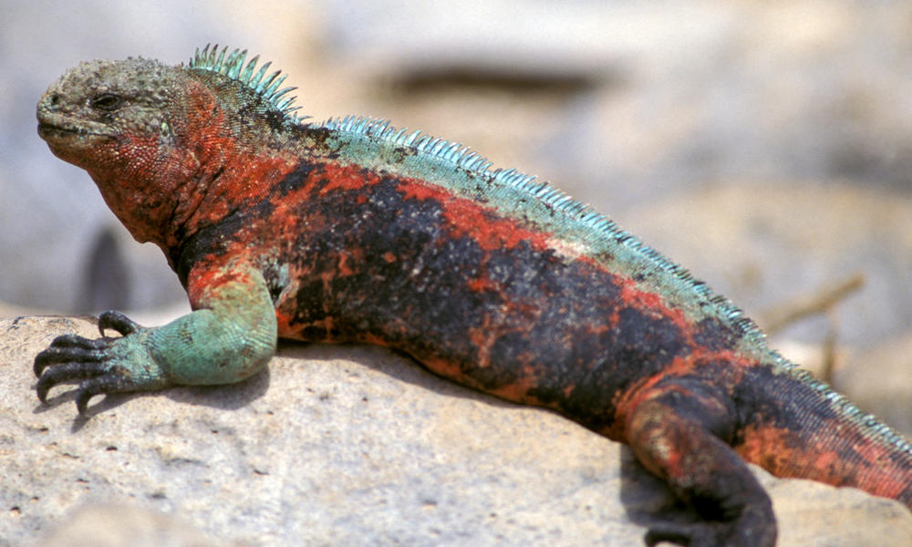
Marine Iguana
source: http://worldwildlife.org/species/marine-iguana

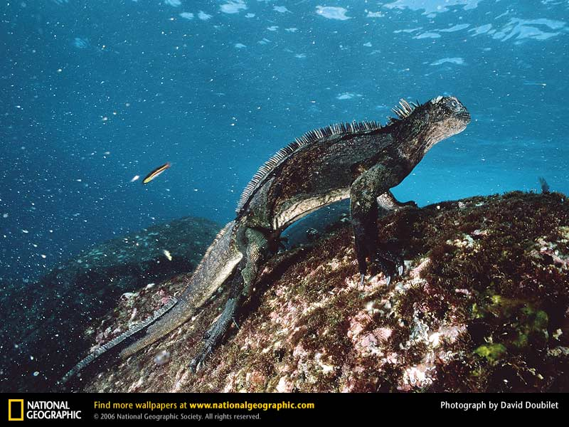<- original (for reference)
Marine Iguana
source: http://animals.nationalgeographic.com/animals/enlarge/marine-iguana-underwater_image.html

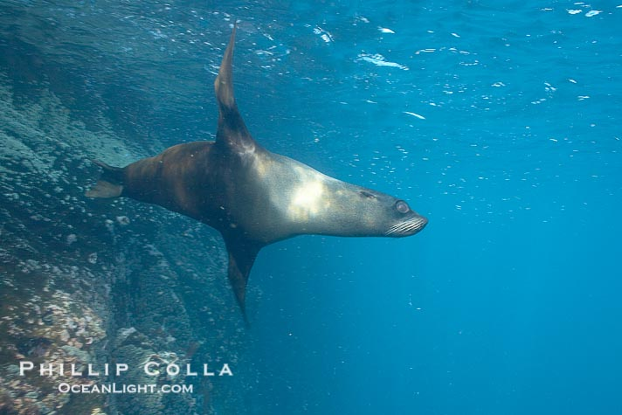
Galapagos Fur Seal (in water)
source: http://www.oceanlight.com/spotlight.php?img=16323

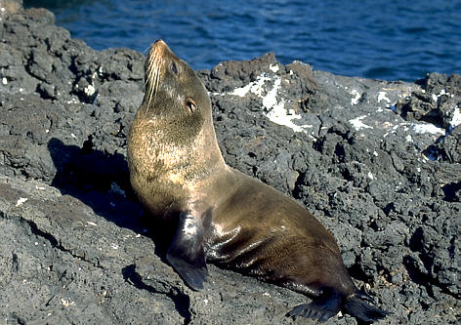
Galapagos Fur Seal (on land)
http://www.biologie.uni-hamburg.de/b-online/e36/pelzseel.htm

