Anatomy of a Volcano

Where does magma come from?

List the two ways that solid mantle rock can melt to form magma.

1.

2.

What is the difference between magma and lava?

What process occurs when magma rises inside of a volcano, but the volcano does not erupt?

What process occurs when magma erupts from a volcano?

Does a volcano always erupt from its peak?

Label the following diagrams.

1. Active Volcano

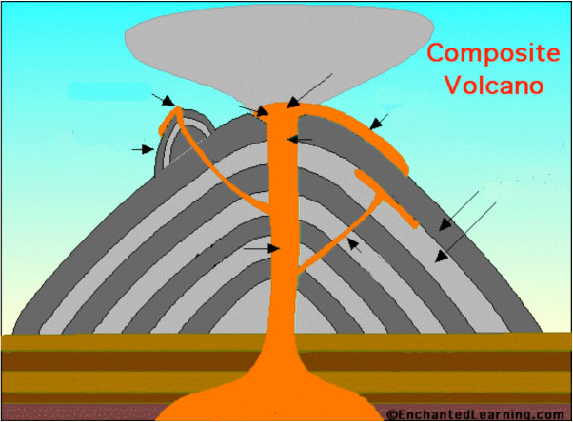

2. Extinct Volcano

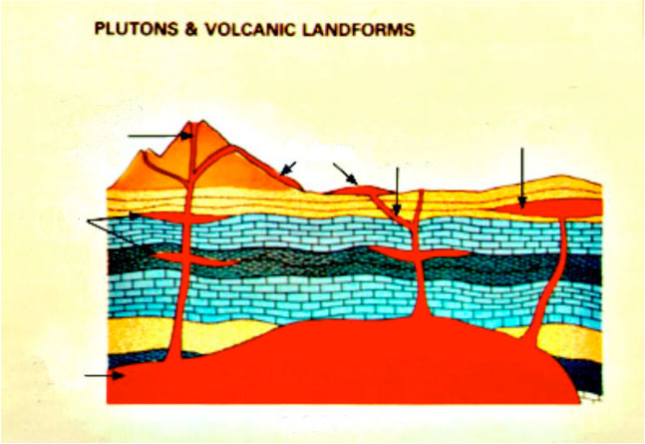

Injection Demonstration

1. Predict what will happen when red water is injected into the gelatin cast. What direction will it go? What shape will it take? Will it erupt through the surface of the gelatin? If so, where?

2. Describe how the experimental results compare with your predictions.

3. Refill and insert the syringe as many times as possible. Compare magma migration each time. Are there differences in the direction the magma takes when the syringe is inserted in different parts of the gelatin cast? Describe and explain what you see.

4. Looking directly down on the gelatin cast, sketch the positions and shapes of the magma bodies. Label your drawing "Map View."

5. Note the traces made by the magma bodies; these are similar to what we see in highway road cuts or cliff faces. Sketch the positions and shapes of the magma bodies on a cut face. Label your drawing "Cross-sectional View."

6. Compare what you see in two dimensions on the cut face with what you see in three dimensions looking into the gelatin cast. Which view gives you more information? Why?

7. How and why does magma move through volcanoes?

