Anatomy of a Volcano

Where does magma come from? The mantle

List the two ways that solid mantle rock can melt to form magma.

1. Decrease in pressure

2. Addition of water

What is the difference between magma and lava?

Magma is molten rock inside the Earth and lava is molten rock on the surface of the Earth

What process occurs when magma rises inside of a volcano, but the volcano does not erupt?
Intrusion

What process occurs when magma erupts from a volcano?
Extrusion

Does a volcano always erupt from its peak? No

Label the following diagrams.

1. Active Volcano

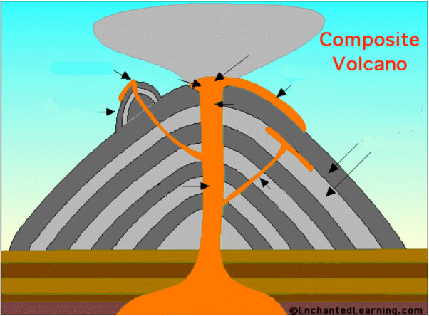
Magma chamber
Rock layers of the Earth’s crust
Throat
Branch pipe
Dike
Conduit
Sill
Layers of lava and ash emitted by the volcano
Lava flow
Vent
Summit
Crater
Ash cloud
Parasitic cone
Side vent
Flank

2. Extinct Volcano

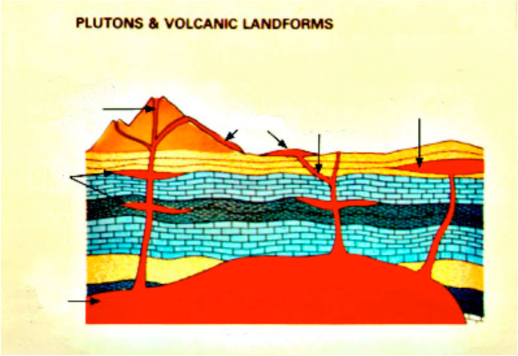
Laccolith
Dike
Flow
Batholith
Pluton
Sill
Volcanic cone

Injection Demonstration

1. Predict what will happen when red water is injected into the gelatin cast. What direction will it go? What shape will it take? Will it erupt through the surface of the gelatin? If so, where?

2. Describe how the experimental results compare with your predictions.

3. Refill and insert the syringe as many times as possible. Compare magma migration each time. Are there differences in the direction the magma takes when the syringe is inserted in different parts of the gelatin cast? Describe and explain what you see.

4. Looking directly down on the gelatin cast, sketch the positions and shapes of the magma bodies. Label your drawing "Map View."

5. Note the traces made by the magma bodies; these are similar to what we see in highway road cuts or cliff faces. Sketch the positions and shapes of the magma bodies on a cut face. Label your drawing "Cross-sectional View."

6. Compare what you see in two dimensions on the cut face with what you see in three dimensions looking into the gelatin cast. Which view gives you more information? Why?

7. How and why does magma move through volcanoes?

