Volcanology Exam

- The three types of volcanoes are _______________________________________ __________________________________________________________________
- The three geological settings of volcanoes are ____________________________ __________________________________________________________________
- Which type of magma has the highest silica content?
  - Andesite
  - Rhyolite
  - Basalt
- What type of magma forms shield volcanoes?
  - Rhyolite
  - Andesite
  - Basalt
- All volcanoes are located along plate boundaries. True or False?
- The two ways that solid rock can melt to form magma are __________________ __________________________________________________________________
- Name three clues that tell you a volcano will erupt soon. ____________________ __________________________________________________________________
- The two factors that determine how explosive an eruption will be are __________________________________________________________________
- In this diagram, label the batholith, dike, sill, magma chamber, stratovolcano, cinder cone, and ash.
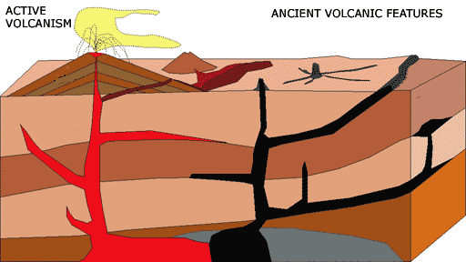
- Which of these is a hazard associated with a volcano?
  - Hurricane
  - Tornado
  - Typhoon
  - Tsunami
- Viscosity describes how dense a fluid is. True or false?
- Latitude describes the position on earth north or south of the equator. True or false?
- Longitude describes the position on earth east or west of the prime meridian. True or false?
- Less viscous fluids hold gas inside longer than more viscous fluids. True or false?
- What is the difference between lava and magma? __________________________
__________________________________________________________________
- The term that describes the process of volcanoes releasing gases into the atmosphere is _________________________________.
- Which of these products of volcanoes can cool the earth?
  - Ash
  - Sulfur dioxide
  - Lava
  - Lahar
- Which of these products of volcanoes can warm the earth?
  - Tsunamis
  - Earthquakes
  - Carbon dioxide
  - Ash
- Which type of eruption involves lava fountaining?
  - Plinian
  - Strombolian
  - Vulcanian
  - Hawaiian
- What type of eruption can create a cinder cone?
  - Hawaiian
  - Plinian
  - Vulcanian
  - Strombolian
- The most explosive type of eruption is:
  - Vulcanian
  - Plinian
  - Hawaiian
  - Strombolian
- Hawaiian eruptions form a
  - Shield volcano
  - Stratovolcano
  - Littoral cone
  - Cinder cone
- Viscous lava is more explosive because
  - Viscous liquids allow pressure to build up in bubbles before they can escape
  - Viscous liquids require more pressure to erupt
  - Viscous liquids are most commonly associated with felsic magma
  - All of the above

- Label the types of volcanoes in this diagram

- Which volcanic hazard is easy to outrun?_________________________________
- Name two toxic gases emitted by volcanoes. _____________________________
__________________________________________________________________
- One volcanic hazard that can burn as well as asphyxiate (suffocate) people is
__________________________________________________________________
- How does a volcanic eruption cause a lahar? _____________________________
__________________________________________________________________
- Name three benefits of volcanoes to humans. _____________________________
__________________________________________________________________
- Magma that flows through several layers before cooling inside the volcano is called a
  - Sill
  - Dike
  - Batholith
  - Laccolith
- Magma that intrudes between two layers of lava and cools inside the volcano is called a
  - Laccolith
  - Dike
  - Batholith
  - Sill
- Magma can erupt from the flank of a volcano. True or false?
- What causes inflation? _______________________________________________
__________________________________________________________________
- Name one effect of volcanoes on the local climate or weather immediately surrounding a volcano. _______________________________________________
- What appearance does a pahoehoe lava flow have? ________________________
- What appearance does an a’a lava flow have? _____________________________

- The following graph shows the changes in tilt of a volcano during an eruption. What event happened at point 30? ______________________________________
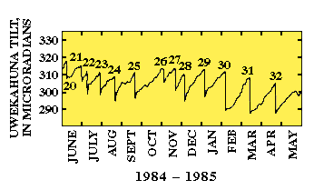
- Volcanic rock that contains a high percentage of silica is called
  - Andesite
  - Felsic
  - Mafic
  - Basalt
- Volcanic rock that contains a high percentage of iron and magnesium is called
  - Rhyolite
  - Dacite
  - Felsic
  - Mafic
- The eruption of which volcano was successfully predicted by volcanologists, which saved tens of thousands of lives?
  - Pelée
  - Krakatau
  - Tambora
  - Pinatubo
- Which volcano had the largest observed eruption in recorded history?
  - Krakatau
  - Pelée
  - Tambora
  - Pinatubo
- A lahar from which volcano wiped out the city of Armero (which had been built on a previous mudflow deposit)?
  - Pinatubo
  - Nevado del Ruiz
  - Pelée
  - Tambora

