APES Dichotomous Key
How to make a dichotomous key
Dichotomous keys use a variety of characteristics to distinguish and categorize living and non-living objects. One of the easiest methods is to categorize by physical traits. For example, one key difference between a fly and a frog is wings. To make the process easy and exciting follow these few simple steps:
- Examine your object and record any physical traits that you notice during your observation. Do this for all of your objects.
- Divide a piece of paper into columns, placing each object at the top of each column. Label the first paper Similarities. Write down all of the physical traits that each object shares with 1 or more other objects (e.g. 4 legs, wings, etc.).
- Divide a piece of paper into columns once again, placing each object at the top of each column. Label this paper Differences. Write down all of the physical traits that are different between 1 or more objects (e.g. one has 8 legs and the others have 4).
- You can now begin to create a dichotomous key.
- Pick the physical trait that most of the objects share and create 2 choices: 1) Object has the physical trait or 2) Object does not have the physical trait.
- Continue to do this from the most common physical trait to the least common physical trait. By the end you should have created a list of dichotomous (two) choice questions for each physical trait.
- To test your dichotomous key, choose an object and see if you reach the correct answer choice. Remember: Each object should end at only one choice.

Example:
Suppose you have a ladybug, fly, dragonfly, and grasshopper. After observing their physical traits you notice that all have wings, some wings have protective casings, some wings point back while others point to the side, and body shapes are either round or elongated.
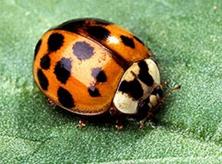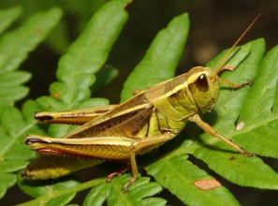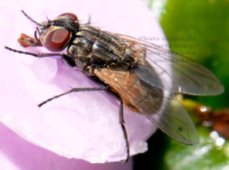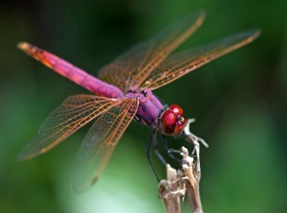

1a. Wings are covered (This could be the ladybug or grasshopper)
1b. Wings are not covered (This could be the fly or dragonfly)
The statements created above must lead to another statement to narrow down your choices.
1a. Wings are covered (Go to step 2)
1b. Wings are not covered (Go to step 3)
2a. Body is round (ladybug)
2b. Body is elongated (grasshopper)
3a. Wings point backwards (fly)
3b. Wings point to the side (dragonfly)

It is as easy as that. A handout will be provided for you to test your skills. It takes practice, but soon enough it will be like second nature.

