APES- Biodiversity Pre-Lab - Dichotomous Key
Name: ___________________________________ Period: ___________
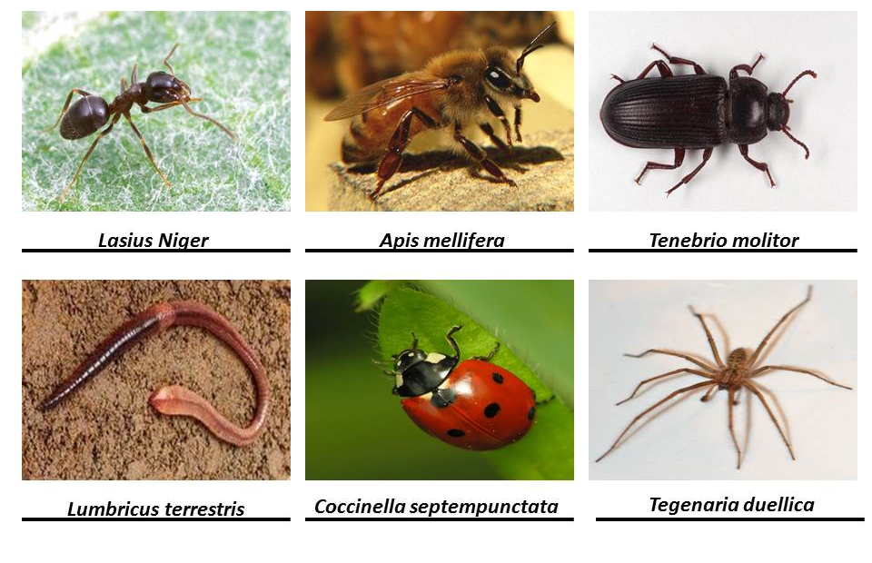
Directions: Try and find the correct scientific name for the organisms provided using the dichotomous key below:
1a) Has legs – Go to step 2
1b) Does not have legs – Go to step 3
2a) Has 6 legs – Go to step 4
2b) Has more than 6 legs – Go to step 7
3a) Has wings – Go to step 5
3b) Does not have wings – Go to step 6
4a) Has wings – Go to step 5
4b) Does not have wings – Lasius niger
5a) Has wings enclosed in a protective casing - Coccinella septempunctata
5b) Has wings unprotected - Apis mellifera
6a) Has a hard segmented body – Tenebrio molitor
6b) Has a soft segmented body - Lumbricus terrestris
7a) Has 8 legs – Tegenaria duellica

