APES- Biomes – Computer Exercise
Name: ___________________________________ Period: ___________

Introduction
The internet has allowed us to browse and search for information far quicker and with more results than ever before. With the amount of information readily available on the web, the challenge now lies in deciding which information to use. Having the skills to do this is something that will be applicable now and in the future. Learning how to search for specific information is a skill that takes practice. The following lab exercise will introduce you to global biomes by testing your online search skills and intuition.
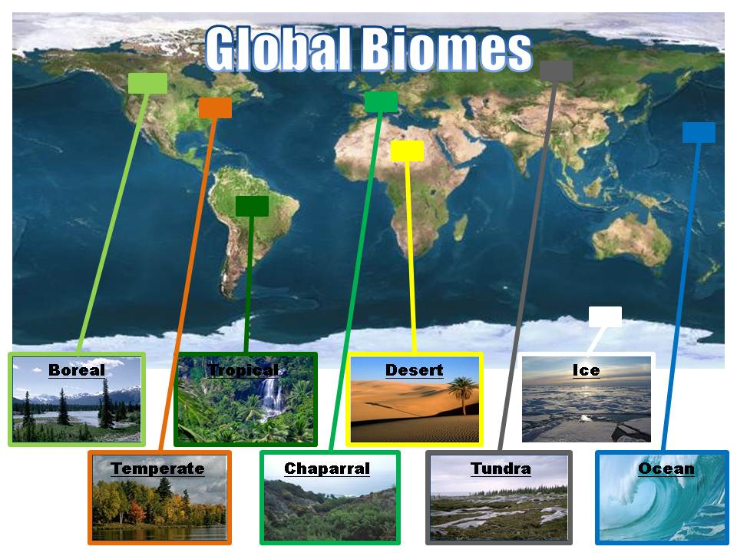
Directions:
You will be provided with a global map showing snapshots of various biomes located throughout the world, and a list of organisms with corresponding rows and columns located to their right. Take time to examine each organism and then using your intuition write in the biome you believe the organism belongs to in the first column titled “Biomes” on the left side of the forward slash. Now using your internet searching skills attempt to fill in the columns with information for each organism. Definitions for each column are provided below.

Biome – global region or area that the organism inhabits
Common Name – the name that the organism is usually called or referred by
Diet – What the organism eats or the process it undergoes to obtain nutrition
Competition – Other organisms that share one or more resources (e.g. diet, habitat)
Predators – Other organisms that may harm and/or consume

Example: Organism – Macrocystis pyrifera
Biome Common Name Diet Competition Predators
Ocean Giant Kelp Photosynthesis P. californica Urchins

The amount of organisms and columns that need to be completed will be at the discretion of your instructor.

