All matter is composed of tiny “building blocks” called ____________.

In the picture below, fill in the blanks using the words provided. Atomic particles with a “+” have a positive charge, and atomic particles with a “-“ have a negative charge.
Proton Nucleus
Neutron Electron Orbital
Electron

Label the different phases “solid”, “liquid”, and “gas”, and draw a line matching the magnified version of the atomic arrangement to each phase.
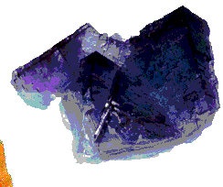
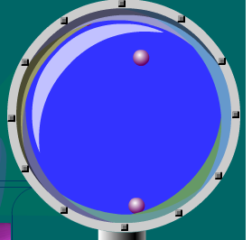

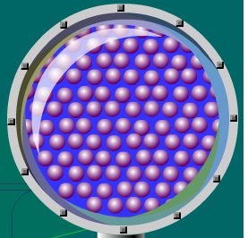
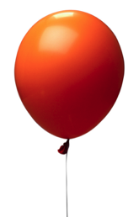

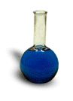

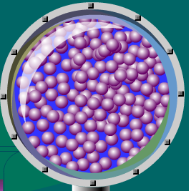

Which phase is missing?

How are the three atomic arrangements different?

