Brianne Moskovitz – Waves

  - Lesson Introduction/Summary (required).
This is a 4-5 day unit on the physics of waves and encounters in the marine environment. Students will have the opportunity to work with actual data, learn about different types of waves, and understand how waves are used in the ocean to learn about the environment. The unit consists of three lessons, two worksheets, a group project, and review game. Topics covered include an introduction to transverse and longitudinal waves, the difference between wind generated waves and tsunamis, and how and why we use sound underwater.

  - Learning Goals (required).
- Students know waves carry energy from one place to another.
- Students know how to identify transverse and longitudinal waves in mechanical media, such as springs and ropes, and on the earth (seismic waves).
- Students know how to solve problems involving wavelength, frequency, and wave speed.
- Students know sound is a longitudinal wave whose speed depends on the properties of the medium in which it propagates.
- Students will be able to distinguish between a wind driven wave and a tsunami with regards to mode of generation, wave speed, frequency, and wavelength.
- Students will be able to describe the uses of sound in the ocean environment.
- Students will be able to understand the driving forces of a sound speed curve in the ocean, and the impacts of the shape of the curve.

  - Science Standards addressed (required).
California Science Standards
Grades 9-12 Physics
4 a,b,c,d

  - Misconceptions (required).
Waves transfer water.
Tsunamis are created by large storms.
Typical ocean waves are created by the moon’s gravity (tides).
Whales generate the most sound in the ocean.

  - Description of Activities (required).
Day 1: What are waves?
- 10-15 min PPT, activity with slinkys and springs, reinforcement worksheet
- Features (amplitude, crest, trough, wavelength, wave speed, longitudinal, transverse)
Day 2: Ocean Waves
- Short PPT, Wave tank demonstration, video clips on tsunami, worksheet, and make your own surfboard competition
Day 3 and 4: Acoustic Waves
- PPT on applications of ocean acoustics, common ocean sounds, and structure of sound speed profile
- Stirring up Sound demonstration
- Group activity with presentations of regional sound speed data.
- Review Jeopardy

  - Context for use (required).
This activity was designed for a high school physics or marine science class, but may be adapted for middle school students. It is helpful if students have a basic understanding of mechanics and energy. This lesson plan was based on five consecutive 90-minute lessons, but could be broken into shorter time periods and spread out over two weeks. An additional lesson on seismogram basics was taught on Day 2 after “What is a wave?” and can be found at http://earthref.org/SCC/lessons/2009/earthquakes/#week2, Day 1

  - Assessment (required).
The provided worksheets may be used for assessment purposes, along with the group Sound Speed project. Each lecture includes warm-up questions to gauge the student’s understanding. The follow up Jeopardy game will also gauge student’s understanding.

  - Teaching Material (optional).

Day 1: Slinkys and Springs (1 for every 3 or 4 students), stop watch, meter sticks, Tuning Forks (at least 2 different sizes)
Day 2: Plexiglass Wave Tank 6’x2’x6” with optional paddle for waves, 2”x4” (approx) piece of cardboard for each student, 5”x5” (approx) piece of aluminum foil for each student
Day 3-4: Tuning forks, hot pot, 2 glasses of the same size that when tapped with a knife make the same sound, butter knife, poster paper and supplies for posters

  - Outside Web Links (if applicable)
http://dsc.discovery.com/videos/assignment-discovery-shorts-waves-of-destruction-tsunamis.html
http://youtu.be/N-M0Q1P_EKs
http://www.nationalgeographic.com/volvooceanrace/interactives/waves/index.html
http://oceanexplorer.noaa.gov/edu/learning/9_ocean_waves/activities/breaking_waves.html
Dosits.org – Discovery of Sound in the Sea
http://dosits.org/resources/teachers/ - Stirring up Sound Activity
http://dosits.org/audio/interactive/ - Audio Gallery: Anthropogenic Sounds (Ship, Airgun), Other Natural Sounds (Waves on a Beach, Earthquake), Any whale
http://dosits.org/science/sciencesummary/ - background understanding of sound

Images:
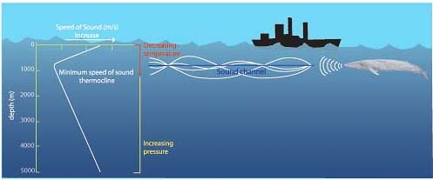
http://oceanexplorer.noaa.gov/explorations/sound01/background/acoustics/media/sofar.html
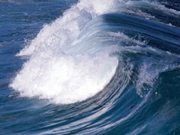
http://oceanexplorer.noaa.gov/edu/learning/media/lesson9_220.jpg
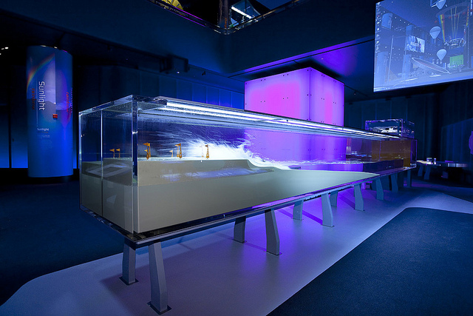
Museum of Science and Industry Chicago
Photo Credit: Lexington Design + Fabrication
http://www.msichicago.org/whats-here/exhibits/science-storms/the-exhibit/tsunami/tsunami-wave-tank/
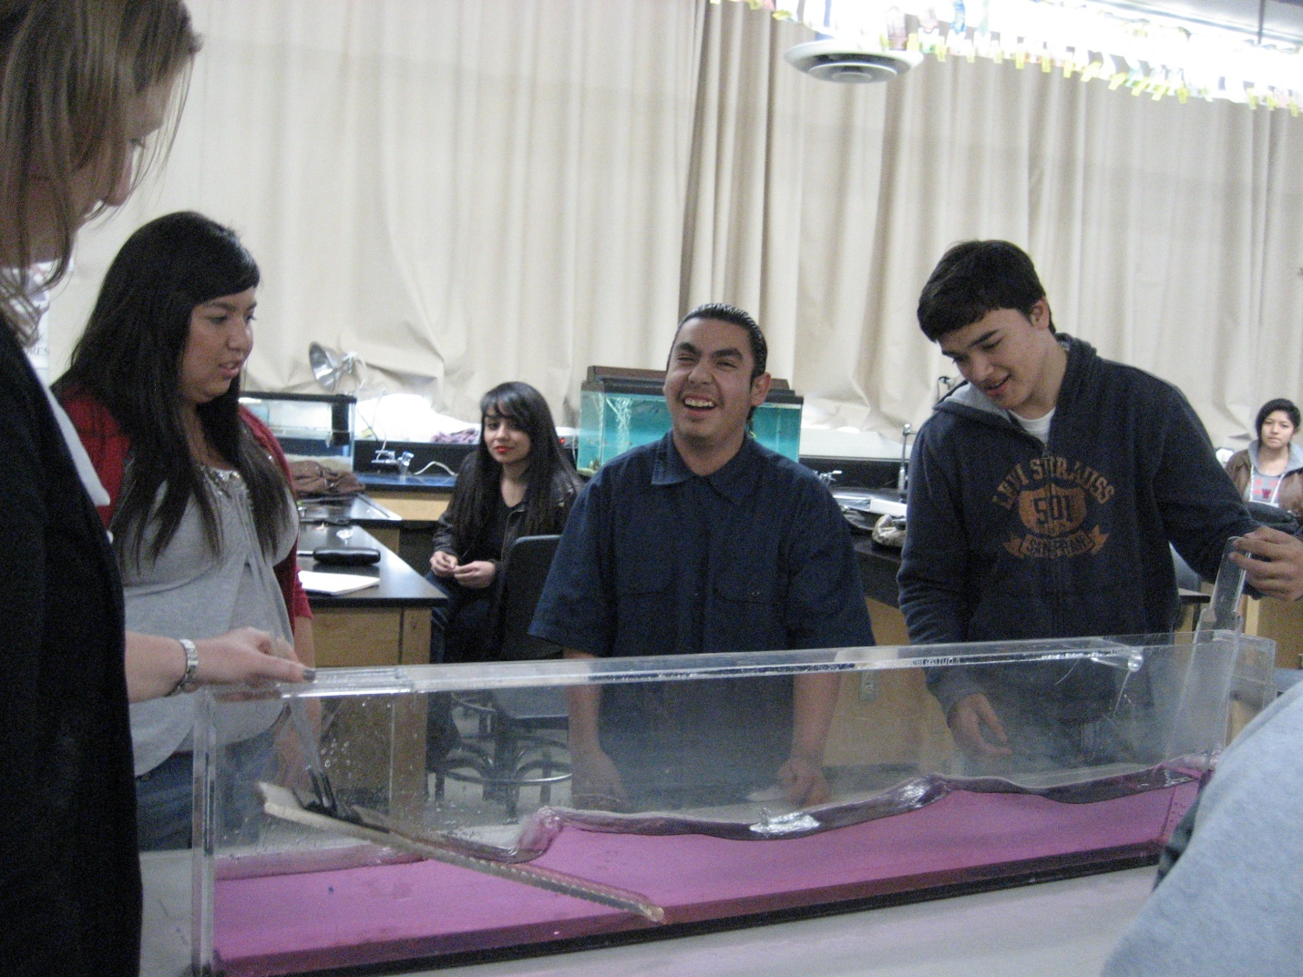
Marine Science Class testing their surfboards in the wave tank.

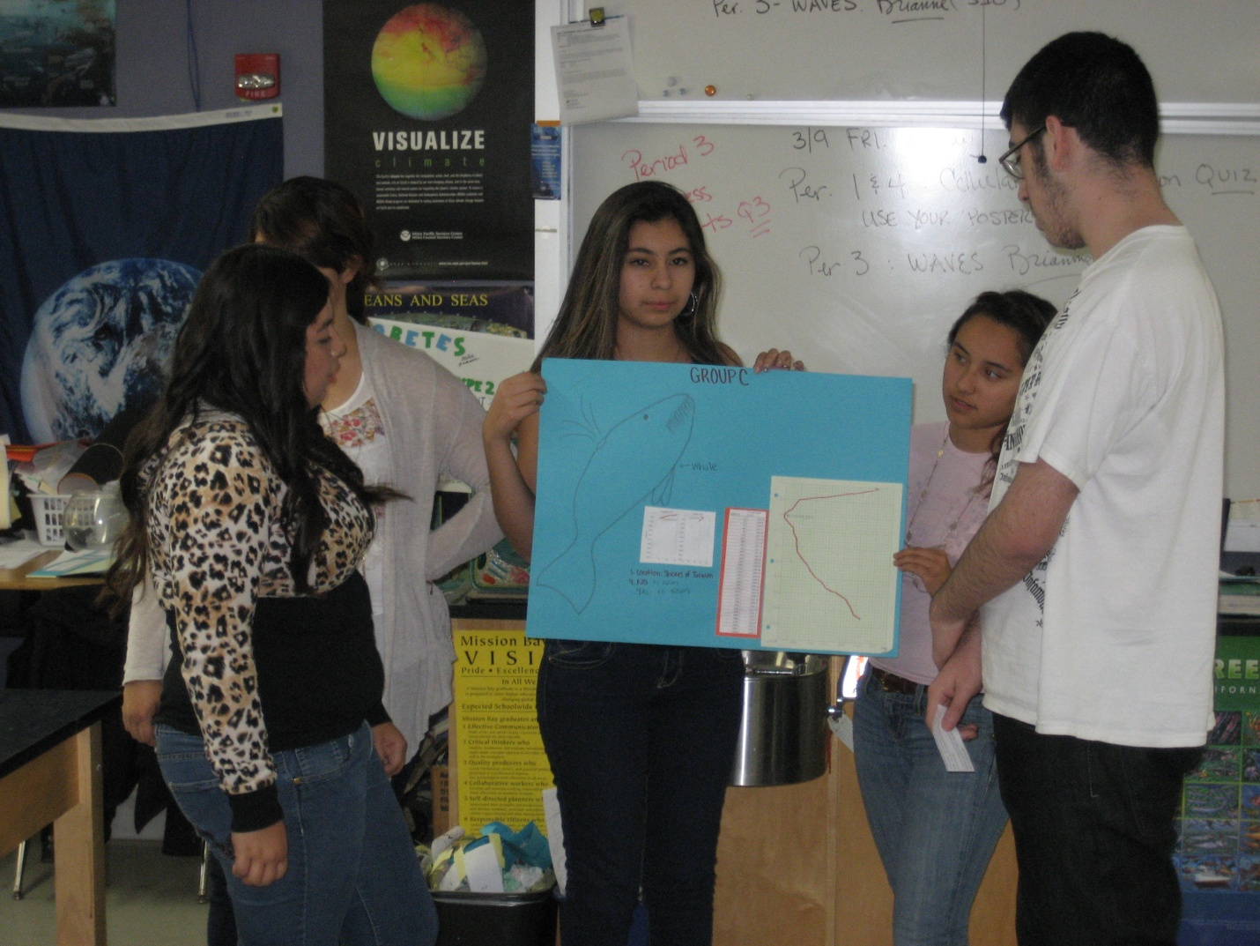
Marine Science Class group Presentation on Sound Speed.

