Name
Class Period
Slinky Waves Lab

You will investigate wave motion with springs. Answer questions 1-14 before beginning the lab.
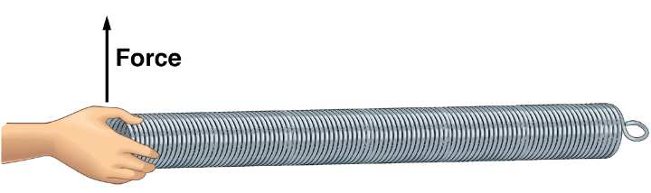

1. Predict what will happen to the spring if a force is exerted on the spring (displacing it) and then the spring is returned to its initial position.

2. By exerting a force through a distance on the spring, what do you transfer to the spring?

3. What happens to this energy?

4. What is this kind of wave called?

5. How can you find the rate at which the wave moves down the length of the spring?

6. If the spring is stretched so that the coils are separated, predict whether the wave speed will be faster or slower.

7. Predict what will happen to the speed of the wave with a spring with small coils instead of large coils.

Work in groups and displace the spring as indicated and find the wave speed.

Unstretched Slinky
Slinky Length  (m) | Trial 1  (sec) | Trial 2  (sec) | Trial 3  (sec) | Trial 4  (sec) | Trial 5  (sec) | Average Time  (sec) | Wave Speed  m/s

Stretched Slinky
Slinky Length  (m) | Trial 1  (sec) | Trial 2  (sec) | Trial 3  (sec) | Trial 4  (sec) | Trial 5  (sec) | Average Time  (sec) | Wave Speed  m/s

Unstretched Thin Spring
Spring Length  (m) | Trial 1  (sec) | Trial 2  (sec) | Trial 3  (sec) | Trial 4  (sec) | Trial 5  (sec) | Average Time  (sec) | Wave Speed  m/s

Stretched Thin Spring
Spring Length  (m) | Trial 1  (sec) | Trial 2  (sec) | Trial 3  (sec) | Trial 4  (sec) | Trial 5  (sec) | Average Time  (sec) | Wave Speed  m/s

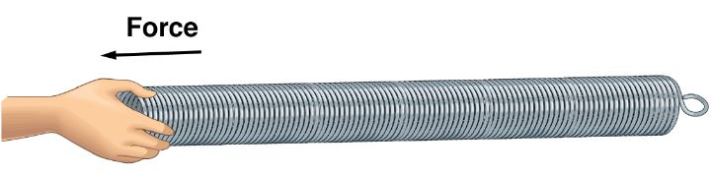
8. Predict what will happen to the spring if a force is exerted on the spring (displacing it) and then the spring is returned to its initial position.

9. By exerting a force through a distance on the spring, what do you transfer to the spring?

10. What happens to this energy?

11. What is this kind of wave called?

12. How can you find the rate at which the wave moves down the length of the spring?

13. If the spring is stretched so that the coils are separated, predict will happen to the rate at which the wave moves down the length of the spring.

14. Predict what will happen to the speed of the wave with a spring with small coils instead of large coils.

Displace the spring as indicated and find the wave speed.

Unstretched Slinky
Slinky Length  (m) | Trial 1  (sec) | Trial 2  (sec) | Trial 3  (sec) | Trial 4  (sec) | Trial 5  (sec) | Average Time  (sec) | Wave Speed  m/s

Stretched Slinky
Slinky Length  (m) | Trial 1  (sec) | Trial 2  (sec) | Trial 3  (sec) | Trial 4  (sec) | Trial 5  (sec) | Average Time  (sec) | Wave Speed  m/s

Unstretched Thin Spring
Spring Length  (m) | Trial 1  (sec) | Trial 2  (sec) | Trial 3  (sec) | Trial 4  (sec) | Trial 5  (sec) | Average Time  (sec) | Wave Speed  m/s

Stretched Thin Spring
Spring Length  (m) | Trial 1  (sec) | Trial 2  (sec) | Trial 3  (sec) | Trial 4  (sec) | Trial 5  (sec) | Average Time  (sec) | Wave Speed  m/s

Follow Up Questions

15. What happens to the spring if a force is exerted on the spring (displacing it) and then the spring is returned to its initial position?

16. By exerting a force through a distance on the spring, what is transferred to the spring?

17. What happens to this energy?

18. What are the two types of waves observed in today’s investigations?

19. How can you find the rate at which the wave moves down the length of the spring?

20. If the spring is stretched so that the coils are separated, what happens to the rate at which the wave moves down the length of the spring?

21. How does the type of spring affect the rate at which a wave moves?

22. Identify three types of waves we encounter every day. Specify the type of wave as well.

23. There are many different waves in a marine environment. Identify three types of waves in a marine environment, and specify the type of wave.

24. Do you notice a difference in the types of waves that exist in a marine environment? What do you think is the reason for the difference?

