Name
Class Period
Slinky Waves Lab

You will investigate wave motion with springs. Answer questions 1-14 before beginning the lab.
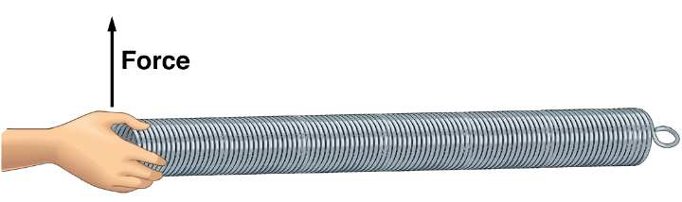

1. Predict what will happen to the spring if a force is exerted on the spring (displacing it) and then the spring is returned to its initial position.
Any prediction acceptable – the wave will travel along the spring.

2. By exerting a force through a distance on the spring, what do you transfer to the spring?
Energy

3. What happens to this energy?
It creates a wave, and travels along the spring.

4. What is this kind of wave called?
Transverse

5. How can you find the rate at which the wave moves down the length of the spring?
Measure the distance the wave travels, measure the time it takes to travel, and use D=RT to calculate the rate.

6. If the spring is stretched so that the coils are separated, predict whether the wave speed will be faster or slower.
Any prediction – Faster or Slower

7. Predict what will happen to the speed of the wave with a spring with small coils instead of large coils.
Any prediction – Faster or Slower

Work in groups and displace the spring as indicated and find the wave speed. Answers vary for each group.

Unstretched Slinky
Slinky Length  (m) | Trial 1  (sec) | Trial 2  (sec) | Trial 3  (sec) | Trial 4  (sec) | Trial 5  (sec) | Average Time  (sec) | Wave Speed  m/s

Stretched Slinky
Slinky Length  (m) | Trial 1  (sec) | Trial 2  (sec) | Trial 3  (sec) | Trial 4  (sec) | Trial 5  (sec) | Average Time  (sec) | Wave Speed  m/s

Unstretched Thin Spring
Spring Length  (m) | Trial 1  (sec) | Trial 2  (sec) | Trial 3  (sec) | Trial 4  (sec) | Trial 5  (sec) | Average Time  (sec) | Wave Speed  m/s

Stretched Thin Spring
Spring Length  (m) | Trial 1  (sec) | Trial 2  (sec) | Trial 3  (sec) | Trial 4  (sec) | Trial 5  (sec) | Average Time  (sec) | Wave Speed  m/s

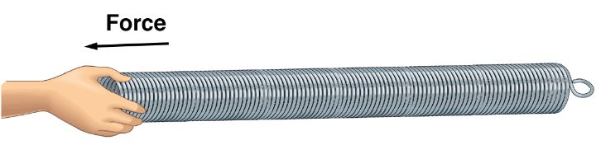
8. Predict what will happen to the spring if a force is exerted on the spring (displacing it) and then the spring is returned to its initial position.
Any prediction – Wave travels along the spring

9. By exerting a force through a distance on the spring, what do you transfer to the spring?
Energy

10. What happens to this energy?
It creates a wave and travels along the spring

11. What is this kind of wave called?
Longitudinal

12. How can you find the rate at which the wave moves down the length of the spring?
Measure the distance the wave travels, measure the time it takes to travel, and use D=RT to calculate the rate.

13. If the spring is stretched so that the coils are separated, predict will happen to the rate at which the wave moves down the length of the spring.
Any prediction – Faster or Slower

14. Predict what will happen to the speed of the wave with a spring with small coils instead of large coils.
Any prediction – Faster or Slower

Displace the spring as indicated and find the wave speed.

Unstretched Slinky
Slinky Length  (m) | Trial 1  (sec) | Trial 2  (sec) | Trial 3  (sec) | Trial 4  (sec) | Trial 5  (sec) | Average Time  (sec) | Wave Speed  m/s

Stretched Slinky
Slinky Length  (m) | Trial 1  (sec) | Trial 2  (sec) | Trial 3  (sec) | Trial 4  (sec) | Trial 5  (sec) | Average Time  (sec) | Wave Speed  m/s

Unstretched Thin Spring
Spring Length  (m) | Trial 1  (sec) | Trial 2  (sec) | Trial 3  (sec) | Trial 4  (sec) | Trial 5  (sec) | Average Time  (sec) | Wave Speed  m/s

Stretched Thin Spring
Spring Length  (m) | Trial 1  (sec) | Trial 2  (sec) | Trial 3  (sec) | Trial 4  (sec) | Trial 5  (sec) | Average Time  (sec) | Wave Speed  m/s

Follow Up Questions

15. What happens to the spring if a force is exerted on the spring (displacing it) and then the spring is returned to its initial position?
It transfers a wave along the spring.

16. By exerting a force through a distance on the spring, what is transferred to the spring?
Energy

17. What happens to this energy?
It travels along the spring.

18. What are the two types of waves observed in today’s investigations?
Transverse and Longitudinal waves.

19. How can you find the rate at which the wave moves down the length of the spring?
Measure the distance the wave travels, measure the time it takes to travel, and use D=RT to calculate the rate.

20. If the spring is stretched so that the coils are separated, what happens to the rate at which the wave moves down the length of the spring?
Stretched spring transfers energy faster.

21. How does the type of spring affect the rate at which a wave moves?
The smaller spring transferred the wave more quickly.

22. Identify three types of waves we encounter every day. Specify the type of wave as well.
Many acceptable answers. Light – Transverse, Sound – Longitudinal, Music strings - Transverse

23. There are many different waves in a marine environment. Identify three types of waves in a marine environment, and specify the type of wave.
Surface Ocean Waves – transverse, Sound Waves – Longitudinal, Light - Transverse

24. Do you notice a difference in the types of waves that exist in a marine environment? What do you think is the reason for the difference?
Transverse waves don’t travel well in the ocean. Most waves underwater are longitudinal because the medium allows transverse waves.

