Name
Class Period
Ocean Waves

Kind of Wave | Mode of Generation | Range of Wavelength | Wave Frequency (Period) | Wave Speed
wind-driven
seismic-sea wave (tsunami)

- Label the parts of the wave, including: trough, crest, wavelength, and amplitude

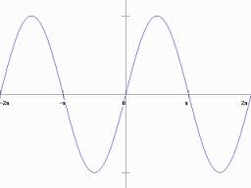

Wave Simulator
The following questions pertain to the wave simulator at http://www.nationalgeographic.com/volvooceanrace/interactives/waves/index.html
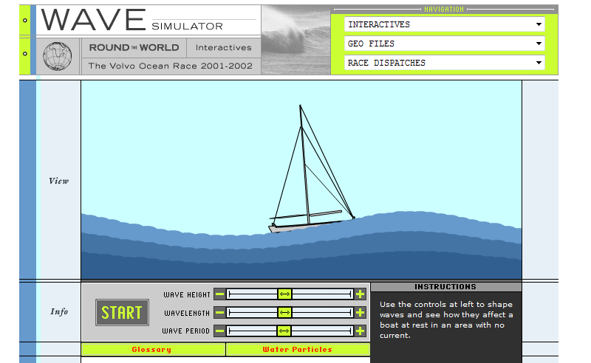

- What do you have to do to the wave height, wavelength and wave period to make the flattest wave?

- What do you have to do to the wave height, wavelength and wave period to make the most bumpy wave?

- Can you model a typical surface wave on the simulation? Explain how or why not.

- Can you model a tsunami on the simulation? Explain how or why not.

Breaking Waves
The following questions pertain to the catch a wave simulator at http://www.montereyinstitute.org/noaa/lesson09/l9la1_a.html

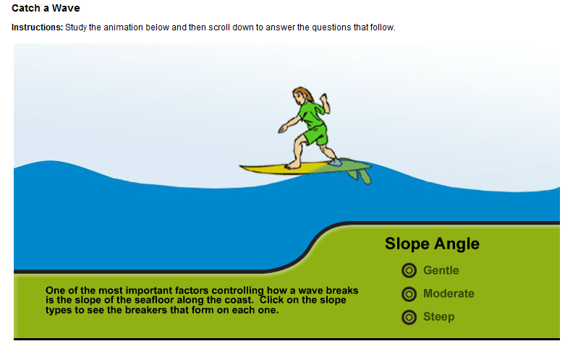
- In your own words, explain the difference between a surface wave and a tsunami.

- Do you think a surface wave could be as powerful as a tsunami? Explain your reasoning.

- What happens to a wave as it moves into shallow water?

- Describe how the slope of the seafloor controls the way a wave breaks.

- What distinguishes a shallow water wave from a deep water wave?

- Which type of breaker - spilling, plunging, or surging – will cause the most coastal erosion? Explain.

- Which type of breaker - spilling, plunging, or surging – will deposit sand onshore and expand beaches? Explain.

- Draw the shore line for a type of wave you would like to surf. Explain your drawing.

- Where would you want to be if a tsunami generating earthquake struck nearby? Explain your answer.

