Name
Class Period
Ocean Waves

Kind of Wave | Mode of Generation | Range of Wavelength | Wave Frequency (Period) | Wave Speed
wind-driven | local or distant winds that blow across the ocean's surface | about 100 m to 200 m | 5s to 20s | about 40 to 90 km/h (40 km/h, the speed of a moped, is most common)
seismic-sea wave (tsunami) | diplacement of the seafloor from sub-marine earthquakes (most tsunamis); volcanic eruptions, landslides, underwater explosions, and meteor impacts | from 100 m to >500 km; are at least three times the ocean depth at which the wave was generated | 10 min to 2 h | variable, up to 1,000 km/h (the speed of a jet plane)

- Label the parts of the wave, including: trough, crest, wavelength, and amplitude

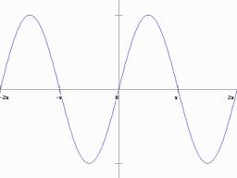

Wave Simulator
The following questions pertain to the wave simulator at http://www.nationalgeographic.com/volvooceanrace/interactives/waves/index.html
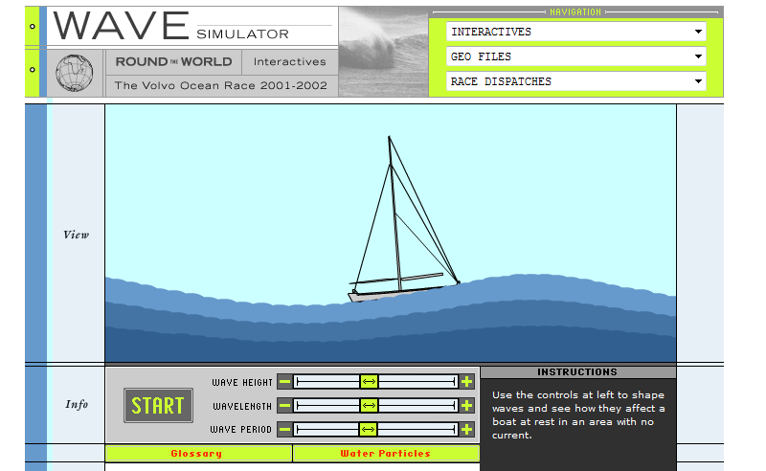

- What do you have to do to the wave height, wavelength and wave period to make the flattest wave?
Lowest wave height, greatest wavelength, lowest wave period (would just affect frequency of the wave).

- What do you have to do to the wave height, wavelength and wave period to make the most bumpy wave?
Greatest wave height, lowest wavelength, highest wave period.

- Can you model a typical surface wave on the simulation? Explain how or why not.
Medium wave height, low wavelength, high wave period.

- Can you model a tsunami on the simulation? Explain how or why not.
Lowest wave height, greatest wavelength, lowest wave period.

Breaking Waves
The following questions pertain to the catch a wave simulator at http://www.montereyinstitute.org/noaa/lesson09/l9la1_a.html

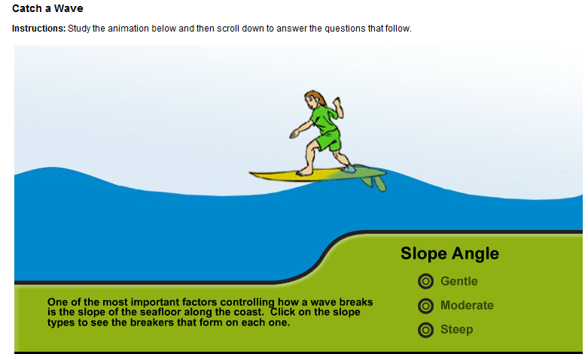
- In your own words, explain the difference between a surface wave and a tsunami.
Surface waves are generated from the wind. Tsunami are generated from ground displacement.

- Do you think a surface wave could be as powerful as a tsunami? Explain your reasoning.
No – the amount of energy in a tsunami is much greater, and is felt throughout the water column.

- What happens to a wave as it moves into shallow water?
Hide Answer
When the water depth decreases to one half of a wave’s wavelength, the wave starts to “feel the bottom”. That means that the deepest water molecules set into circular motion by the wave’s energy run into the seafloor. This forces the wave to grow upwards, so wave height increases. The base of the wave is slowed down by friction against the sea bottom, while the top of the wave rushes ahead, so the wave crest begins to lean more and more forward until it topples over, and breaks on the shore.
- Describe how the slope of the seafloor controls the way a wave breaks.
Hide Answer
On a gentle slope, waves begin to feel the bottom far from the shore. The waves grow slowly taller and lean forward, and foam spills down their fronts as they run up onto the beach. On a moderate slope, the waves get closer to shore before they break. Because the water shallows more rapidly, wave energy is rapidly concentrated into a small area, so the waves grow very tall and the crests curl far forward of the troughs. On a steep slope, the waves don’t interact with the bottom until they are almost right at the shore, so they don’t have time to build-up, and instead just surge far up the beach without breaking.
- What distinguishes a shallow water wave from a deep water wave?
Shallow water waves “feel the bottom.” The depth is 1/20 of the wavelength.

- Which type of breaker - spilling, plunging, or surging – will cause the most coastal erosion? Explain.
Hide Answer
A surging breaker will cause the most erosion because it slams into the beach at full speed. Spilling and plunging breakers slow down as they drag across the seafloor, so their energy is dissipated over a wider zone.
- Which type of breaker - spilling, plunging, or surging – will deposit sand onshore and expand beaches? Explain.
Hide Answer
Waves can move sand when their energy is in contact with the bottom. Spilling breakers spend the most time and energy dragging across the seabed, so they should be able to push more sand onto the beach. Surging waves hardly interact with the bottom at all, so they will have little effect on offshore sand.

- Draw the shore line for a type of wave you would like to surf. Explain your drawing.

Students may draw shallow seafloors, or more steep if they are daredevils.

- Where would you want to be if a tsunami generating earthquake struck nearby? Explain your answer.
Inland, high ground, or out in the middle of the ocean! The surface displacement of the water in the deep ocean is only on the order of 1 m.

