Goal: Design a house that will survive a volcanic eruption

You just invented a car that runs on Gatorade and are now a billionaire. You decide to move to the Big Island of Hawaii to live in luxury in tropical paradise. Since you’re a good scientist you know that Hawaii has several active volcanoes and that it can be dangerous living on a volcanic island. You plan to build a mansion but you also want to build a safehouse, or bunker, that might be able to survive an eruption and keep you safe (although the safest thing to do is evacuate!). You are also free to build your house anywhere on the island. Using what you know about volcanoes and their hazards, design a safehouse that can survive a volcanic eruption and choose the safest location on the island using volcanic hazard maps.

What type of volcano is on that the Big Island? ____Shield Volcano_____

From the list on the right, which volcanic hazards you are MOST likely to encounter on Hawaii (remember that you are near the coast):

1. ________________________

2. ________________________
Pyroclastic flow
Volcanic ash
Volcaniclastic debris
Lava flows
Superheated air
Volcanic gasses
Earthquakes
Tsunami
Lahars

3. ________________________

4. ________________________

5. ________________________

6. ________________________

7. ________________________

8. ________________________

Now that you know what hazards you face, it is time to choose your building location. Look at the volcano and earthquake hazard maps on the next page and choose the safest location for your house. Also keep in mind that tsunamis are a great danger close to sea level.

What district on Hawaii will you build your house? Why?
Kohala is predicted to be the least severe area for a volcanic eruption, although there have been several small earthquakes there.

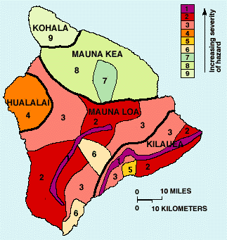
Big Island Volcano Hazard Map

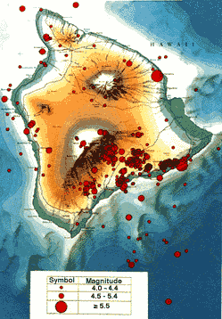
Big Island Earthquake Map:
Recent earthquakes from 1962-1985

Now it’s time to design your house! On the following page choose from a number of locations, designs and materials to build with.

Once you select the basic design for your house, write a few sentences explaining why you chose your features.

For example: “I chose to have a house with an angled roof so ash won’t collect on top.”

Choose one feature from each of the following categories:
Roof
Flat
Angled
Doesn’t matter, underground

Windows
None
Normal glass
Pyrex glass

Evacuation Vehicle (You’re rich!)
Helicopter
Speed Boat
Zip line
Jet
HumVee

Location
Underground
Above ground
On stilts

Location pt. 2
On top of a hill
In a valley
On a plain

Building Material
Steel
Wood
Cement
Volcanic rocks

Shape
Square
Circular
Triangular
Doesn’t matter, underground

Lava Defenses
None
Moat
Rock wall

In the space below describe why you chose your safehouse characteristics.

Now that you’ve chosen a building location and safehouse design, let’s see how your building might stand up to an actual Hawaiian eruption. The website below is by the US Geological Survey describing the ways people in Hawaii have tried to protect themselves from volcanic hazards. Read the page and compare the real life solutions to the house you designed.

“Living with volcanic hazards”
http://pubs.usgs.gov/gip/hazards/living.html

Based on the USGS report, do you think your house could survive a volcanic eruption? Why or why not?
Answers will vary, but should address locations of the house (e.g. on a hill) and the success of man-made diversions.

What is the recommended method for surviving eruptions and tsunamis?
Evacuation is the only sure way to survive a volcanic eruption

How successful are man-made barriers for deflecting lava flows? When do they work? When do they fail?

Barriers work when there is a limited supply of lava. Voluminous eruptions can easily overrun any barriers. There are also complications in large urban areas where there is no place to divert the lava without some property damage.

