Name: ______________________________________ Date: ________

Surface Tension, Surfactants, and Sea Foam: Part I

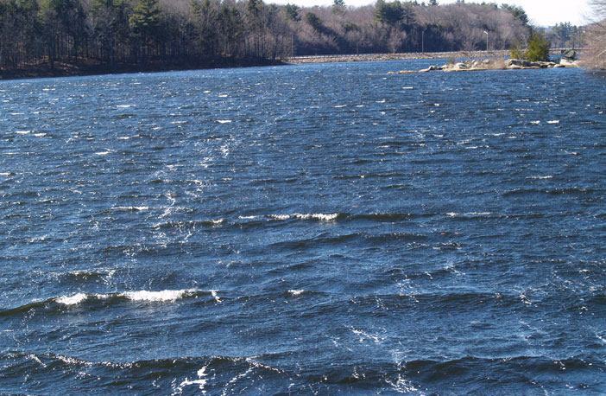
Surface tension is a property of liquids that causes the surface of a liquid to contract. Because of hydrogen bonding in water, its surface tension is very high. The effects of water's high surface tension can be seen all around us. Bubbles form more easily in a solution with lowered surface tension. The lowered surface tension allows air to separate the molecules forming a bubble wall and allows the bubble to expand. This worksheet and accompanying presentation will detail the properties of surface tension and culminate in an activity investigating bubble size and life span. This worksheet is to be completed during the associated Surface Tension, Surfactants, and Sea Foam: Day 1 presentation. Do not answer questions ahead of pace. Your instructor will let you know when to answer each question.

- Describe the similarities and differences when soapy water is agitated vs. fresh water.

_____________________________________________________________
_____________________________________________________________

_____________________________________________________________

_____________________________________________________________

- Water strider. Describe what is happening and where the effects of surface tension can be seen.

_____________________________________________________________
_____________________________________________________________

_____________________________________________________________

- For each of the figures (A-E), describe what is happening and where the effects of surface tension can be seen.

- ___________________________________________________________
- ___________________________________________________________

- ___________________________________________________________

- ___________________________________________________________

- ___________________________________________________________

- Drops on a penny: Hypothesize how many drops of water you can fit on your penny. Write that number below.

hypothesis: ________

Now use your dropper to place drops of water on your penny. How many drops were you able to fit?

number of drops: ________
- How did the water look on the penny before it spilled off? Explain how surface tension plays a role in giving the water this shape.

_____________________________________________________________
_____________________________________________________________

_____________________________________________________________

- If the water was hotter, would you be able to fit more or less drops on the penny? Why? Use your knowledge of surface tension to make an educated guess.

_____________________________________________________________
_____________________________________________________________

_____________________________________________________________

- After seeing the plot of surface tension vs. temperature, would your answer to the previous answer stay the same or change? Why? Use words like average kinetic energy, intermolecular forces and surface tension.

_____________________________________________________________
_____________________________________________________________

_____________________________________________________________

