Name: ______________________________________ Date: ________

Surface Tension, Surfactants, and Sea Foam: Part I

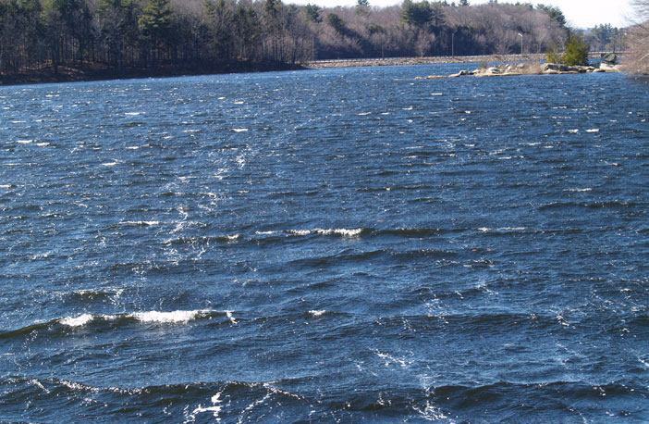
Surfactants in the ocean lower the water’s surface tension and increases sea foam persistence. Increased sea foam leads to increased bubble-mediated gas exchange between the ocean and atmosphere and increased marine aerosol production. This worksheet and accompanying presentation will detail the properties of surface tension and surfactants while stressing the importance of sea foam. This worksheet is to be completed during the associated Surface Tension, Surfactants, and Sea Foam: Day 1 presentation. Do not answer questions ahead of pace. Your instructor will let you know when to answer each question.

- Describe the similarities and differences when soapy water is agitated vs. fresh water.

Small bubbles are formed in the fresh water when agitated, however they quickly rise to the surface and pop. Many more bubbles are formed when the soapy water is agitated. After the soapy water is agitated, bubbles remain on the surface of the liquid while the fresh water has very few or no bubbles on its surface when agitation is stopped.

- Water strider. Describe what is happening and where the effects of surface tension can be seen.

The water strider is an insect that can walk on water. The weight of the water strider is not high enough to overcome the force of surface tension in water. If a human were to walk on water, we would sink to the bottom because our weight is strong enough to break the intermolecular forces between water molecules causing the surface tension.

- For each of the figures (A-E), describe what is happening and where the effects of surface tension can be seen.

- The water is not streaming from the faucet, rather it is forming distinct spherical droplets.
- The force due to surface tension of the liquid is high enough to keep the coin floating on the surface.

- As the water runs down the hand, it forms distinct sheets and streams near the base of the palm.

- Instead of forming a thin film, the water on the leaf beads up and forms distinct droplets of water.

- The surface tension of the soapy solution keeps the bubbles spherically shaped.

- Drops on a penny: Hypothesize how many drops of water you can fit on your penny. Write that number below.

hypothesis: any number

Now use your dropper to place drops of water on your penny. How many drops were you able to fit?

number of drops: typically between 25-40
- How did the water look on the penny before it spilled off? Explain how surface tension plays a role in giving the water this shape.

Before it spilled off, the water formed a round spherical shape. In fact the side of the water appeared to slightly extend over the side of the coin. Surface tension is an attractive force between liquid molecules. The high surface tension of water allows water molecules to “stick” to each other and stay on top of the coin rather than sliding off.

- If the water was hotter, would you be able to fit more or less drops on the penny? Why? Use your knowledge of surface tension to make an educated guess.

Answers here will vary, however the correct answer is given below to question #7 after the plot of surface tension vs. temperature is shown.

- After seeing the plot of surface tension vs. temperature, would your answer to the previous answer stay the same or change? Why? Use words like average kinetic energy, intermolecular forces and surface tension.

If the water was hotter, less drops would fit on the penny. Surface tension is responsible for holding the water molecules together instead of sliding off the coin. As the figure shows, surface tension decreases with increasing temperature. Temperature is a measure of the average kinetic energy of atoms within matter. Hotter water implies that the water molecules are moving fast past one another. This weakens the average force of hydrogen bonding between molecules because individual hydrogen bonds are being broken more frequently by faster moving molecules.

