Name: ______________________________________ Date: ________

Surface Tension, Surfactants, and Sea Foam: Part II

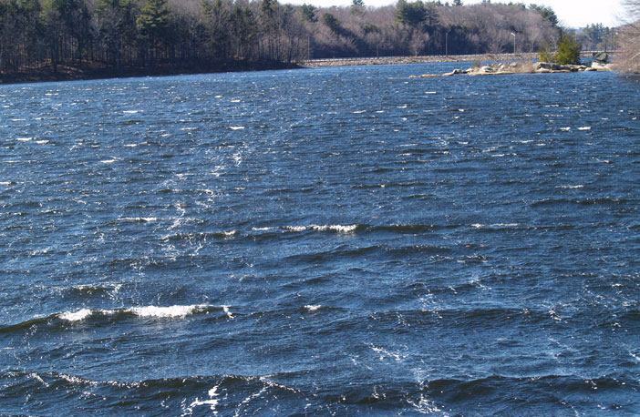
Surfactants in the ocean lower the water’s surface tension and increases sea foam persistence. Increased sea foam leads to increased bubble-mediated gas exchange between the ocean and atmosphere and increased marine aerosol production. This worksheet and accompanying presentation will detail the properties of surfactants while stressing the importance of sea foam. This worksheet is to be completed during the associated Surface Tension, Surfactants, and Sea Foam: Day 2 presentation. Do not answer questions ahead of pace. Your instructor will let you know when to answer each question.

- Surfactants and ocean surfactants

- Draw how you would expect 5 surfactant chains (an example is shown below) to align themselves at an air-water interface.

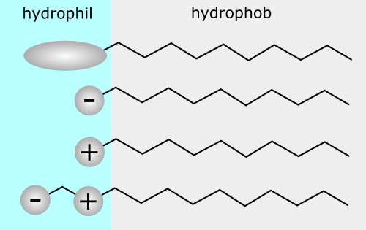

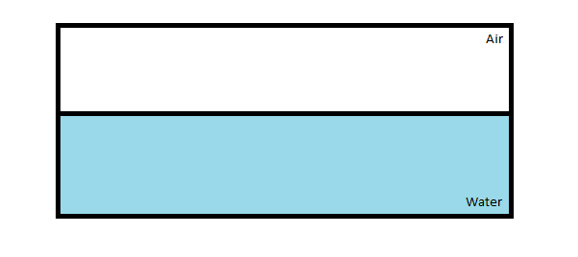
- Would you be able to blow a bubble from fresh water alone? What would happen? How does adding a surfactant like dish soap allow bubbles to be formed? Use words like surface tension, surfactant, and intermolecular forces.

- Sea foam

- Initial ideas. What is foam?

- Which situation (A or B) is more important to air-sea gas transfer and cloud formation? Why?

- Describe in your own words how bubbles and foam are created during wave breaking.

- Where does the majority of wave breaking events occur in the ocean?

- How is increased biological productivity in the ocean similar to adding dish-soap to water?

- How is agitating the water in the opening demo yesterday similar to the effect of wind blowing over the ocean?

- Cloud nucleation

- Describe in your own words what happens as a bubble bursts.

- What three particulates are highlighted as important for cloud nucleation? Which of these particulates result from bursting bubbles?

- Technology

- W is the percentage of ocean surface covered in sea foam. U₁₀ is the wind speed 10 m above the ocean surface. What are the units for both W and U₁₀?

- What happens to the percentage of ocean surface covered in sea foam as the wind speed increases? Why do you think this is true?

- Would you say the relationship between W and U₁₀ is linear? Why or why not?

