Name: ______________________________________ Date: ________

Surface Tension, Surfactants, and Sea Foam: Part II

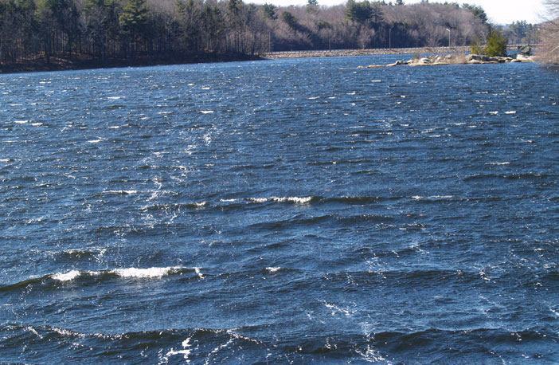
Surfactants in the ocean lower the water’s surface tension and increases sea foam persistence. Increased sea foam leads to increased bubble-mediated gas exchange between the ocean and atmosphere and increased marine aerosol production. This worksheet and accompanying presentation will detail the properties of surfactants while stressing the importance of sea foam. This worksheet is to be completed during the associated Surface Tension, Surfactants, and Sea Foam: Day 2 presentation. Do not answer questions ahead of pace. Your instructor will let you know when to answer each question.

- Surfactants and ocean surfactants

- Draw how you would expect 5 surfactant chains (an example is shown below) to align themselves at an air-water interface.

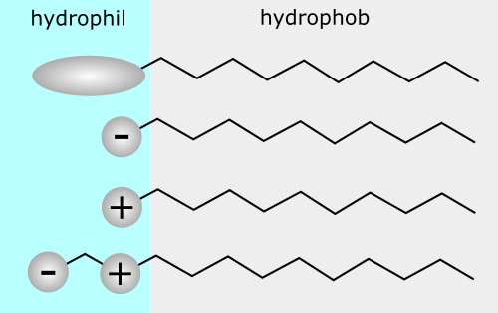

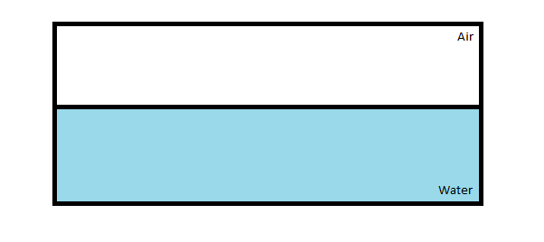
- Would you be able to blow a bubble from fresh water alone? What would happen? How does adding a surfactant like dish soap allow bubbles to be formed? Use words like surface tension, surfactant, and intermolecular forces.

A bubble could not be blown from fresh water. The high surface tension of water does not allow the water molecules to be stretched enough to allow air inside. However when a surfactant has been added, like dish soap, the surface tension of water is lowered by disrupting the intermolecular forces between water molecules. This allows air to fill the bubble and the bubble wall to be stretched against the contractive tendency of surface tension. Surface tension, while lowered however, still tends to contract the water molecules together, resulting in the bubble having a spherical shape.

- Sea foam

- Initial ideas. What is foam?

Foam is a substance that is formed by trapping pockets of gas in a liquid of solid.

- Which situation (A or B) is more important to air-sea gas transfer and cloud formation? Why?

Situation B is more important to air-sea gas transfer and cloud formation. This is because wave breaking like in case B, known as white-capping is happening all throughout the world’s ocean basins. Shoaling waves that break on shore and generate foam occurs only along the coastline and so the amount of foam generated there is small compared to foam generated in open ocean white-capping

- Describe in your own words how bubbles and foam are created during wave breaking.

The wave in the figure above is propagating from left to right in each panel. The wave is shown to steepen so much that the crest overturns and by the third panel intersects the wave face. This type of breaking wave is known as a plunging breaker. When the air above the wave face is totally enclosed by the crest, it is entrained in the water and immediately fragments into much smaller bubbles. The buoyant rising of those bubbles occurs even after the majority of wave energy propagates downstream past the position where it broke. The life-span of the bubbles sitting on the surface after wave breaking will depend on the concentration of surfactants and other chemicals in the water.

- Where does the majority of wave breaking events occur in the ocean?

As described earlier, the majority of wave breaking events occur in the open ocean.

- How is increased biological productivity in the ocean similar to adding dish-soap to water?

Dish-soap is a commercial surfactant. Increased biological productivity in the upper ocean also is a production source of surfactants, mostly from phospholipids that make up the cell membrane. Thus you would expect more bubbly and foamy conditions with increased biological productivity.

- How is agitating the water in the opening demo yesterday similar to the effect of wind blowing over the ocean?

Wind blowing over the ocean supplies energy and a momentum flux to the wave field. This is synonymous with transferring momentum flux to water by stirring with a rod like in the opening demo.

- Cloud nucleation

- Describe in your own words what happens as a bubble bursts.

The bubble wall becomes significantly thin due to evaporation and downward drainage. Then a small hole forms somewhere in the bubble cap. The hole grows larger as the force due to surface tension pulls liquid molecules back down to the air liquid interface. As the bubble cap collapses, small fragmented droplets form spray and fly away from the bubble in strands known as ligaments.

- What three particulates are highlighted as important for cloud nucleation? Which of these particulates result from bursting bubbles?

Important cloud condensation nuclei are sulfate (SO₄), sea salt, and organic matter. Sea salt and organic particulates result from bursting bubbles.

- Technology

- W is the percentage of ocean surface covered in sea foam. U₁₀ is the wind speed 10 m above the ocean surface. What are the units for both W and U₁₀?

The units on W are percentage. The units on U₁₀ are meters/sec.

- What happens to the percentage of ocean surface covered in sea foam as the wind speed increases? Why do you think this is true?

As the wind speed increases, the percent of ocean surface covered in white caps increases. This is because the wind transfers energy and momentum flux into the wave field which makes waves steepen. Once waves reach a critical steepness, they break and transfer that momentum flux into ocean currents.

- Would you say the relationship between W and U₁₀ is linear? Why or why not?
The relationship between W and U₁₀is nonlinear. In fact on the vertical axis, W is not plotted, but W^(1/3). This forces the graph to appear linear which is easier to read. In certain regimes, like between U₁₀= [2,12] m/s, W^(1/3) is linear with U₁₀. and again between U₁₀= [12,24], W^(1/3) is linear with U₁₀.

