Name: ______________________________________ Date: ________

Soapy and Sticky Bubbles

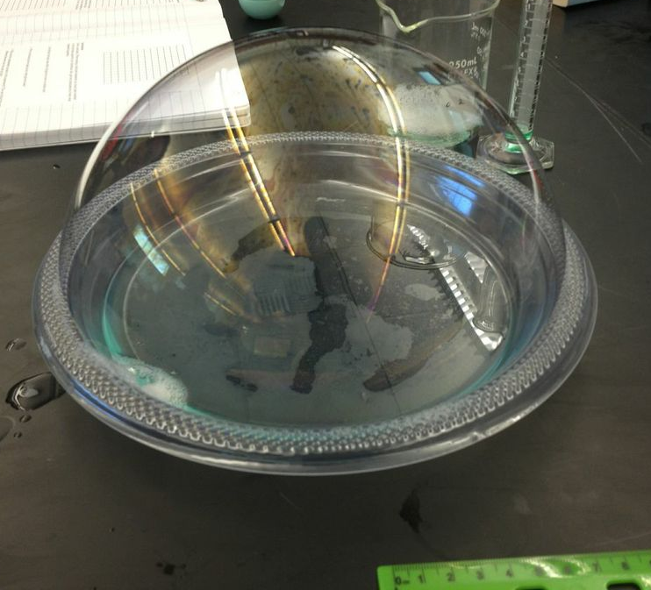
Bubbles are thin spheres of liquid enclosing air or another gas. Common examples of bubbles include water vapor in boiling water, air mixed into agitated water, sea foam, and escaping gas from carbonated beverages. Surfactants, like dish soap, lower the surface tension of a liquid and more readily allow the formation of bubbles. Soap bubbles burst when evaporation causes a bubble to become so thin that a hole forms. In this activity, you will be investigating the size and life span of bubbles formed from both a soapy water solution and a soapy sticky water solution. The sticky substance added to the second solution will be glycerin. Glycerin is a colorless, odorless, highly viscous liquid that is formed both naturally through biological processes and commercially for use in foods, pharmaceuticals, and soaps. One special property of glycerin is that it is hygroscopic, meaning it has the ability to attract and hold water molecules from the surrounding environment.

Materials:

- plastic plate with a raised edge
- measuring ruler
- stop watch
- straw
- stirrer
- 200 mL beaker
- 10 mL graduated cylinder
- dish soap
- glycerin
- water

Observations:
- Describe the physical properties of glycerin

- Hypothesize what effect you think glycerin will have on the bubbles? Will the glycerin (sticky) bubbles last longer? Why do you think so?

Procedure:
Preparation of soap and water solution:
- Fill the beaker with 150 mL of water.
- Measure 10 mL of dish soap in the graduated cylinder.
- Add the dish soap to the beaker filled with water.
- Stir until well mixed.
Blowing soapy bubbles and measurement:
- Add about 75 mL of your soapy solution to the plate.
- Insert your straw and carefully blow a bubble until it is the size of the plate. You may need to practice a few times before you can blow a bubble large enough to fill the entire plate.
- Remove your straw from the bubble and record the time from when you remove the straw to when the bubble pops.
- While you are timing the life span of the bubble, measure its height from the plate with a ruler.
- Repeat steps #6-#8 for 10 bubbles and record in Table 1.

Preparation of soap, glycerin, and water solution:
- Empty out the beaker with solution into a sink. Refill with 150 mL of water.
- Measure 10 mL of dish soap in the graduated cylinder.
- Add the dish soap to the beaker filled with water.
- Rinse the graduated cylinder and measure 5 mL of glycerin.
- Add the glycerin to the beaker with water and dish soap.
- Stir until well mixed.

Blowing sticky bubbles and measurement:
- Add about 75 mL of your soapy and sticky solution to the plate.
- Insert your straw and carefully blow a bubble until it is the size of the plate.
- Remove your straw from the bubble and record the time from when you remove the straw to when the bubble pops.
- While you are timing the life span of the bubble, measure its height from the plate with a ruler.
- Repeat steps #17-#19 for 10 bubbles and record in Table 2.

Data collection:

Table 1 – Soapy bubble height and life span
Bubble Number | Height (cm) | Life span (sec)
1
2
3
4
5
6
7
8
9
10
Average

Table 2 – Soapy and sticky bubble height and life span
Bubble Number | Height (cm) | Life span (sec)
1
2
3
4
5
6
7
8
9
10
Average
Results:
- Describe the physical properties of glycerin.

- Compute the averages (arithmetic mean) for the heights and life spans you recorded in tables 1 and 2. Record those averages in the last row of each table.

- Your teacher will ask you to share your average height and average life span for bubbles of each type of solution. Collect that class data in the table below.

Table 3 – Class results
 | Solution 1: soapy |  | Solution 2: soapy and sticky
Group Number | Avg. height (cm) | Avg. life span (sec) | Avg. height (cm) | Avg. life span (sec)
1
2
3
4
5
6
7
8
9
10
11
12
13
14
15
Class Average

- In figure 1 below, make a bar graph showing your average bubble height for the soapy solution and for the sticky solution. Draw a dashed line for the class average value for each case.

- Make a similar bar graph in figure 2 showing your average bubble life span for the soapy solution and for the sticky solution. Draw a dashed line for the class average value for each case.

Example of bar graph for question #4 and #5:
Class avg = 10.5 cm
Class avg = 7.4 cm

- What effect does adding glycerin have on bubble size?

- What effect does adding glycerin have on bubble life span?

- Why do you think the glycerin causes this effect? Hint: you may want to consider some of the properties of glycerin mentioned in the introduction.

Graphs:

Figure 1 – Bubble height vs. solution

Figure 2 – Bubble life span vs. solution

