Name: ______________________________________ Date: ________

Global Warming: Effects, causes, remedies

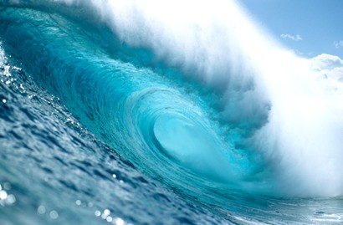
Increased global temperatures have led scientists and policy makers to better understand the effects of a warming planet. In order to find solutions to the problems associated with global warming, its cause must first be understood. Human intervention in the Earth's climate system, in order to moderate global warming, is known as geoengineering. In this lesson you will learn about the cause of global warming, its consequences, and ideas about how to control global temperatures. This worksheet is to be completed during the associated Global warming: Effects, causes, remedies presentation. Do not answer questions ahead of pace. Your instructor will let you know when to answer each question.

Rising temperatures

- How much warmer, in degrees Celsius, is the Earth today compared to 1880?
_____________________________________________________________

- Would you say that the Earth temperature has changed between 1940-1970? How about between 1980-2010?
_____________________________________________________________
_____________________________________________________________

_____________________________________________________________

- Is temperature change constant across the entire planet? In 2012, which part of the world has experienced the largest rise in temperature?
_____________________________________________________________
_____________________________________________________________

_____________________________________________________________

- Of the 5 controls on the Earth's temperature, which has changed, resulting in increased global temperature between 1880-2013?
_____________________________________________________________
_____________________________________________________________

_____________________________________________________________

- How is a “greenhouse” building where plants grow similar to the greenhouse effect in relation to the Earth's atmosphere?
_____________________________________________________________
_____________________________________________________________

_____________________________________________________________

- Atmospheric carbon dioxide concentrations oscillate on a yearly cycle. Why do carbon dioxide levels decrease from May-September, then increase again?
_____________________________________________________________
_____________________________________________________________

_____________________________________________________________

- Why are the carbon dioxide measurements taken atop a mountain in Hawaii?
_____________________________________________________________
_____________________________________________________________

_____________________________________________________________

- What are some consequences that will occur because of increased global temperatures?
_____________________________________________________________
_____________________________________________________________

_____________________________________________________________

- What percent of sunlight is reflected by each type of material? Take a guess first, then label each material with the correct value shared with the class.

Material Guess (%) Actual (%)
Fresh snow _____ _____
Forests _____ _____
Grass _____ _____
Crops _____ _____
Asphalt _____ _____
Concrete _____ _____
Brick/stone _____ _____
Light roof _____ _____
Dark roof _____ _____
Water bodies _____ _____
Moon _____ _____
Earth's average _____ _____

Aerosols

- Over which parts of the Earth are aerosols most heavily concentrated?
_____________________________________________________________
_____________________________________________________________

_____________________________________________________________

- What is the cause of the aerosols originating from central Africa? What is the cause of the aerosols originating from India and China?
_____________________________________________________________
_____________________________________________________________

_____________________________________________________________

Geoengineering

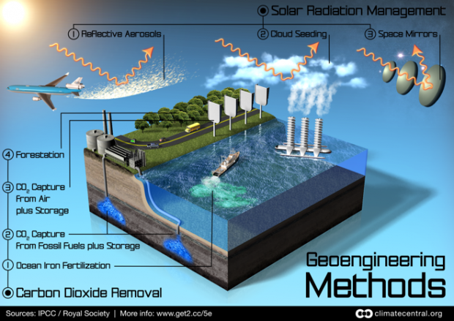

- Proposals to remove carbon dioxide from the atmosphere include ocean iron fertilization, CO2 capture from fossil fuels, CO2 capture from air, and forestation. Which of these strategies do you think is the most realistic to implement? Why?
_____________________________________________________________
_____________________________________________________________

_____________________________________________________________
_____________________________________________________________

- Proposals to manage solar radiation include reflective aerosols, cloud seeding, and space mirrors. Which of these strategies do you think is the most realistic to implement? Why?

_____________________________________________________________
_____________________________________________________________

_____________________________________________________________
_____________________________________________________________
_____________________________________________________________

- Increased cloud coverage would lower global temperatures by increasing the Earth's albedo and reflecting light back to space. With regard to cloud formation by sea spray injection, what are some negative consequences of forming clouds for this purpose?
_____________________________________________________________
_____________________________________________________________

_____________________________________________________________

Do you think this proposed idea will be easy to implement?

_____________________________________________________________
_____________________________________________________________

_____________________________________________________________

What challenges would someone face who would like to implement this management strategy?

_____________________________________________________________
_____________________________________________________________

_____________________________________________________________

