Name: ______________________________________ Date: ________

Global Warming: Effects, causes, remedies

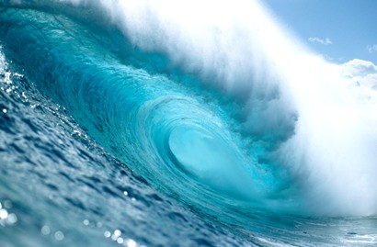
Increased global temperatures have led scientists and policy makers to better understand the effects of a warming planet. In order to find solutions to the problems associated with global warming, its cause must first be understood. Human intervention in the Earth's climate system, in order to moderate global warming, is known as geoengineering. In this lesson you will learn about the cause of global warming, its consequences, and ideas about how to control global temperatures. This worksheet is to be completed during the associated Global Warming: effects, causes remedies presentation. Do not answer questions ahead of pace. Your instructor will let you know when to answer each question.

- Rising temperatures

- How much warmer, in degrees Celsius, is the Earth today compared to 1880?
The Earth is about 0.8 degrees Celsius warmer today than in 1880.

- Would you say that the Earth temperature has changed between 1940-1970? How about between 1980-2010?

Between 1940-1970 the Earth temperature remained mostly constant. Between 1980-2010 global temperature rises.

- Is temperature change constant across the entire planet? In 2012, which part of the world has experienced the largest rise in temperature?

No, temperature change varies both spatially and temporally. However there is a net warming trend as time increases. In 2012, the Artic polar region has experienced the largest rise in temperature.

- Of the 5 controls on the Earth's temperature, which has changed, resulting in increased global temperature between 1880-2013?

The albedo of the Earth is changing because of changing ice, snow, and glacier coverage. Also the amount of greenhouse gases in the atmosphere is increasing.

- How is a “greenhouse” building where plants grow similar to the greenhouse effect in relation to the Earth's atmosphere?

The glass roof of a greenhouse allows sunlight to enter as visible light. As the contents of the greenhouse warm, they reemit infrared radiation that cannot pass through the glass room. This process allows light to enter but for heat to be trapped. This is analogous to greenhouse gases in the atmosphere which allow visible light in from the sun yet trap infrared radiation from the Earth.

- Atmospheric carbon dioxide concentrations oscillate on a yearly cycle. Why do carbon dioxide levels decrease from May-September, then increase again?

The decrease in atmospheric carbon dioxide from May-September is due to increased carbon uptake by land plants in the northern hemisphere summer months via photosynthesis. The increase in atmospheric carbon dioxide in the winter months is due to net respiration of tree litter fall and browning vegetation.

- Why are the carbon dioxide measurements taken atop a mountain in Hawaii?

Hawaii is isolated from other land masses where people live. Also being high up on a mountain helps isolate the atmospheric measurements from the local influences of car pollution and smog present in more populated areas.

- What are some consequences that will occur because of increased global temperatures?

Some but not all consequences include a rise is sea levels, change in rain patterns, expansion of subtropical deserts, and the melting of glaciers, permafrost, and sea ice.

- What percent of sunlight is reflected by each type of material? Take a guess first, then label each material with the correct value shared with the class.

Material Guess (%) Actual (%)
Fresh snow _____ 80-95%
Forests _____ 10-20%
Grass _____ 25-30%
Crops _____ 10-25%
Asphalt _____ 5-10%
Concrete _____ 17-27%
Brick/stone _____ 20-40%
Light roof _____ 35-50%
Dark roof _____ 8-18%
Water bodies _____ 10-60%
Moon _____ 6-8%
Earth's average _____ 31%

Aerosols

- Over which parts of the Earth are aerosols most heavily concentrated?

Aerosols are most heavily concentrated over central Africa, India, and China.

- What is the cause of the aerosols originating from central Africa? What is the cause of the aerosols originating from India and China?

Aerosols over central Africa originate from sand and dust blown by the Trade winds off the Saharan desert. Aerosols originating from India and China are due to urban and industrial pollution.

Geoengineering

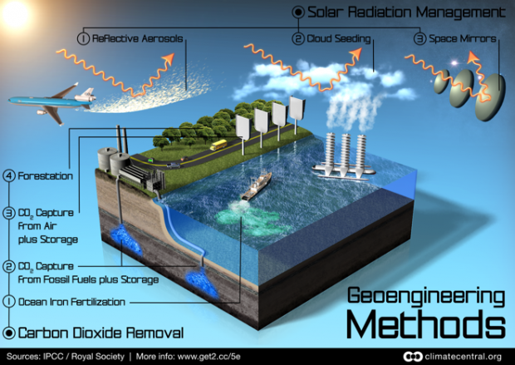

- Proposals to remove carbon dioxide from the atmosphere include ocean iron fertilization, CO₂ capture from fossil fuels, CO₂ capture from air, and forestation. Which of these strategies do you think is the most realistic to implement? Why?

Answers will vary. Of all the strategies, CO2 capture from fossil fuels (followed by subsequent burial) and forestation are the most realistic methods to implement to remove carbon dioxide from the atmosphere.

- Proposals to manage solar radiation include reflective aerosols, cloud seeding, and space mirrors. Which of these strategies do you think is the most realistic to implement? Why?

Answers will vary. None of the proposals to manage solar radiation seem realistic to implement. Reflective aerosols and cloud seeding is too controversial to implement and space mirrors would be too expensive to implement.

- Increased cloud coverage would lower global temperatures by increasing the Earth's albedo and reflecting light back to space. With regard to cloud formation by sea spray injection, what are some negative consequences of forming clouds for this purpose?

Some negative consequences of forming clouds for the purpose of increasing earth’s albedo include unpredicted changes in rain patterns that may cause flood or draught to certain locations.

Do you think this proposed idea will be easy to implement?

The sea spray ships cost-wise seem easy to build, however more science needs to be known about the exact mechanism of cloud formation from marine spray before such a technology could be implemented on a global scale.

What challenges would someone face who would like to implement this management strategy?

Besides the obvious cost challenge, someone who would like to implement this management strategy would have to gain approval from an international community of scientists and policy makers.

