Name: _________________________
Date: _____________________________

Title: Erosion and Deposition
Question: Where does sand at the beach come from?

Initial Ideas: _______________________________________________________

Experiment Procedures:
Make a model of the earth’s surface following the instructions below to observe how sediment is moved from place to place.

- Using the beaker, measure 300 mL of sand and place at the upper end of the water table.
- Smooth out the sand, keeping it in the upper 1/3 of the water table as shown in the diagram below.
- Using your finger, make a curvy line through the sand as shown below.
- On the diagram below, label the parts of the model that represent the mountains, river, floodplain, and the ocean.
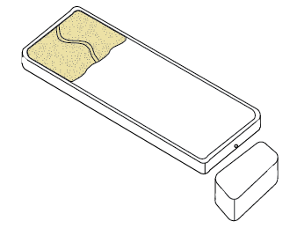
- Measure 100 mL of water in your beaker.
- Hold the flow cup over the upper end of the river and pour the water from the beaker into the flow cup. Don’t move the cup until all the water has drained out.

Q: Which way does water flow and where does it end up? __________________________________________________
Q: Is anything besides water moving on the table? _____ If so, what is moving and where is it moving? ___________________________ ___________________________________________________

- Now put a dam across the river.
- Pour 100 mL of water from your beaker into the flow cup at the upper end of the river.

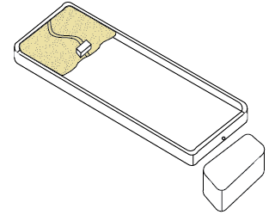
Q: What happens to the water when it hits the dam? _________________________________________________________________________________________________________
Q: What happens to the sediment when it hits the dam? ___________________________
______________________________________________________________________

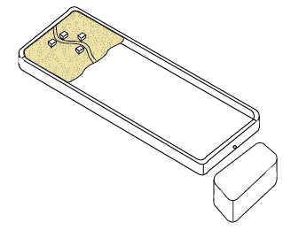
- Smooth out your sand and make a new river.
- Put houses right along the edge of the river.
- Pour 100 mL of water from your beaker into the flow cup at the upper end of the river.

Q: What happens to the houses? ______________________________________
____________________________________________________________________________

- Now instead of using the flow cup, pour 100 mL of water though the funnel.

Q: What happens to the houses now? _______________________
___________________________________________________
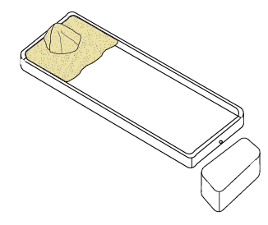
- Now build up a hill of sand at the top of the water table.
- Pour 100 mL of water through the flow cup over the top of the hill.

Q: What happens to the hill? ______________________________
__________________________________________________________________

Q: Look in your basin. What is in the basin? ______________________________________________________________________________________________________________

Interpretation/Conclusions:
Q: Where does sand on the beach come from? ___________________________________________________
Q: How does sand get to the beach? ___________________________________________________
Q: How do your experiment results compare with your initial ideas? ___________________________________________________
___________________________________________________

