Stratigraphic Column Guide

GRAIN SIZE CHART
Grain Size (mm) | Sediment Type
> 256.0 | Boulder
64.0 – 256.0 | Cobble
4.0 – 64.0 | Pebble
2.0 - 4.0 | Gravel
0.062 – 2.0 | Sand
0.004 - 0.062 | Silt
< 0.004 | Clay

ROUNDING CHART
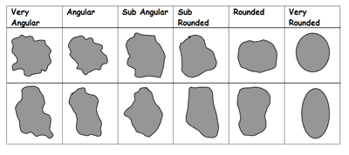

ROCK NAMES CHART
Rock Name | Sediment Type | Rounding | Other Characteristics
Conglomerate | Gravel, Pebble, Cobble | Sub-rounded to Very Rounded | --
Breccia | Gravel, Pebble, Cobble | Sub-angular to Very Angular | --
Sandstone | Sand | -- | --
Siltstone | Silt | -- | --
Claystone | Clay | -- | --
Shale | Clay-Silt | -- | Breaks along layers
Limestone | Skeletal/Shell fragments | -- | Dissolves with acid

Stratigraphic Column symbols:
FOSSILS:
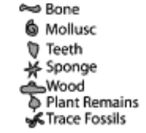

ROCK TYPE:
Conglomerate:
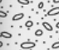
Rounded grains vs. angular grains
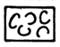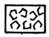
Sandstone:
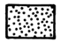
Shale:
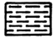
Limestone:
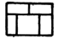
Lens within different rock:
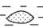

http://www.sciencedirect.com/science/article/pii/S0031018205004426

