LD-50 Lab for Blackworms
AP Environmental Science- Teacher Notes

Part I (1 class period): LD-50 of Copper sulfate with blackworms

Background Information:

“The dose makes the poison.” Paracelsus said this in the 1500s, when he was studying medicine and toxicology, and because of this he is often considered the father of toxicology. What he did mean by this? Paracelsus realized that many substances can be both beneficial and harmful to humans, depending on their dose, or how much of it is consumed. For example, if you take one Advil it might help your headache, but if you took a whole bottle it might poison you.

Since the toxicity, or harmful effects, of a substance is often determined by its dose, scientists need to test what dose of various chemicals can be harmful to humans in order to regulate them. Obviously scientists can not directly test toxicity on humans, so this is usually done in the laboratory with rats or mice. Scientists will give a population of rats or mice different doses (concentrations) of the chemical in question, and observe changes in behavior in the rats or mice. One of the important pieces of data the scientists collect is called the LD-50 of the chemical, which is the concentration (or dose) of the chemical where 50% of the rat or mice population dies upon exposure. Similarly, they also often determine the ED-50 which is the concentration of the chemical where they see negative effects in 50% of the population. These two values help scientists to determine which levels of chemicals are safe to use in humans, and safe to have in the environment.
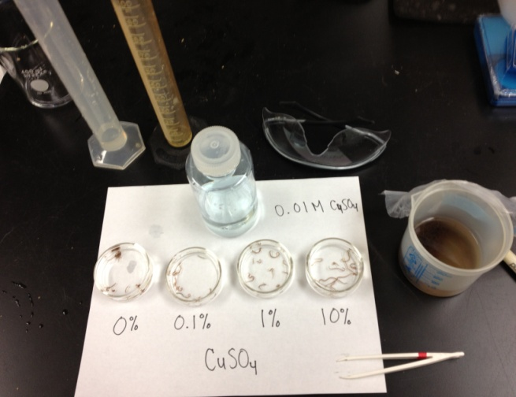
There are many chemicals present in the environment that are regulated. Certain metals such as mercury, arsenic, lead and copper are very harmful to humans and are often present in polluted waters and soils. In order to determine is water is safe for recreational use, drinking, and other uses, metal concentrations have to be below a certain limit set by the local government. Often, these levels are based on experiments done by scientists to determine the LD-50. In this lab, you will be the scientist trying to determine the level of copper that might be safe to have in a local water source. You will determine the LD-50, and ED-50 of blackworms in freshwater with various copper concentrations, and answer follow-up questions related to your investigation.
Experimental set-up for the LD-50 lab.

Objectives: (Students will):
- Prepare various concentrations of copper sulfate (CuSO₄) using serial dilution.
- Collect and graph data for mortality rate of increasing concentrations of copper sulfate with blackworms.
- Determine the LD-50 and threshold values of copper sulfate for blackworms.
Materials:
- Stock 0.0025 M copper sulfate solution
  - Notes: This can made from a liquid AA standard (atomic adsorption) of copper sulfate, or from ordering copper sulfate salt and preparing the solution in weak acid (~1% HCl) to keep the copper in solution.
- Distilled water
  - Notes: Use only distilled water for this lab, and not tap water because blackworms are very sensitive to chlorine in tap water.
- Graduated cylinders - for class use
  - Notes: These are to help the students measure out 2.5 mL of the copper solutions and 22.5 mL of distilled water. A pipette might be necessary for measuring out the 2.5 mL for the copper solutions.
- 5 petri dishes- each student group
  - Notes: Small beakers of other containers can be used as well, as long as they hold 25 mL of solution.
- Grease pencil
  - Notes: Any writing utensil to label the containers for the copper solutions.
- 50 blackworms- each student group
  - Notes: These can usually be obtained from an aquarium store or ordered online.
- Timer- each student group
  - Notes: Students can also just use any clock in the classroom.
Procedure:
- Have the students read the background information and form two initial questions that they have about the lab or about blackworms. Have the students write them down on the lab sheet, and share with their lab partner.

- Next, briefly review the lab with the class and go over the steps. Then, have them follow the directions on their lab sheet.
3. The students will lay out each petri dish and pre-label them with the following concentrations
using the grease pencil:
  - 0% CuSO₄
  - 0.01% CuSO₄
  - 0.1% CuSO₄
  - 1% CuSO₄
  - 10% CuSO₄

- Then they will place 22.5 mL of distilled water into the 0, 0.1, 1 and 10% CuSO₄ petri dishes. They will be doing a serial dilution for the CuSO₄ concentrations in this lab. To start, they should add 2.5 mL of the CuSO₄ standard (found on the lab bench for the class to share) to the 10% CuSO₄ petri dish. Next,they should take 2.5 mL of the 10% CuSO₄ petri dish and place it in the 1% dish. Then take 2.5 mL of the 1% dish and place it in the 0.1% CuSO₄ petri dish. Then take 2.5 mL of the 0.1% dish and place it in the 0.01% CuSO₄ petri dish Take 2.5 mL from the 0.01% dish and discard that into the waste bin. All the beakers should have 22.5 mL of solution in them at the end of the serial dilution.

- Students will then place 10 blackworms into the 0, 0.01, 0.1, 1 and 10% CuSO₄ solutions and record initial observations into the table provided in the column labeled “Initial Observations”. They can also gently prod and poke the blackworms and note how they move, etc… Students should initially observe them for about 1 minute. Next, they will observe the blackworms after 5, 10, 15, 20 and 30 minutes. They can record their observations for each petri dish in the columns labeled with the appropriate time. They should be noting how many blackworms in each treatment are moving, and how they look. They should be specific and quantitative. For example, you might record for the 1% solution that 5 of the worms are moving, and 4 are clumped together, and 1 has died. At the end of the class period, students should count how many blackworms have died and record that in the column labeled “Final.”
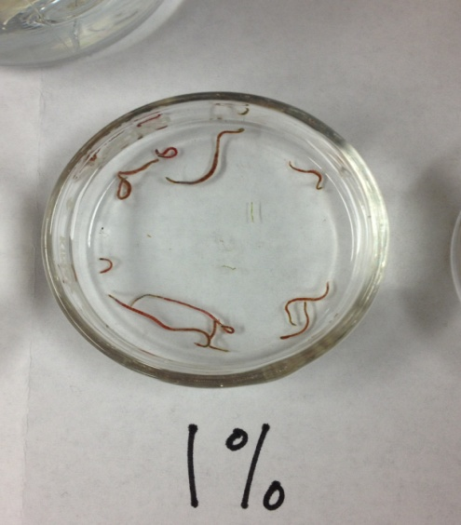

- Students should graph their data from each treatment from the “Final” observations using the axes provided on their lab worksheet. They can plot the concentration of the CuSO₄ on the x-axis and the % of blackworms that died on the y-axis, or any other parameters they noted (i.e. % of blackworms slowly moving, etc…).
Example of the 1% copper solution with blackworms.
- Once the lab is complete, students can complete the related case study for homework (see Katrina’s Troubled Waters Part I and II), and finish the follow-up questions listed on their lab sheet.

