Phytoremediation Lab
AP Environmental Science- Teacher Notes

Background Information:

What should we do with a toxic site once we realize it may be dangerous to animals or humans? There are many forms of environmental remediation, or the removal of pollution from soil or water for the benefit of human or animal health, but all have their positives and negatives. Imagine you are in charge of cleaning up a pond or a lake in your neighborhood that has been determined to dangerous to human health. What should you do? You have learned that in wastewater treatment plants, there are many filters and other forms of treatment that can clean up contaminated water. Should you use these types of treatments, or something else?
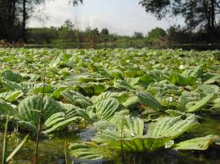
Another way to clean-up toxic sites is to use bioremediation or phytoremediation. These types of remediation use naturally occurring plants and animals to clean up toxic waste. But how? Some naturally occurring plants and bacteria have the ability to concentrate contaminants without being negatively affected. Plants that can concentrate pollutants in their tissues are called hyperaccumulators because they can accumulate toxins in their tissues in much greater concentrations in which they are being grown. Some bacteria are also able to process environmental contaminants, such as “oil-eating” bacteria, or bacteria that can process hydrocarbons, or the chemical compounds that make up oil. These are often used today in large oil spills such as the recent Deepwater Horizon oil spill.
Water lettuce, a hyperaccumulator growing in a pond.

You might be thinking, wow! Can naturally occurring plants and bacteria really clean up toxic sites? Well, yes they can, but there are positives and negatives just like all other clean-up strategies. The plants or bacteria needed to do the clean-up might be invasive species or might out-compete other native plants or bacteria. There might be a need to dispose of the contaminated plants once the site has been remediated. In this lab you will explore the effectiveness of phytoremediation, using water lettuce in a contaminated copper solution. Water lettuce is a naturally occurring, native plant to San Diego and if often found in ponds and rivers. It grows quickly and can hyperaccumulate copper in its leaves. You will be monitoring copper levels in your contaminated solution over several days while the water lettuce grows.

Objectives (Students will):
- Monitor copper levels over time using copper test kits
- Graph copper changes over time
- Repeat a portion of the LD-50 lab using blackworms and the remediated solution
- Determine the effectiveness of phytoremediation

Materials:
- 1 Water lettuce plant (per group)
  - Notes: These can be found in most ponds, and grow very fast. You can also substitute this with any other hyperaccumulator.
- 1 beaker (per group)
  - Notes: These need to be at least 200 mL, and will be used to hold the copper solution and water lettuce.
- 0.0025 M copper sulfate (CuSO₄) solution
  - Notes: This can made from a liquid AA standard (atomic adsorption) of copper sulfate, or from ordering copper sulfate salt and preparing the solution in weak acid (~1% HCl) to keep the copper in solution.
- 10, 1, 0.1, 0.01 % CuSO₄ stocks
  - Notes: These can be made from the 0.0025 M CuSO₄ solution by first taking 20 mL of the 0.0025M solution and mixing it with 180 mL of distilled water to make the 10% solution. Then you can use the 10% solution to make the serial dilution. This can be scaled up if you want to provide it for the whole class.
- Distilled water
  - Notes: Use only distilled water for this lab, and not tap water because blackworms are very sensitive to chlorine in tap water.
- Plant nutrient solution (one per class)
  - Notes: Students will simply have to put in one drop of this solution into their copper solution. This can also be obtained from any aquarium store.
- Graduated cylinder
  - Notes: These are to help the students measure out 5 mL of the copper solutions and 45 mL of distilled water.
- Grease pencil (one per group)
  - Notes: Any writing utensil to label the containers for the copper solutions.
- Plastic spoon (one per group)
  - Notes: This can be any scooping device used to put the water lettuce into the copper solution.
- 10 blackworms (per group)
  - Notes: These can usually be obtained from an aquarium store or ordered online.
- Timer (one per group)
  - Notes: Students can also just use any clock in the classroom.
- Copper test kit (one to two per class)
  - Notes: This can be obtained from any aquarium store, and usually involved a test strip similar to a pH strip. Some kits come with a separate vial and test strips, and tell you to remove 5-10 drops of solution before testing.

Part I Procedures:
- Have the students look at their LD-50 lab with blackworms and determine the concentration of CuSO₄ that killed 50% of the blackworm population (the LD-50). Their value should be close to one of the values that were tested during that lab (0, 0.01, 0.1, 1 and 10% CuSO₄, probably around 0.1%). Once they determine the LD-50, they should write that concentration on their beaker. Please round your LD-50 to one of the values listed above if it was not exact (for example, if you calculated your LD-50 to b e 0.15%, then use 0.1% as your CuSO₄ concentration for this lab). You can also just assign a concentration for everyone to use if they did not complete the LD-50 lab.
- Once they have determined the CuSO₄ concentration they will use in this lab, the students can look at the table below to see how to make the CuSO₄ solution. They should have a total of 50 mL of solution.

Final % CuSO₄ | Amount of CuSO₄ | Amount of Distilled Water
0 | 0 mL | 200 mL
0.01 | 20 mL of 0.1% CuSO₄ stock | 180 mL
0.1 | 20 mL of 1% CuSO₄ stock | 180 mL
1 | 20 mL of 10% CuSO₄ stock | 180 mL
10 | 20 mL of 0.0025 M CuSO₄ | 180 mL

- Students should make their copper solution and place it in the beaker. They can take an initial copper measurement using the copper kit provided in class. Follow the directions on the copper measuring kit. They can record the first copper reading in the data table below in the “Day 1” section. They should record any initial observations they might have in the table provided on their lab sheet.
- Now they can add one drop of nutrient solution to the beaker, and 1 water lettuce plant. The water lettuce plants are fragile, so students should carefully scoop them up out of the class tank with a spoon and place them in the beaker.
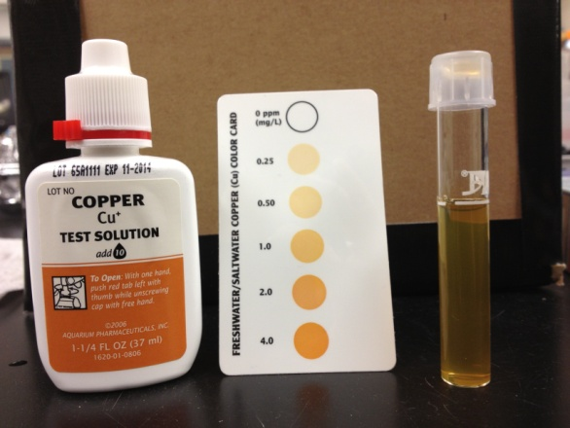
- Students should place their beaker with the water lettuce in a sunny spot in the classroom.
- Students should record copper measurements everyday for the next 3-5 days in the table provided. When removing solution for the copper measurement, they should be careful not to disturb the water lettuce.
- They should graph the changes in the observed copper concentrations over time on the graph provided below. Use the “day” as the x-axis and the copper concentration as the y-axis on the graph provided.
An example of a copper test kit and copper solution.

Part II Procedures:
- After the 3-5 days of monitoring the copper concentrations in the contaminated solution, students should carefully remove the water lettuce and place them in the waste container. They can place 10 blackworms in the solution and monitor them after 5, 10, 15, 20, 30 minutes and at the end of the class period. They can record their observations in the table provided on the lab sheet.
- Finally, have the students answer the follow-up questions provided. An additional lab write-up can also be assigned, to incorporate the data from both the LD-50 lab and this Phytoremediation lab.

