ENVIRONMENTAL SCIENCE
SECTION II
Time—22 minutes
Adapted from APES Exam 2010 (collegeboard.com)

Directions: Answer this one question; the suggested time is about 22 minutes for answering this question. Write all your answers on the pages following the questions in the pink booklet. Where calculations are required, clearly show how you arrived at your answer. Where explanation or discussion is required, support your answers with relevant information and/or specific examples.

- Read the following article from the Fremont Gazette and answer the questions that follow.
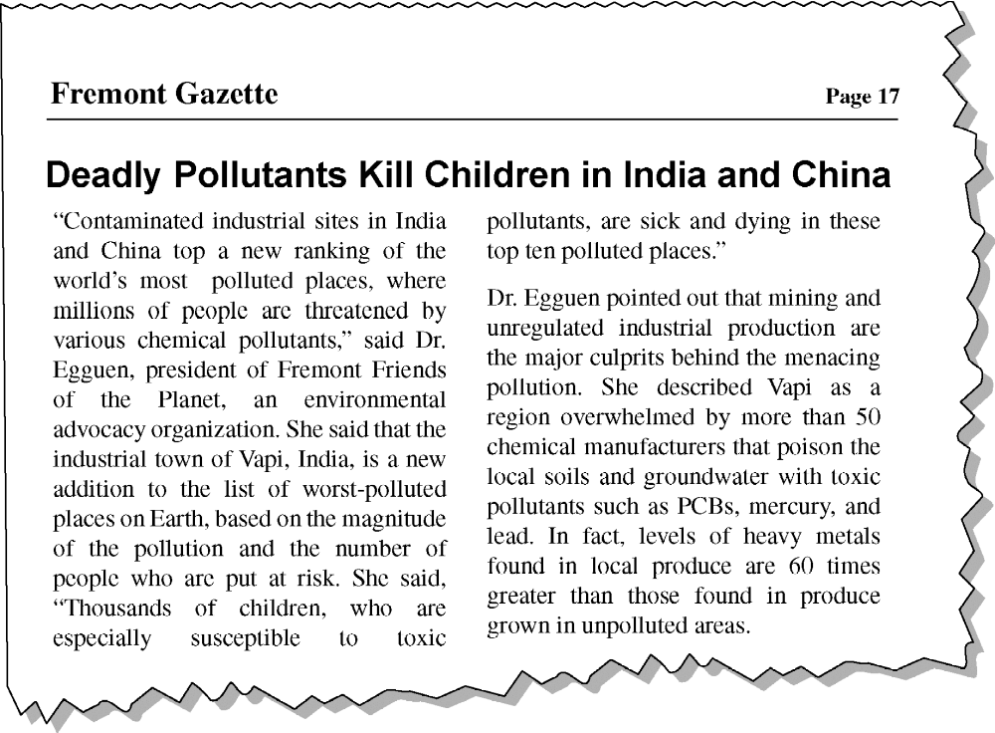
(a) Choose any ONE of the three pollutants mentioned above and respond to each of the following.
(i) Describe one specific source, other than the local chemical plants, for the toxic pollutant you chose.
(ii) Describe how the pollutant you chose enters the human body and one specific effect it can have on
human health.
(iii) Describe TWO specific steps, other than an outright ban, that a city or nation can take to reduce the
threat posed by this pollutant.

(b) Give one reason why Dr. Egguen is correct in asserting that children are particularly susceptible to toxic pollutants.

(c) An important contributor to global climate change is the release of CO2 from the rapidly increasing number
of coal-burning power plants in China. Assume that the coal burned at these plants to provide the power to
manufacture a single MP3 player releases 40 kg of CO2 and that it costs $0.75 to capture 1 kg of CO2 and keep it from entering the atmosphere. Determine the cost, in dollars, to capture the total amount of CO2 released from manufacturing one MP3 player.

(d) Coal-burning power plants also release other pollutants, including nitrogen oxides (NOx ), sulfur oxides
(SOx ), and particulates. Select one of these pollutants and identify one technology that can be used to remove it from the waste stream of coal-burning power plants.

(e) Discuss TWO reasons why a multinational company would choose to build a manufacturing facility in India
and/or China rather than in the United States or Europe.

