Free Response Question #1 Scoring Guide
Adapted from APES Exam 2010 (collegeboard.com)
Ask the students to discuss their answers in class and then go through the following answers one by one and discuss.

(a) Choose any ONE of the three pollutants mentioned above and respond to each of the following.
(i) Describe one specific source, other than the local chemical plants, for the toxic pollutant you chose. One point can be earned for the description of a specific source of the pollutant. (Only the first answer is scored.)
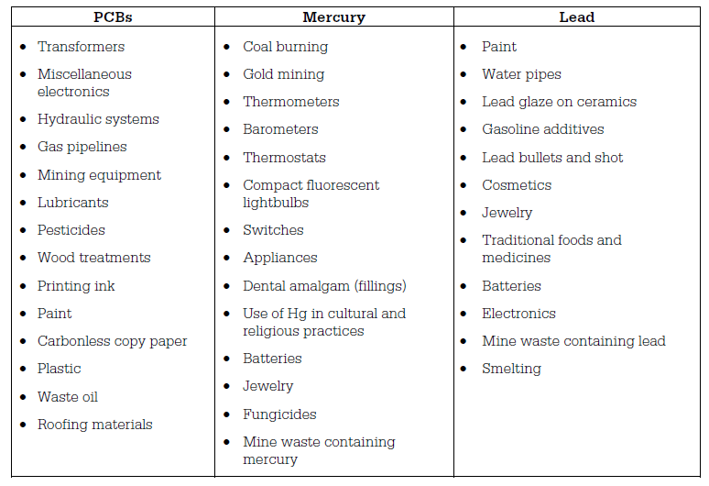
(ii) Describe how the pollutant you chose enters the human body and one specific effect it can have on human health.
Two points can be earned: 1 point for describing how the pollutant enters the human body and 1 point for describing one human health effect of the pollutant.
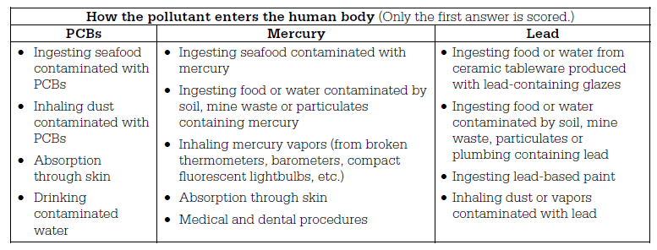

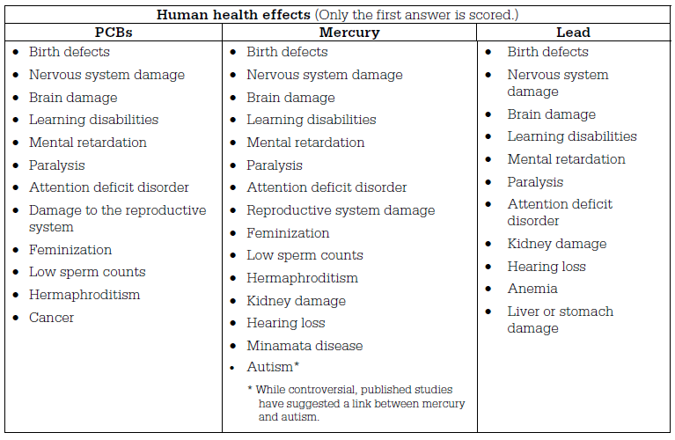
(iii) Describe TWO specific steps, other than an outright ban, that a city or nation can take to reduce the threat posed by this pollutant.
Two points can be earned: 1 point for each specific step that will reduce the threat posed by the pollutant. (Only the first two answers are scored.)

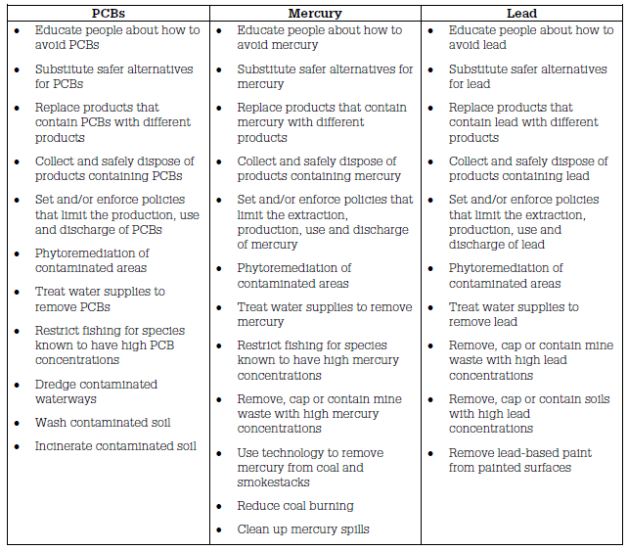

(b) Give one reason why Dr. Egguen is correct in asserting that children are particularly susceptible to toxic pollutants. One point can be earned for a correct reason that children are particularly susceptible to toxic pollutants. (Only the first answer is scored.)
• Children take in more water, food and air per unit of body weight than adults.
• Children often put dirty objects or hands in their mouths.
• Children have less developed immune systems.
• The liver of a child does not metabolize pollutants as efficiently as the liver of an adult.
• The growing organ systems of children are more sensitive to pollutants than the mature systems of adults.
• Children will accumulate pollutants for a longer period of time than adults.
(c) An important contributor to global climate change is the release of CO2 from the rapidly increasing number of coal-burning power plants in China. Assume that the coal burned at these plants to provide the power to manufacture a single MP3 player releases 40 kg of CO2 and that it costs $0.75 to capture 1 kg of CO2 and keep it from entering the atmosphere. Determine the cost, in dollars, to capture the total amount of CO2 released from manufacturing one MP3 player.
Two points can be earned: 1 point for a correct setup and 1 point for the correct answer. (Units are not required.)
40 kg CO2 × | $0.75 | = $30
40 kg CO2 × | 1 kg CO2
(d) Coal-burning power plants also release other pollutants, including nitrogen oxides (NOx), sulfur oxides (SOx), and particulates. Select one of these pollutants and identify one technology that can be used to remove it from the waste stream of coal-burning power plants.
One point can be earned for identifying a correct technology for the pollutant selected.

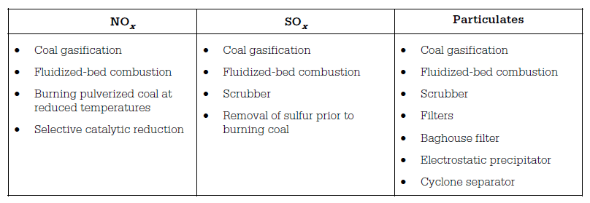
(e) Discuss TWO reasons why a multinational company would choose to build a manufacturing facility in India and/or China rather than in the United States or Europe.
Two points can be earned: 1 point for each correct reason that is discussed. (Only the first two answers are scored.)
• Less stringent environmental regulations
• Lax enforcement of environmental regulations
• Less expensive labor
• Large populations of workers willing to work for lower wages
• Fewer workplace regulations
• Lower health-care costs for workers
• Less expensive property
• Less expensive raw materials
• Lower/fewer taxes and fees
• Government subsidies
• Lower litigation costs
• Expansion of markets

