LD-50 and Phytoremediation Lab Follow-Up

You have learned in this lesson that metals can be toxic to organisms in the environment (in this case blackworms) and can be difficult to eliminate from the environment once it is contaminated. There are several methods for removing these contaminants, and one of them is phytoremediation. All forms of remediation though can have costs and benefits. Your goal is to combine in this follow-up activity what you have learned in the two lab activities with a remediation plan for San Diego Bay.

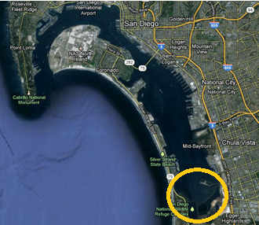
Background: We have discovered in the beginning of this lesson that San Diego Bay is highly contaminated for copper. Imagine that you are an environmental scientist working for UCSD and have been hired to clean up the copper in one area of San Diego Bay. The San Diego Water Quality control board wants you to clean up the South Bay circled in the diagram to left near the San Diego National Wildlife Refuge. As an environmental scientist, you have decided there are 3 possible ways you could clean up the contaminated copper.

- Pump the seawater out of the south bay and run it through copper scavenging filters.
- Phytoremediate the copper from the south bay by adding water lettuce and allowing it to grow in the south bay.
- Educate the public about sources of copper to the bay and allow the existing copper to settle out into the sediments.

In the Venn diagram below, compare and contrast the 3 methods of remediating the south bay from copper contamination, based on what you have learned in this lab and your general knowledge about water treatment. Include issues such as the time it would take to remediate, the cost associated with the remediation, and other uncertainties such as invasive species, or waste disposal. You can also do additional research if necessary.

Once you have compared and contrasted all three options, answer the questions below.

Follow up questions:

- Which of the options for cleaning up San Diego Bay do you think would be the fastest? Why?

- Which of the options for cleaning up San Diego Bay do you think would be the best in the long term? Why?

- Which of the options for cleaning up San Diego Bay do you think would cost the most? Why?

- Which of the options would you choose for cleaning up San Diego Bay? You can use a combination of options, but explain your answer and timeline you would use for each type of remediation.

