These are the teacher instructions for the Lesson2-Melt in the Earth activity.

Students can do this activity alone, in pairs or in groups.

The activity asks students to use their notes to define key terms from the presentation and describe the three types of melting associated with melt. The terms in bold are the key terms, while the unbolded sentences are the definitions and processes the students use to define each key term.

The activity document, “Lesson2_Activity Strips”, has the definitions in their correct place under the key terms (see sample photos below). Successful students will recreate the order of terms and definitions exactly as listed in that document.

- Prior to class, cut up each key term and definition into individual strips.
- Make as many sets as necessary for your class
- Place each collection of strips into an envelope

- Following the powerpoint presentation, have the students to get in groups
- Hand one envelope with strips to each group
- Instruct the students to rearrange the strips so that the unbolded terms correctly define or describe the bolded terms
- Terms will be used only once (except the term “MELT” which describes successful melting of mantle rock)
- Students should use their notes from the presentation to complete this activity

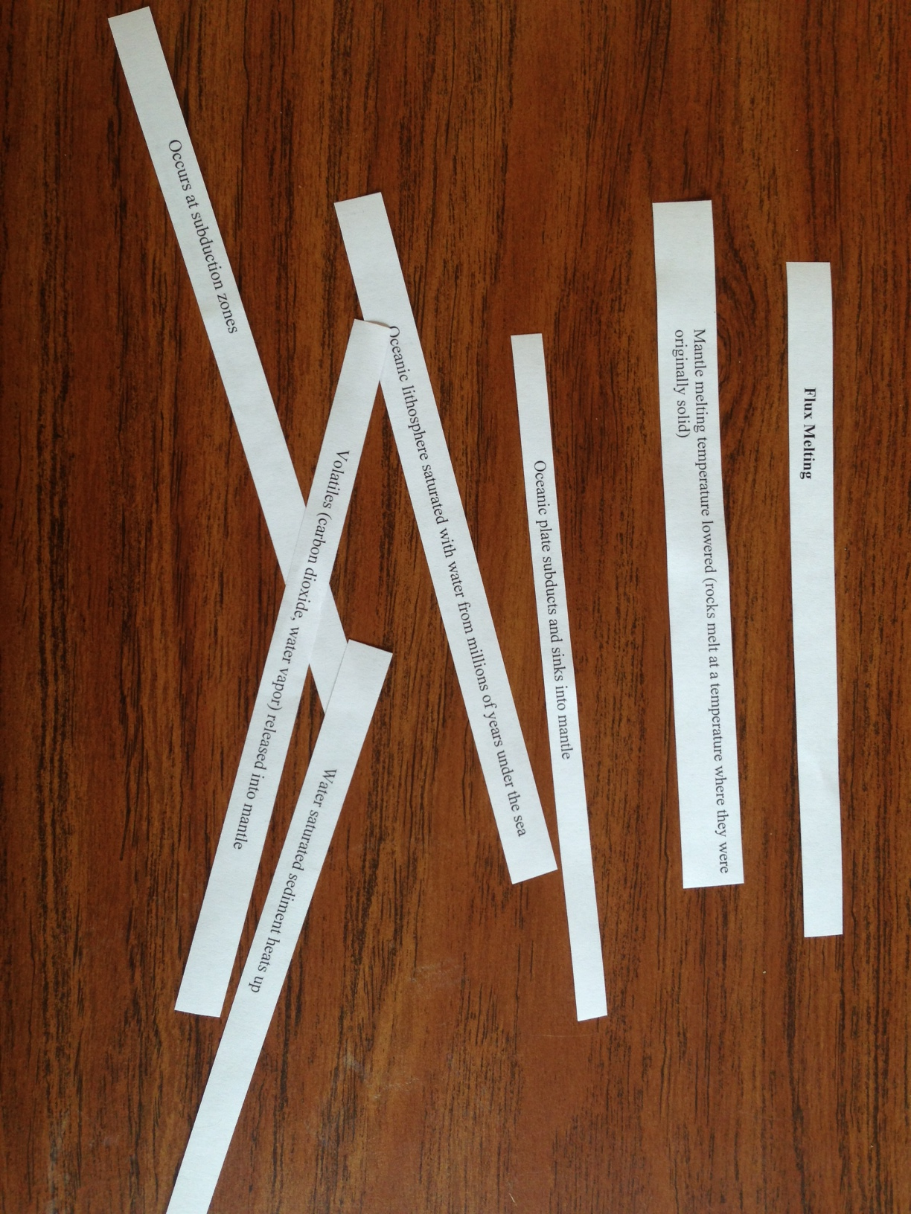
After activity strips are cut up,
they should be randomly scattered
for students to organize
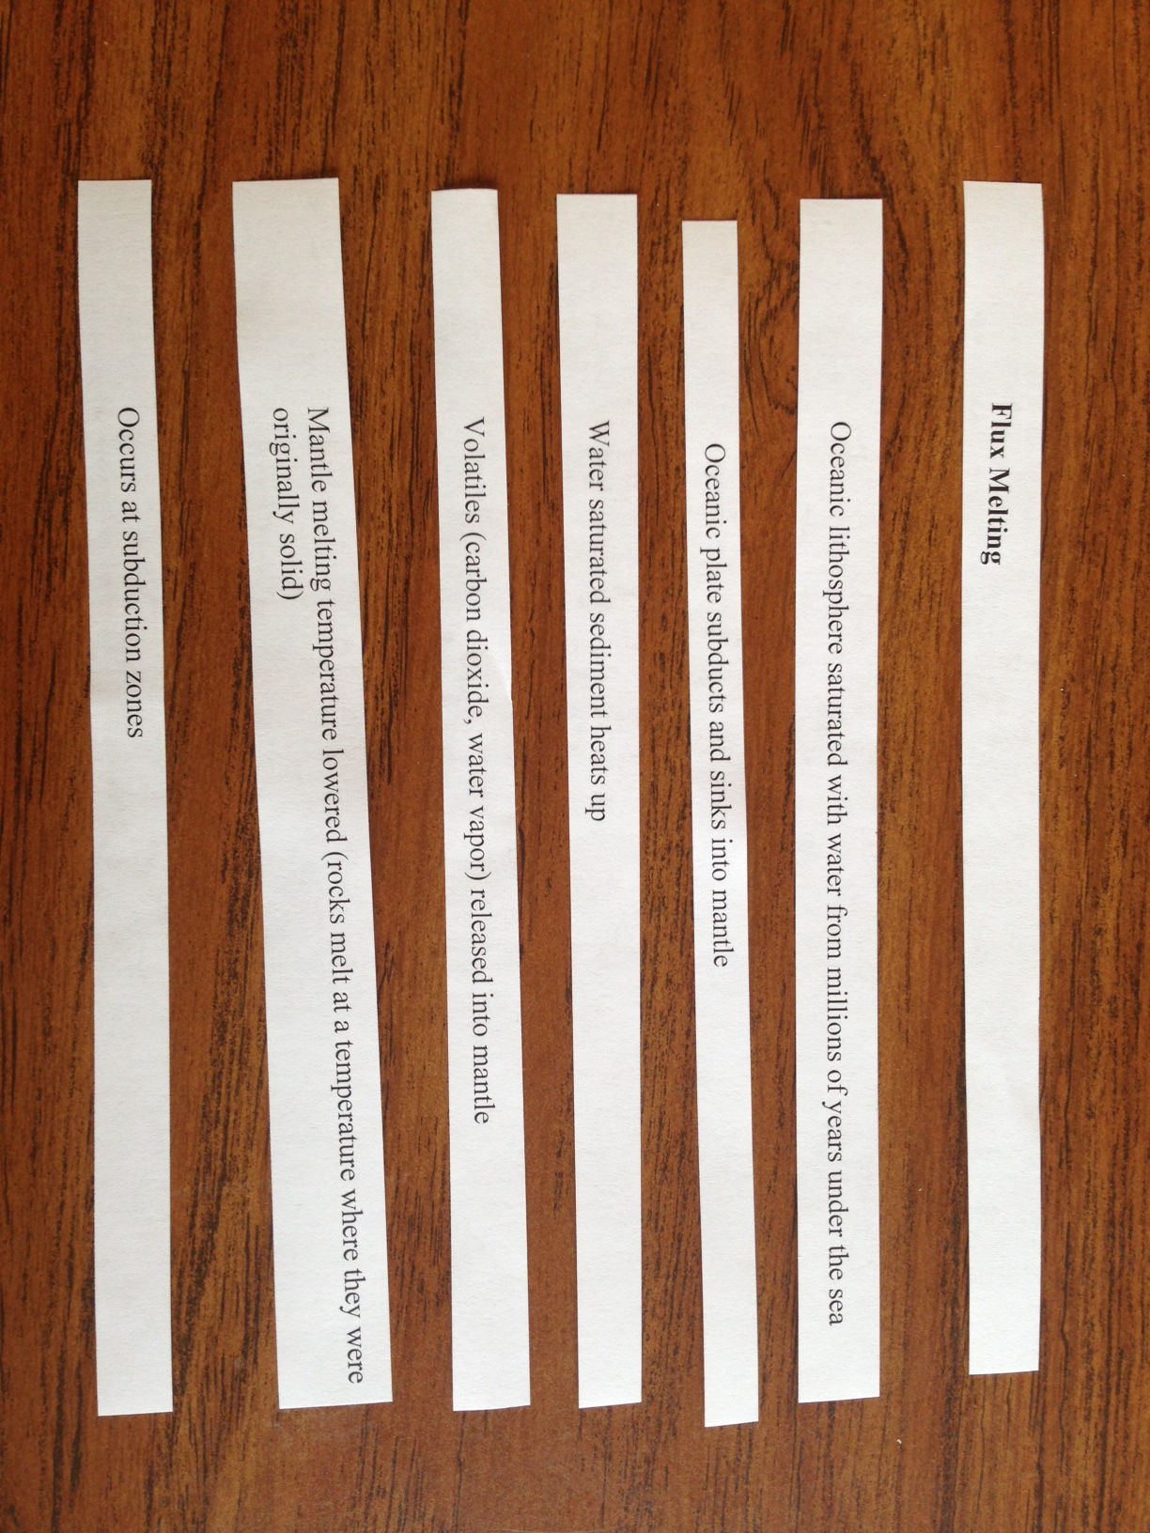
This is an example of how students
should successfully organize their
activity strips.

