Faulting and Stress – For Teachers
Valerie Sahakian and Joe Krupens

How to make the foam fault blocks

Materials:
- 3 rectangular pieces of foam, about 5 inches long, 3 inches high, and 2 inches deep (other sizes are ok as well).
- Paint (acrylic works well)
- Knife

To make the normal and reverse blocks:
- Paint one of the wide rectangular sides with 3 stripes – each stripe is a different color.
- Cut the block into three – the middle section should look almost like a triangle (with a flat side instead of a point). See the picture below.
- Do this twice – once for a normal fault, and once for a reverse fault.
- Place these at a station, with the respective fault printout from Lesson2ActivityPrintOuts.docx.

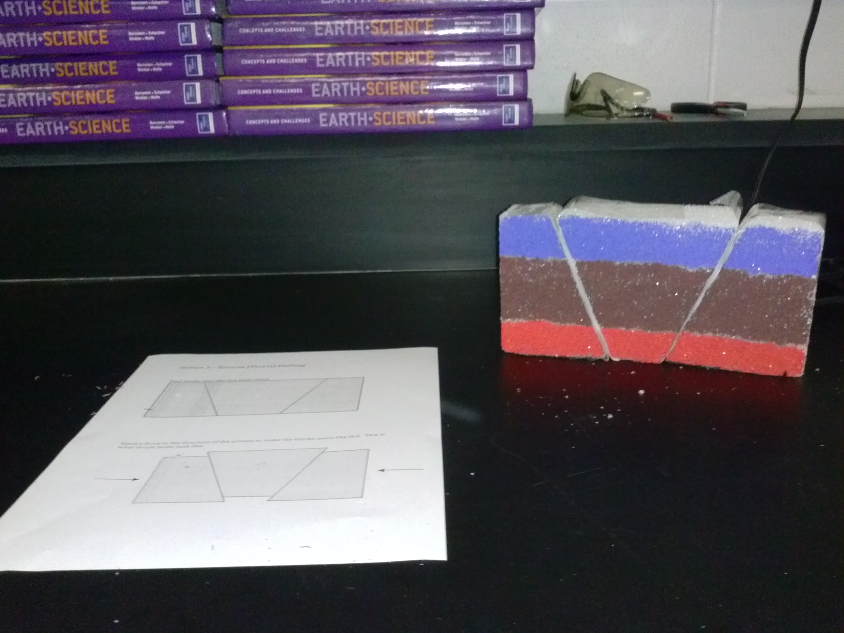
Figure 1 - Reverse fault at station, with the station printout.

For the strike-slip fault:
- Paint one of the wide rectangular sides with some feature, like a road (in the figure below, the road is in the middle.) You could paint green for grass on both sides of the road.
- Cut the block width-wise, so across the road. See the figure. This is the fault, so students can see how it displaces the road.
- Place this at a station with the strike-slip print out from Lesson2ActivityPrintOuts.docx.

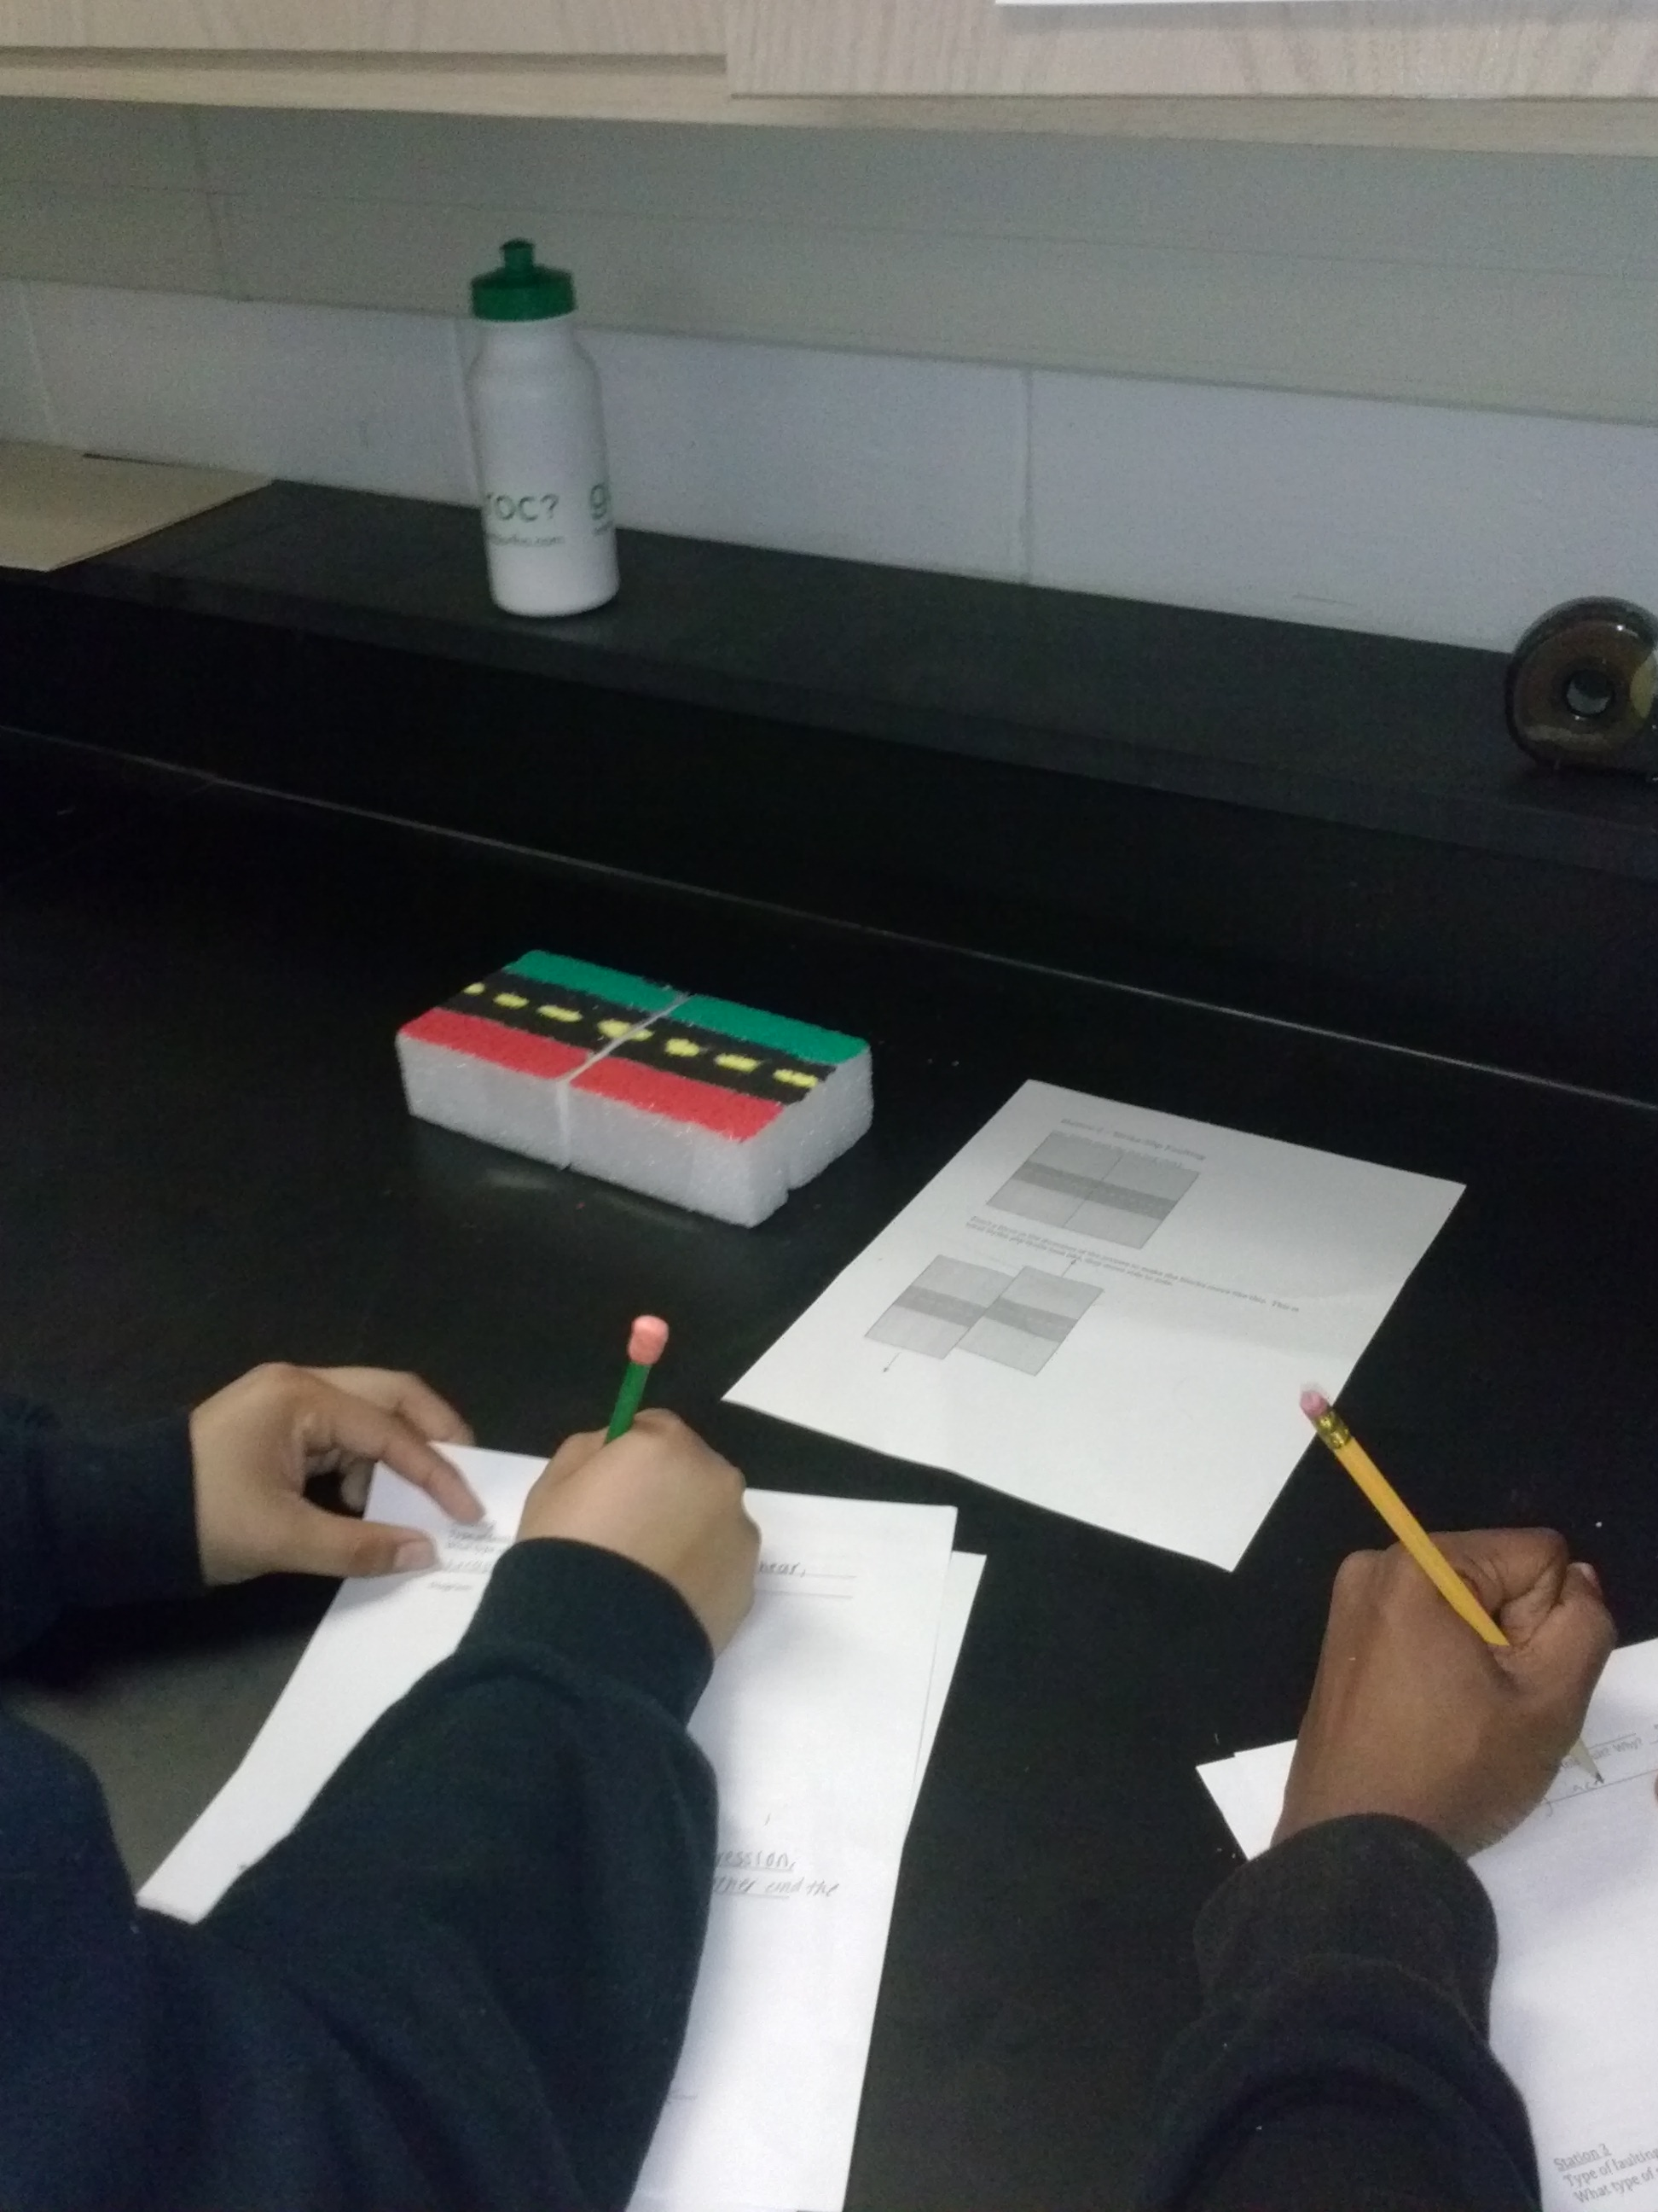
Figure 2 - Strike-slip block at station with print-out.

