Station 1 – Normal Faulting

Your blocks start like this (side view):
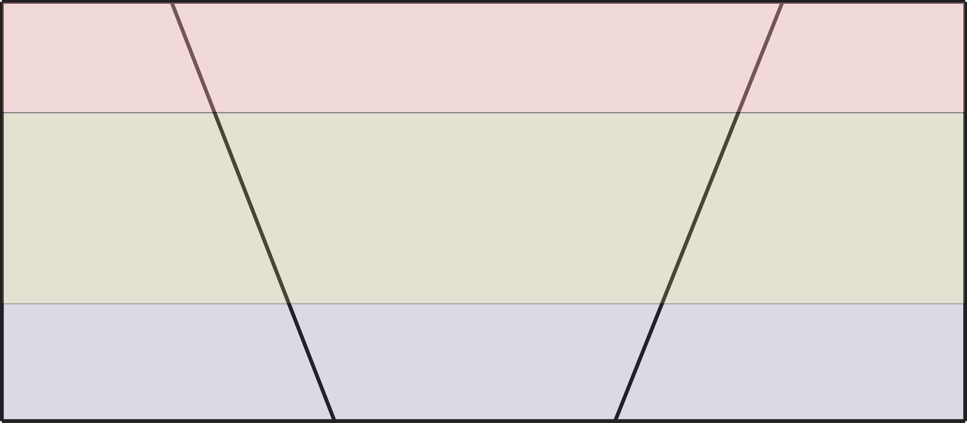

Exert a force in the direction of the arrows to make the blocks move like this. This is what Normal faults look like.

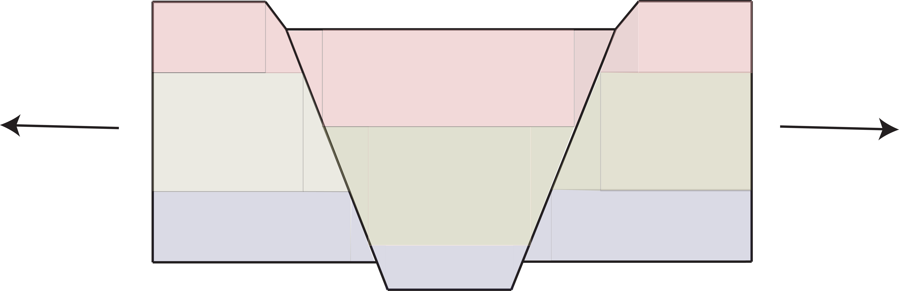

Station 2 – Strike-Slip Faulting

Your blocks start like this (top view):
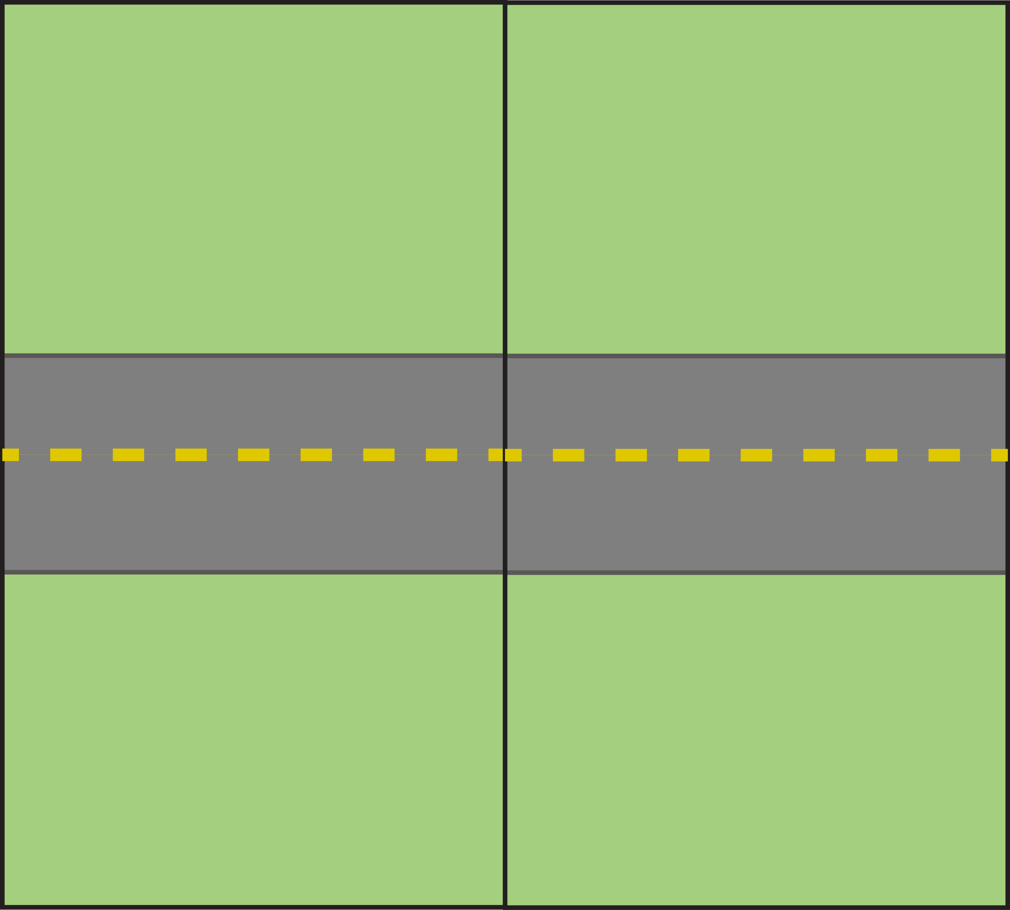

Exert a force in the direction of the arrows to make the blocks move like this. This is what Strike-slip faults look like, they move side to side.
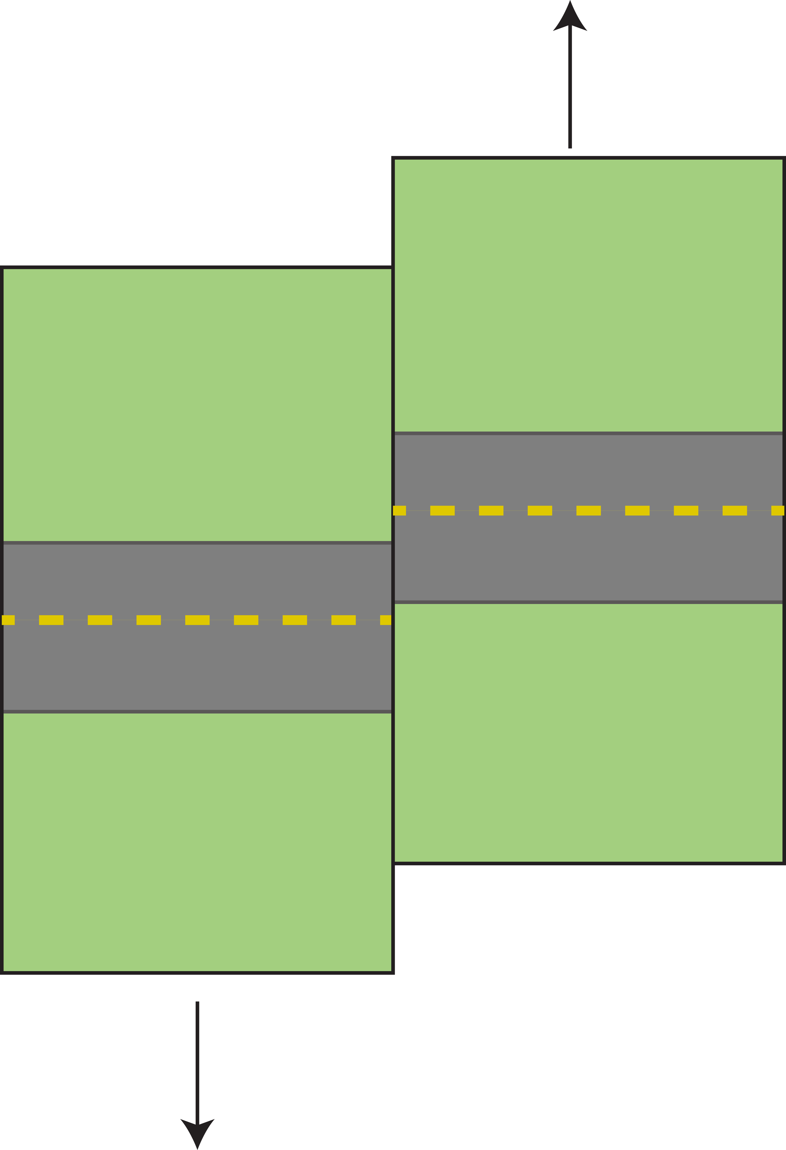

Station 3 – Reverse (Thrust) Faulting

Your blocks start like this (side view):

Exert a force in the direction of the arrows to make the blocks move like this. This is what thrust faults look like.
