Wave Tank and Demo
Valerie Sahakian and Joe Krupens

Materials:
- Long, clear tank or plastic bin – at least 3 feet long, preferably narrow (about 4 or 5 inches wide).
- 2 pieces of wooden or plastic board, approximately the width of the tank and about 4 or 5 inches long
- String (about 12 inches)
- Duct tape
- Foam – it is important to use foam for the engineering exercises later on.
- Fan
- Weights for the foam, like a rock (optional – for if your foam floats too much.)

Instructions:

- On one of the boards, duct tape both sides of one edge.
- Place the board at the bottom of one end of the tank, with the taped end facing the middle of the tank. Stick it to the bottom so that if it’s standing up straight, it has a piece of duct tape facing both the top and bottom of the tank.
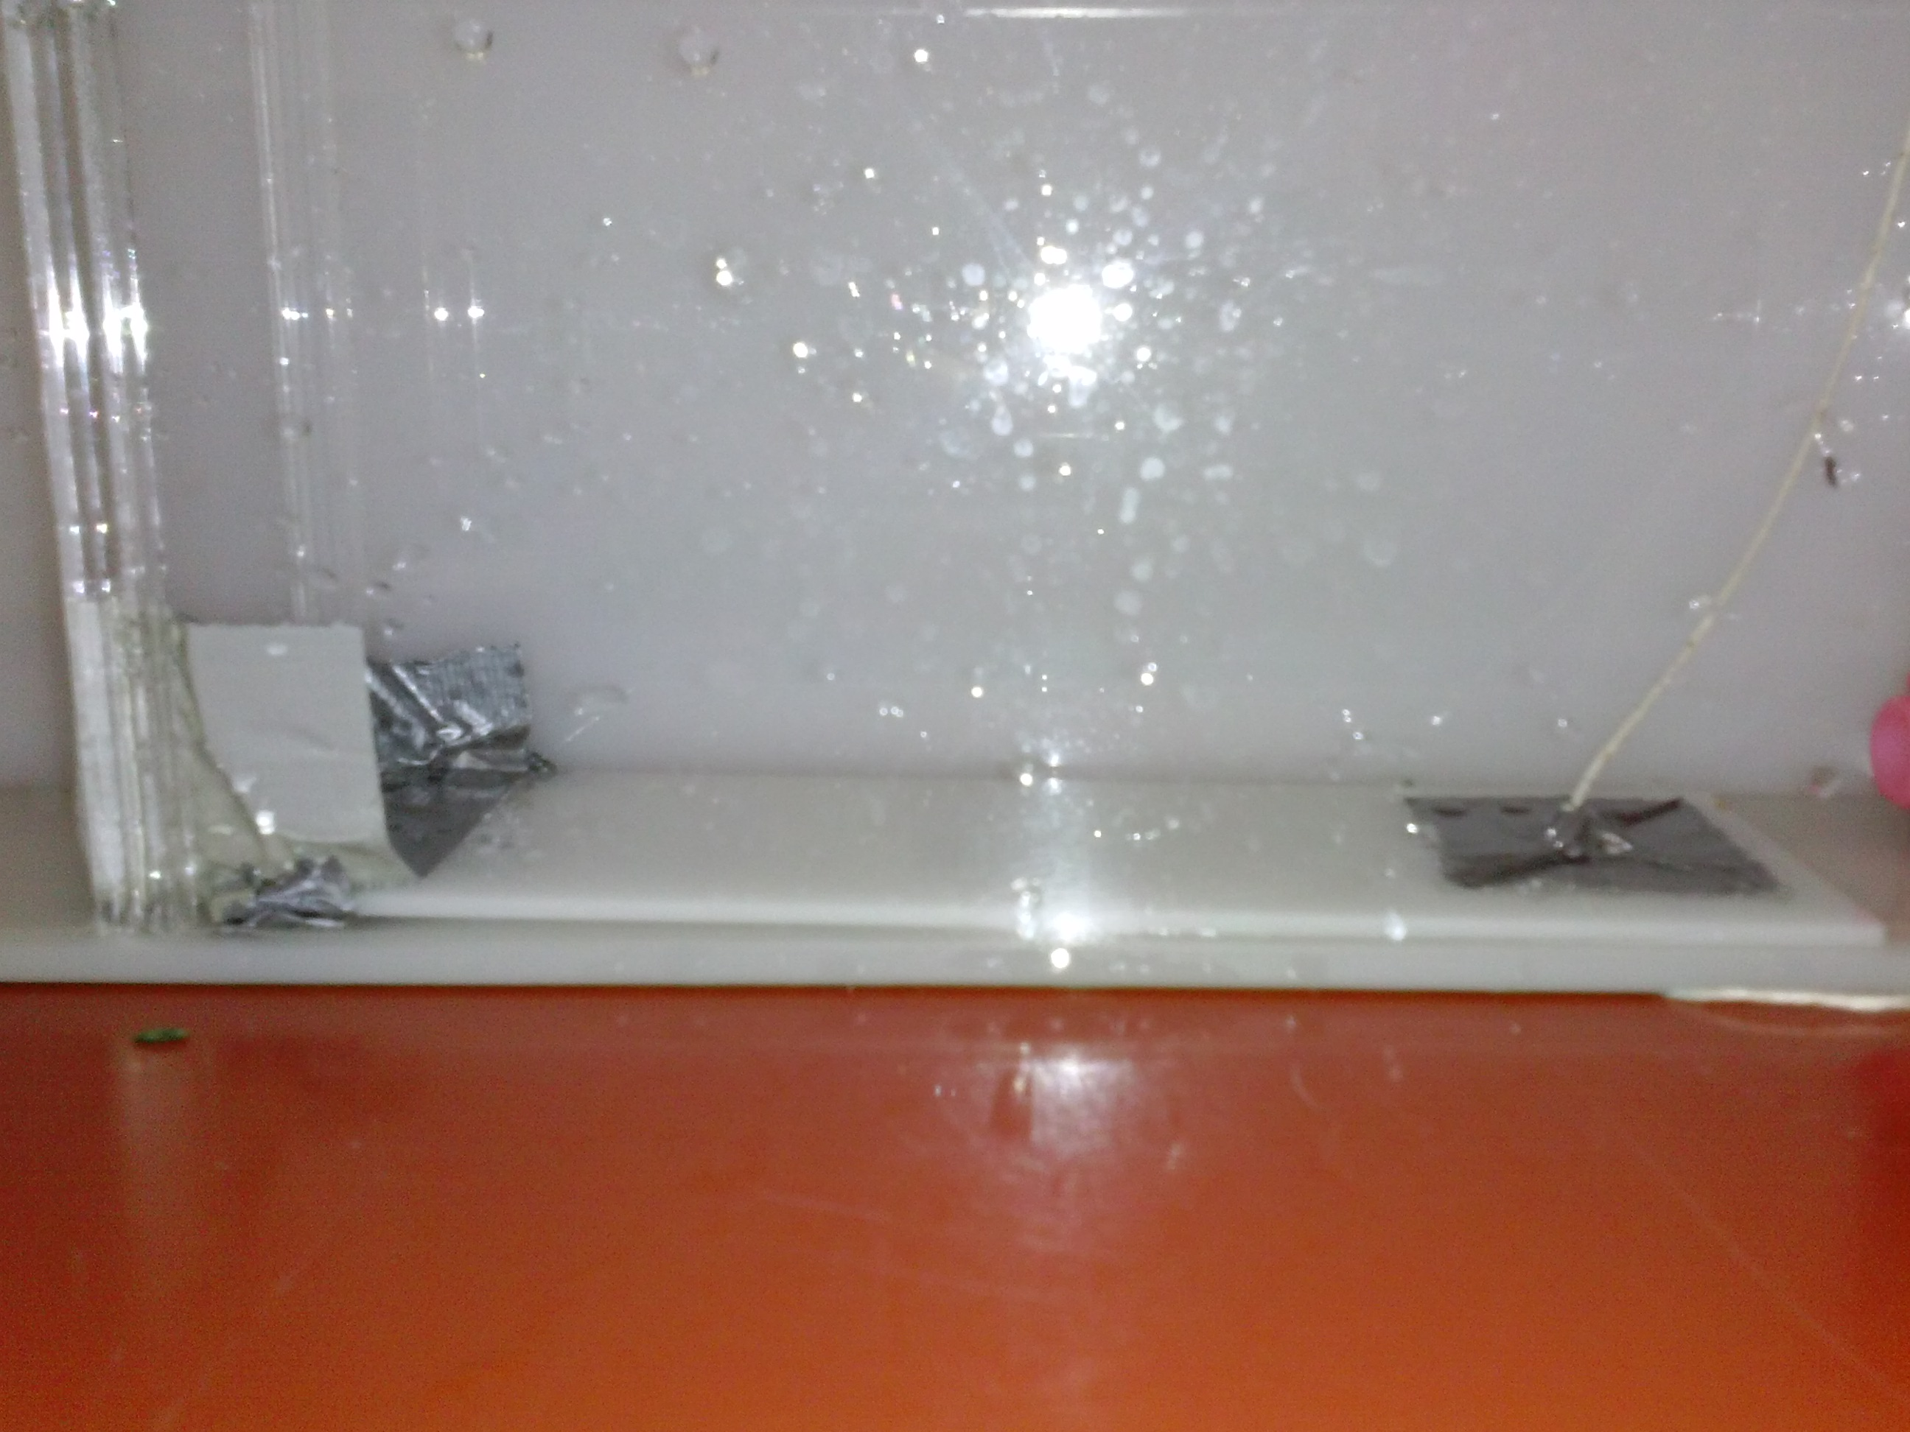

- Cut a piece of duct tape about 1 inch long. Pierce a hole in the middle, and stick a piece of string through. Tie a knot in the string on the adhesive side, so the string cannot come through.
- Stick this to the other end of the board, facing the edge of the tank.
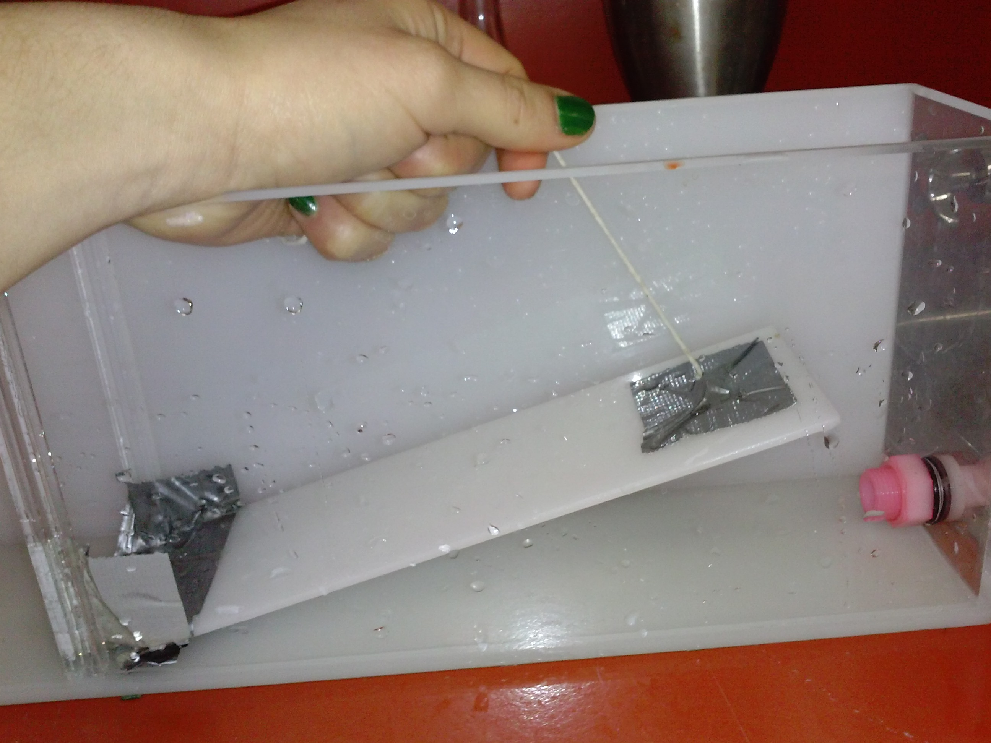

- At the other end of the tank, place a piece of foam so that it fills the tank, leaving about an inch of space above it. If it floats when you put water in, put a couple of weights on top.
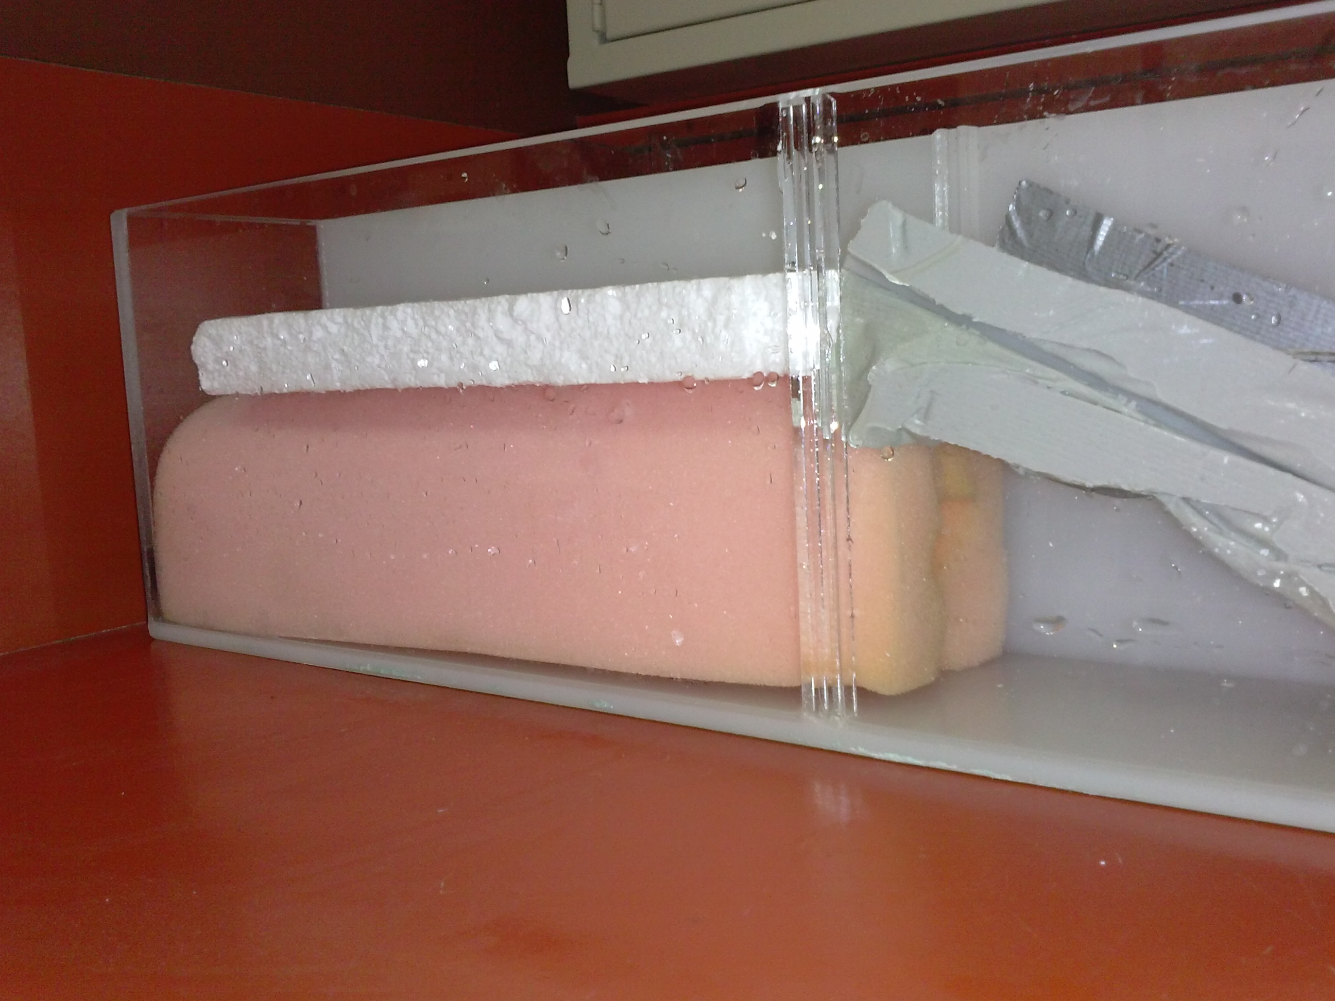

- Take the other board, and tape it in the tank at an angle, so it rests both on the foam and on the bottom. Tape both sides of the board, and both edges (the top and bottom) so that it stays in place. If it needs support, place some foam underneath the board.
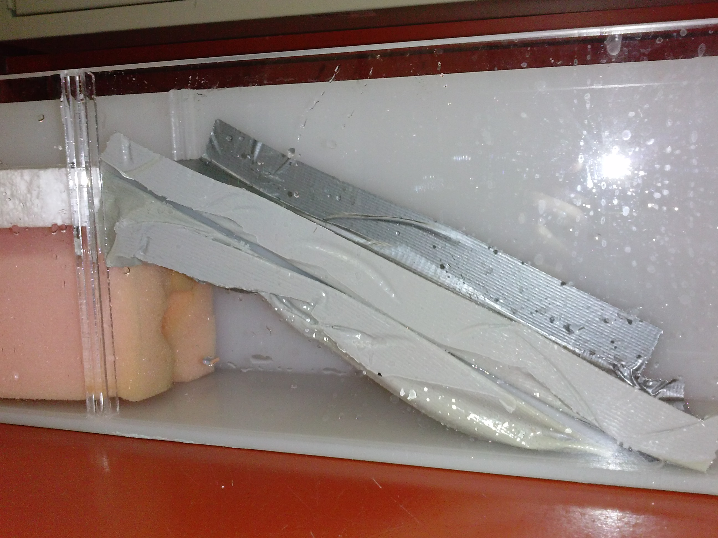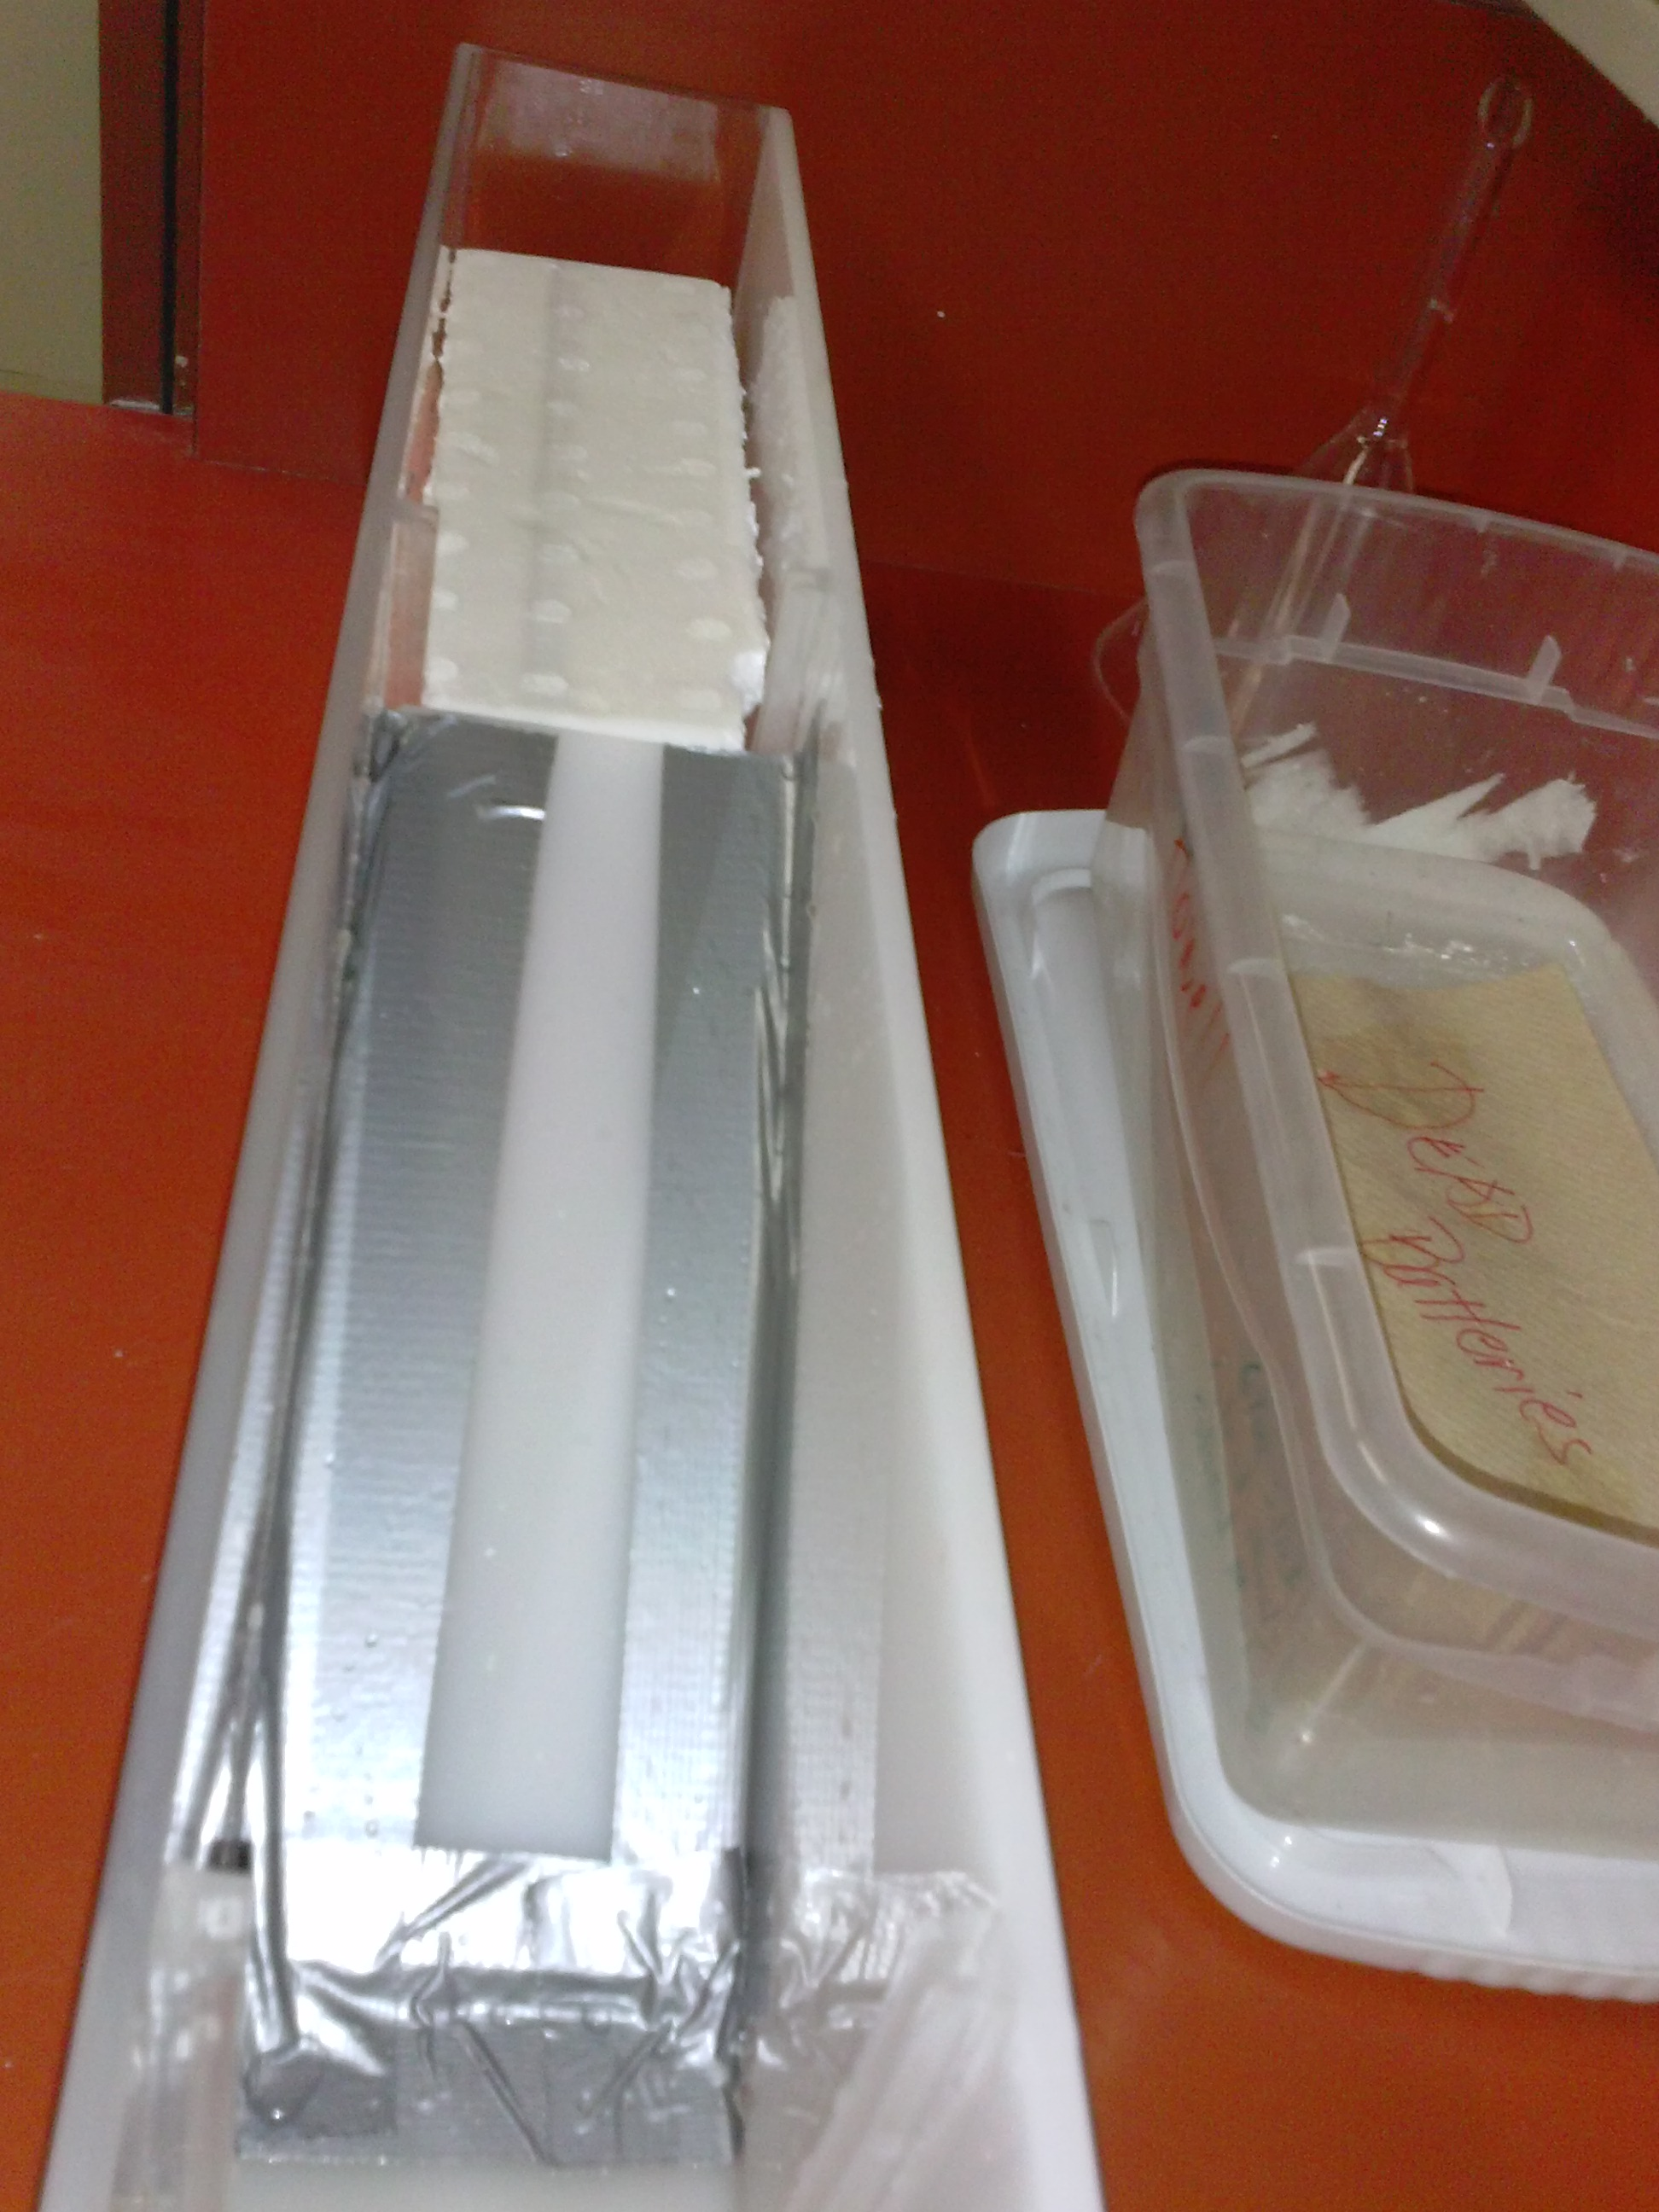

The finished product:
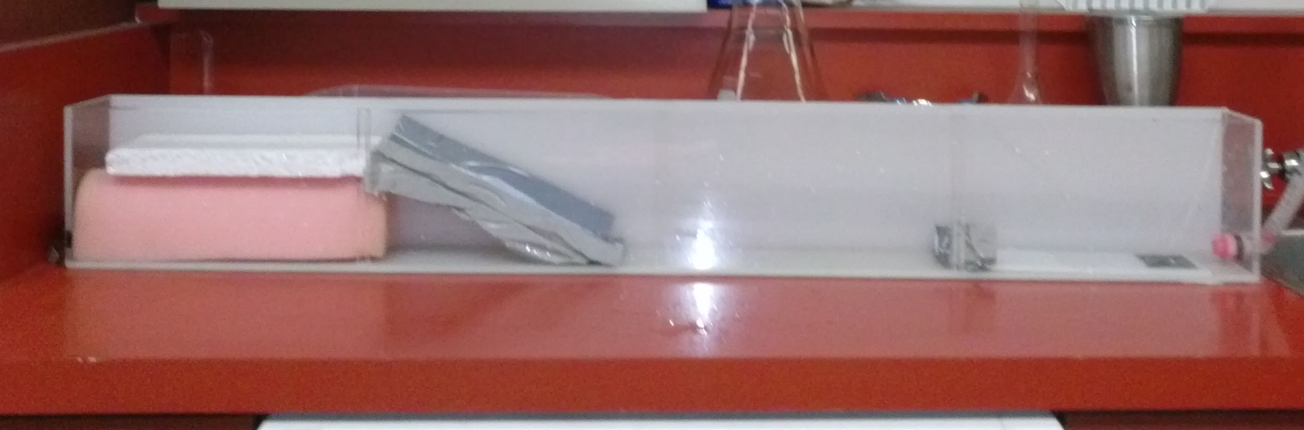

To run the demo:

- Fill the tank with water to about the level of the top of the foam.
- Place a few pebbles on the bottom.
- To make ocean waves, place a fan at the end of the tank opposite the foam. Turn it on high, and observe the ripples it forms (if you do not have a fan, you can blow on the water to observe a similar effect) – these are ocean waves. They are primarily wind-driven, and only disturb the top of the water column.
- To make a tsunami, tug on the string attached to the board at the end of the tank. Pull the wooden board until it reaches the top of the water (or adjust depending on the size of the wave you’d like to create).

Have students place a ruler next to the tank to measure the wavelength of tsunamis, and ocean waves. Have them perform 5 trials, and measure the amplitude of both tsunamis and wavelengths for each trial. Record these on the board. Then, have them compute the average value of wavelength for ocean waves, and for tsunamis.

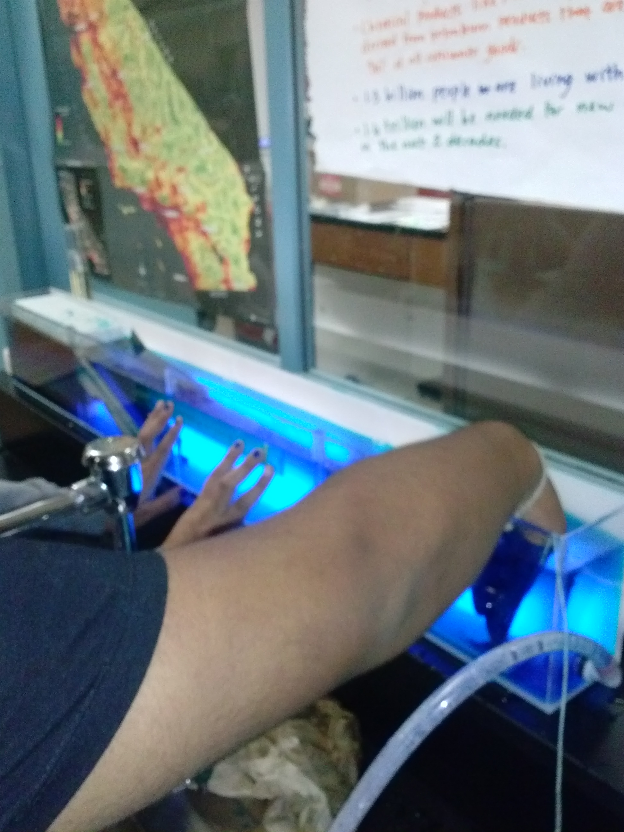
Figure 1 - One student places a ruler at the water line on the side of the tank, while a second student creates a tsunami wave. The water is has been dyed blue to help distinguish the wave crests and peaks.

**This wave tank used a commercial tank from an educational supplies company, meant for density experiments, etc. You could also make one with a plastic tub, some newspaper, dirt, and cardboard as seen here from Safer World Communications:
https://www.youtube.com/watch?v=DZZFPCY6RlE

