Valerie Sahakian and Joe Krupens

Now that you know a little more about plate tectonics, we can explore earthquakes a little further. Earthquakes usually happen at plate boundaries. Although these plates are moving, they are not literally sliding next to each other all the time, but instead they stick – just like holding two pieces of sand paper next to each other. This builds up energy. After a while, the plates will “slip”, releasing a lot of energy. This release of energy is called an earthquake, and most of that energy goes into creating seismic waves.

There are several different kinds of seismic waves – there are Primary waves (or P-waves), Secondary waves (or S-waves), and Surface waves. The P-waves travel the fastest, so you will feel them first (hence why they’re called “Primary waves). P-waves are compressional or longitudinal waves – the motion is back and forth.

The S-waves travel a little slower than P-waves, so you will feel these next (this is why they’re called “Secondary waves”). S-waves are transverse waves (they travel side-to-side, or up-and-down) so they can only travel through solids, like rock. They cannot travel through liquids, like water.

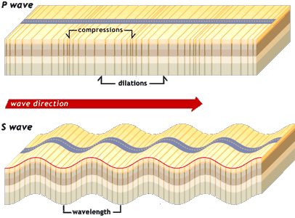
Photo: Exploratorium, Faultline Seismic Science
http://www.exploratorium.edu/faultline/basics/waves.html

Both P and S waves are called Body waves because they travel straight through the earth (through the body of the earth).

Lastly, the surface waves are even slower than the S-waves, and only travel on the surface of the earth. These are usually responsible for most of the shaking felt on the surface of the earth during an earthquake. These can either move like S-waves, so side-to-side (these are called Love waves), or they can move both up-and-down and back-and-forth (Rayleigh waves).

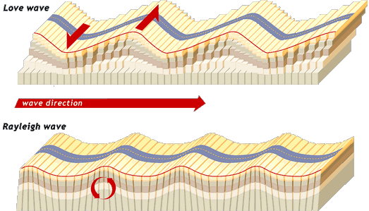
Photo (Top): Exploratorium, Faultline Seismic Science
http://www.exploratorium.edu/faultline/basics/waves.html

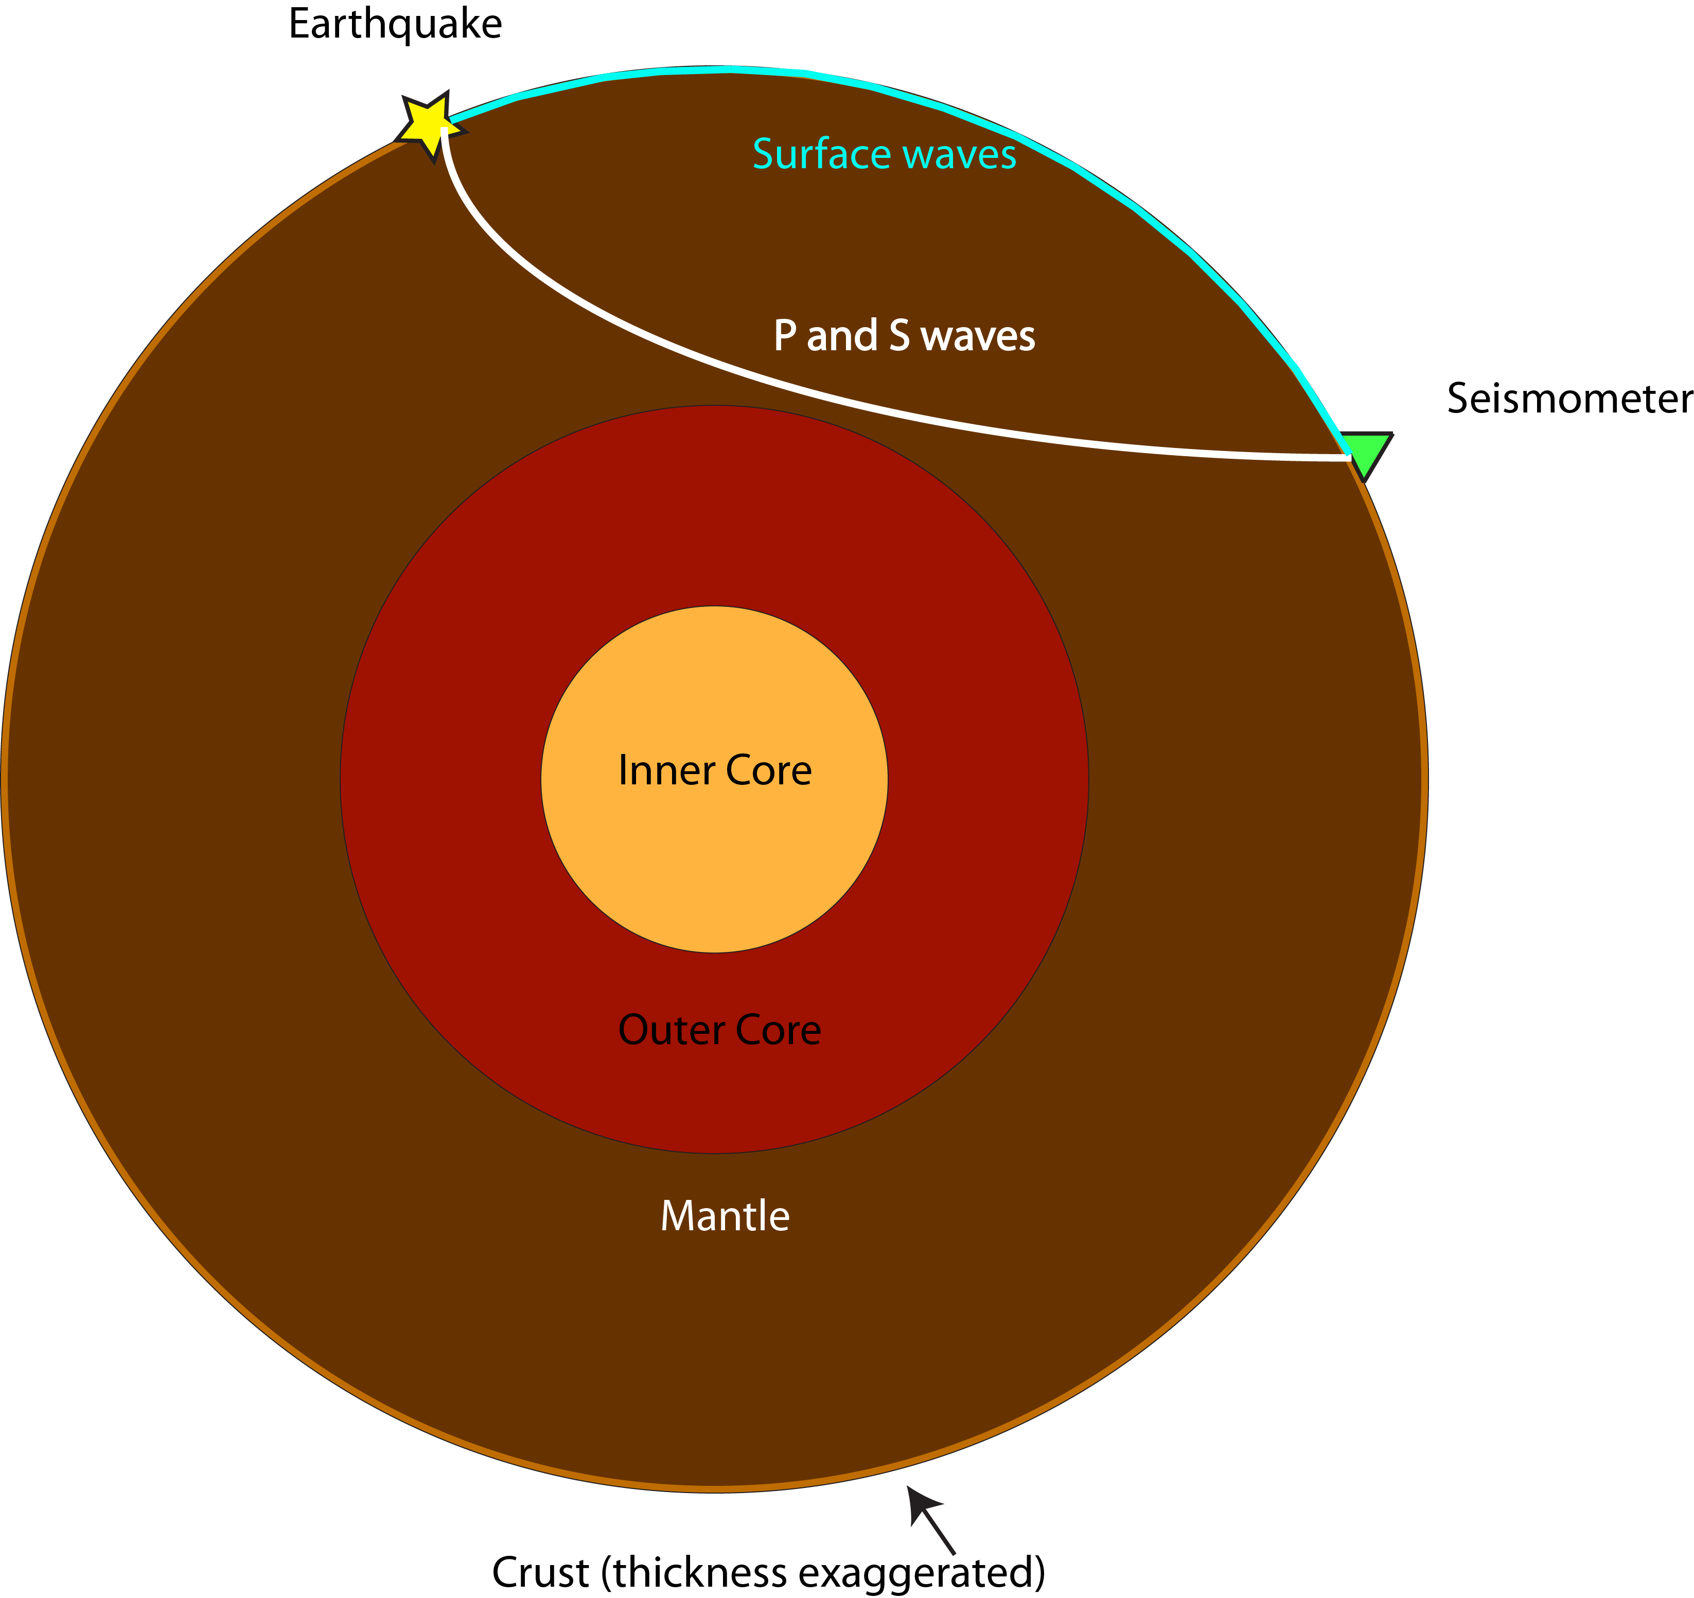
Left: The white line shows how body waves, (P and S waves) travel. The blue line shows how Surface waves (Love and Rayleigh waves) travel.
Diagram: Valerie Sahakian

