Shake Table Activity – for Teachers
Valerie Sahakian and Joe Krupens

Shake Table Materials:
- Baking tray (at least 9X13 inches)
- Two rulers
- 10, 6 inch Wooden skewers per group
- 10, 10 inch wooden skewers per group
- 15 large gum drops per group

This is a simple shake table. To ensure that all buildings experience the same “earthquake”, set up two rulers. One will be parallel to the short edge of the tray (ruler #1), and the other parallel to the long end (ruler #2). Ruler #1 will be used to measure how much to shake the tray, and Ruler #1 will be used as a starting point.

- Line up the short edge of the tray with Ruler #1.
- Gently push the tray until it’s short edge moves ½ inch (use Ruler #2 to measure how far you push it), and pull it back. Push it back and forth at a moderate pace to generate a small “earthquake”.
- Repeat for 1 inch and 3 inches, more if the building seems to be performing well.
- Every time you increase the distance you push it, also decrease the time that it takes to push or pull it that far – that way you increase the acceleration/velocity as well. Be sure to ask students what exactly is increasing or is stronger, and why it has a certain effect on the building.

During the shake table activity, be sure that some groups try a version of these two building techniques (BE SURE TO TAPE THE BUILDINGS TO THE TRAY!!):

- Cross braces – these are designed to reduce shear in building columns or supports. You can have students add diagonal cross braces on their building (if they have not already thought of it) – instead of having the side skewers be only vertical and horizontal, have them also add a cross on the side with skewers connecting to the same gum drops, and making an X. See photo below.
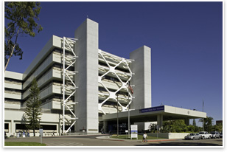
Photo: Veterans Affairs Medical Center in San Diego
The American Institute of Architects. Volume 15, May 30, 2008
http://info.aia.org/aiarchitect/thisweek08/0530/0530p_seismic.cfm

- Base Isolators – These are meant to control vibration; they decouple a structure from the ground it rests on, so it can slide with the ground motion instead of the entire structure rigidly responding to the earthquake. This can be in the form of rubber “bearings” at the corners of a foundation, or a bottom piece to slide on.
  - You can have students simulate this by putting 10 or more wooden dowels on the baking tray that students shake. Place a piece of cardboard or surface on top of this for the building to rest on. This will allow their building to be “decoupled” from the tray, or ground.
  - Alternatively, you could obtain a second baking tray – 9X13 inches and a couple inches deep. Fill this with squash or racquet balls, and place the larger baking tray on top.
Photo: Base isolators on a power transformer owned by Bonneville Power Administration.
http://www.bpa.gov/news/newsroom/Pages/BPAs-ground-shaking-research-could-better-protect-power-transformers-in-quake.aspx
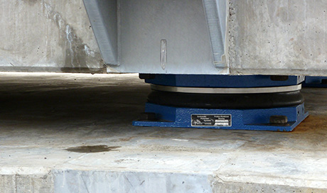

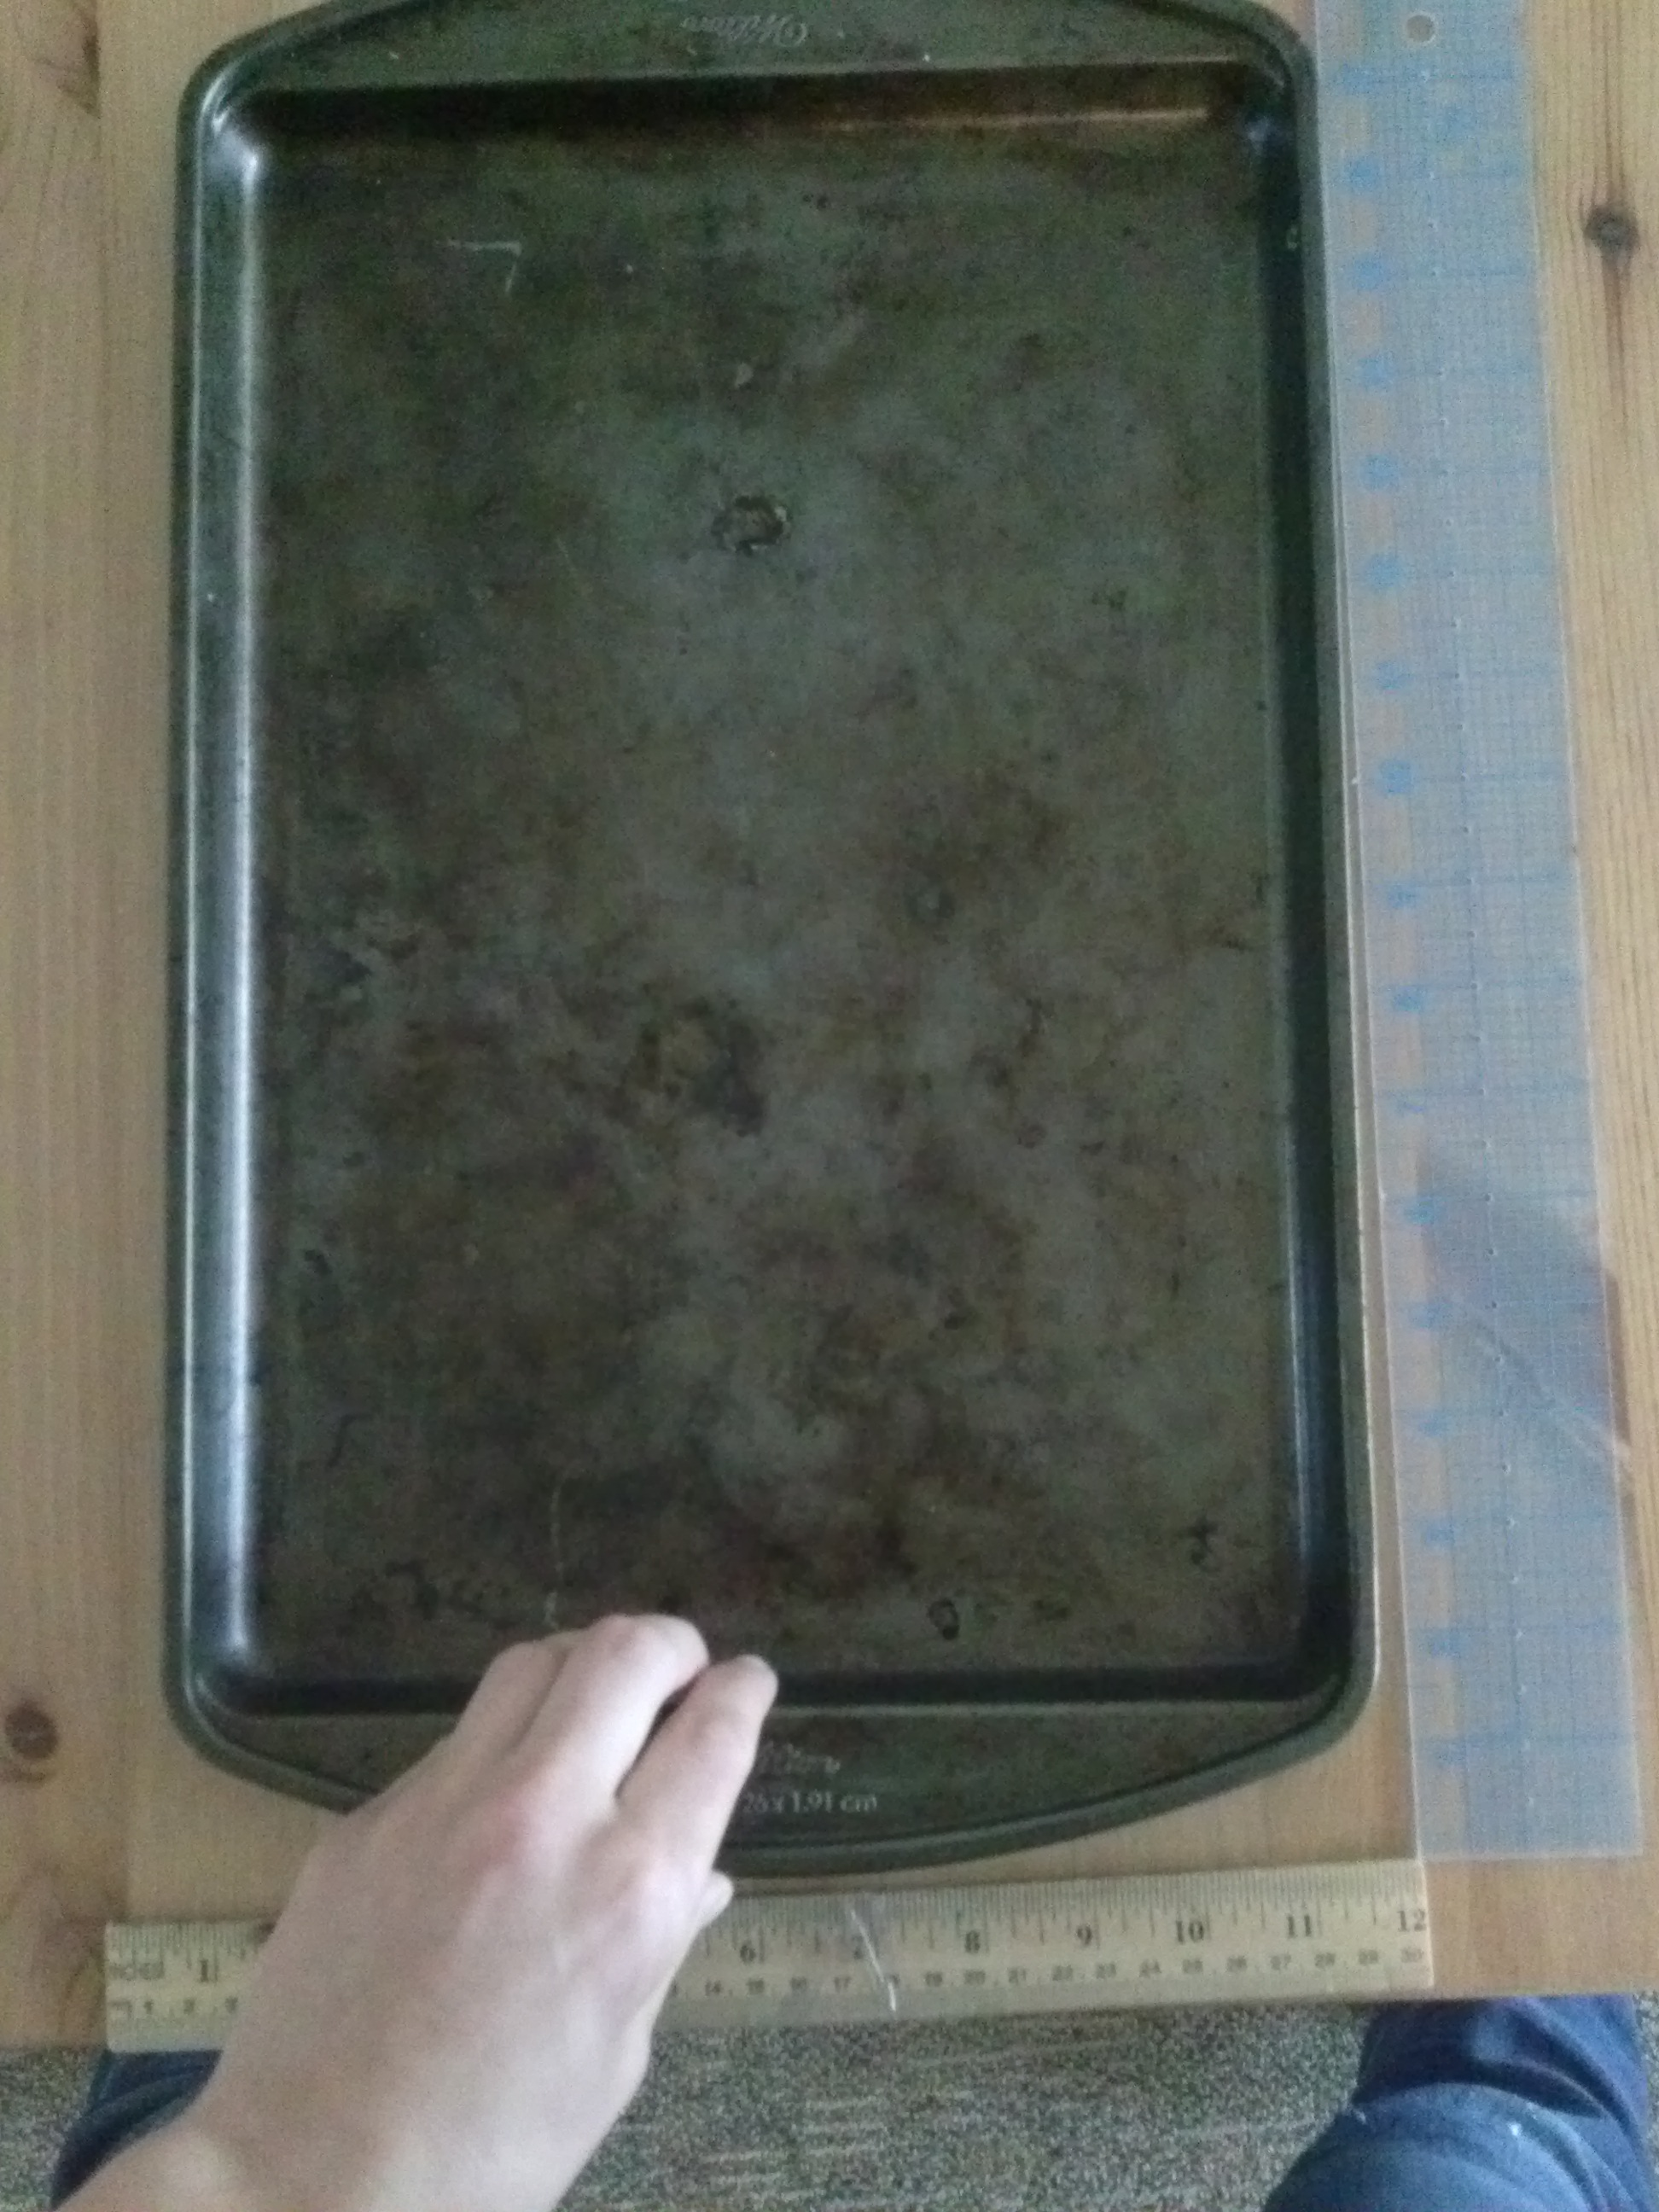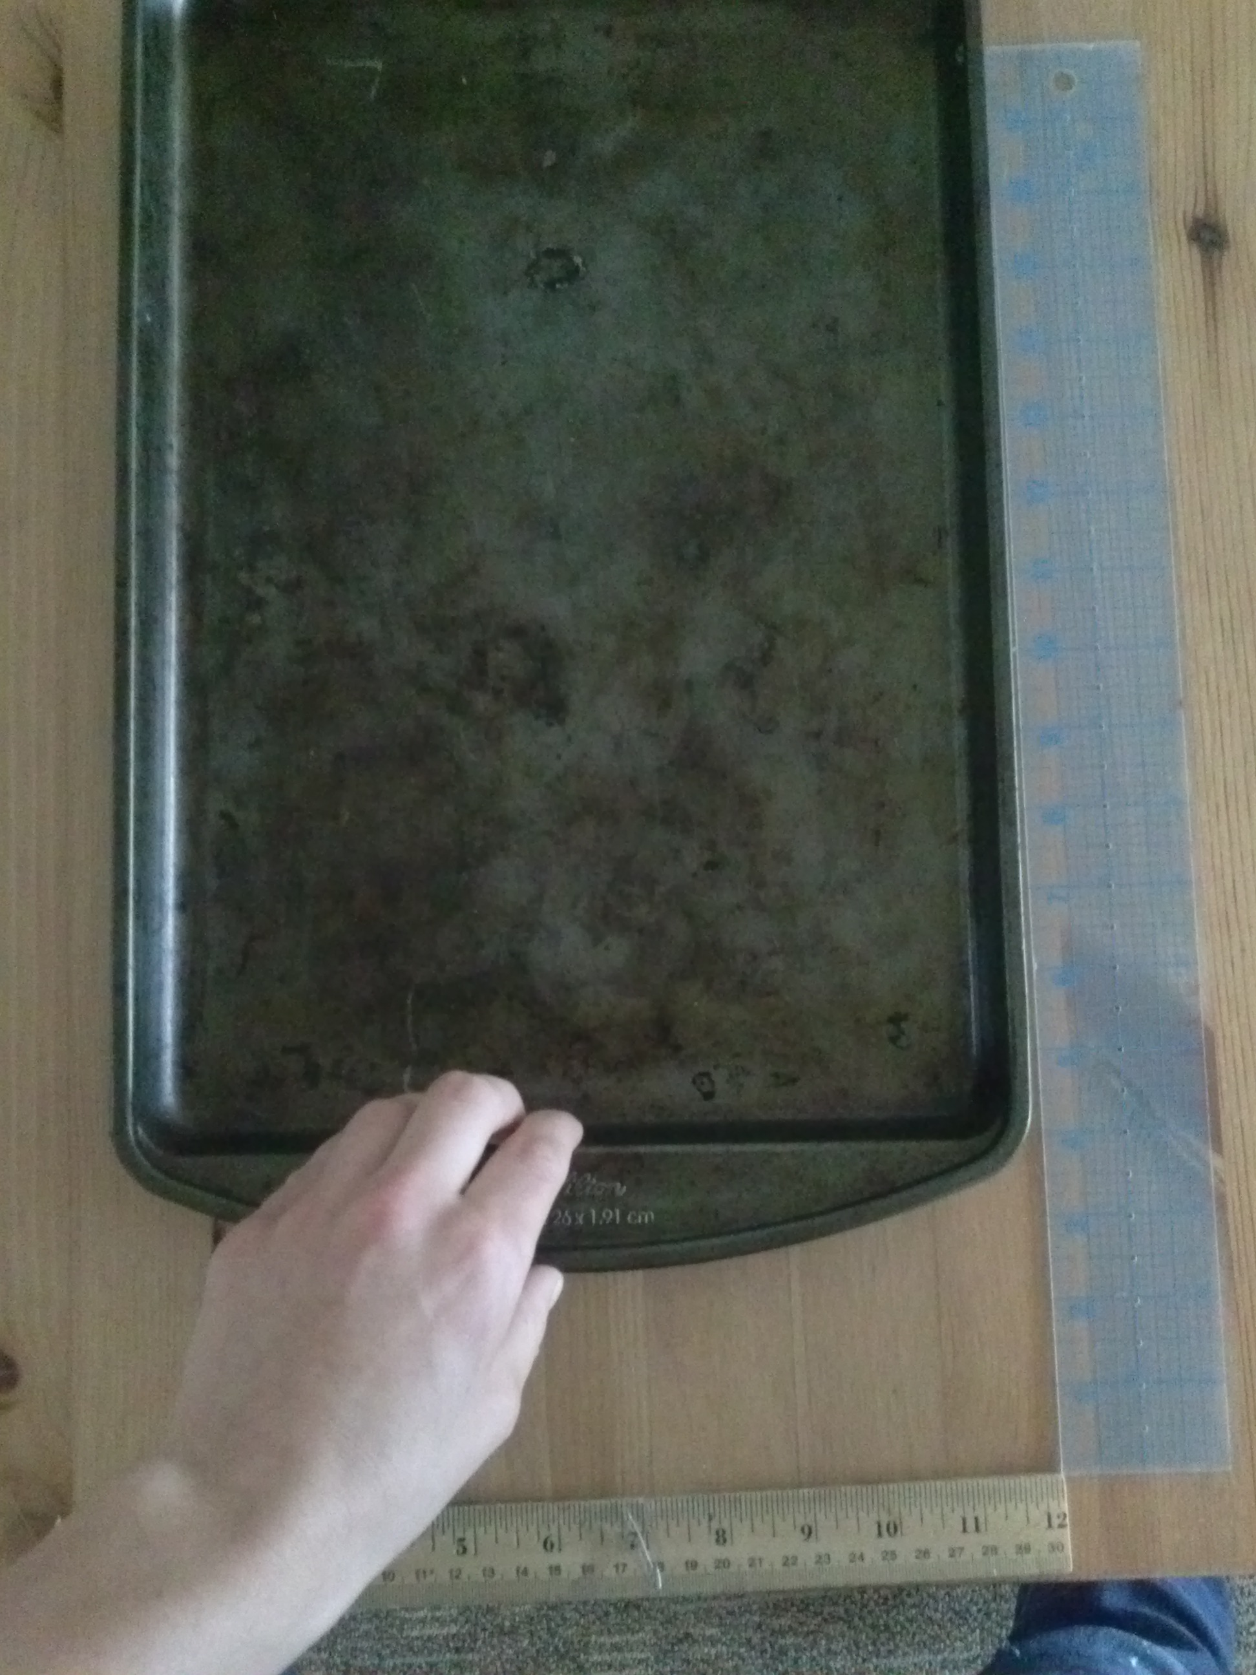

Above Photos: The baking tray set-up, with two rulers. You may wish to tape the rulers to the table.

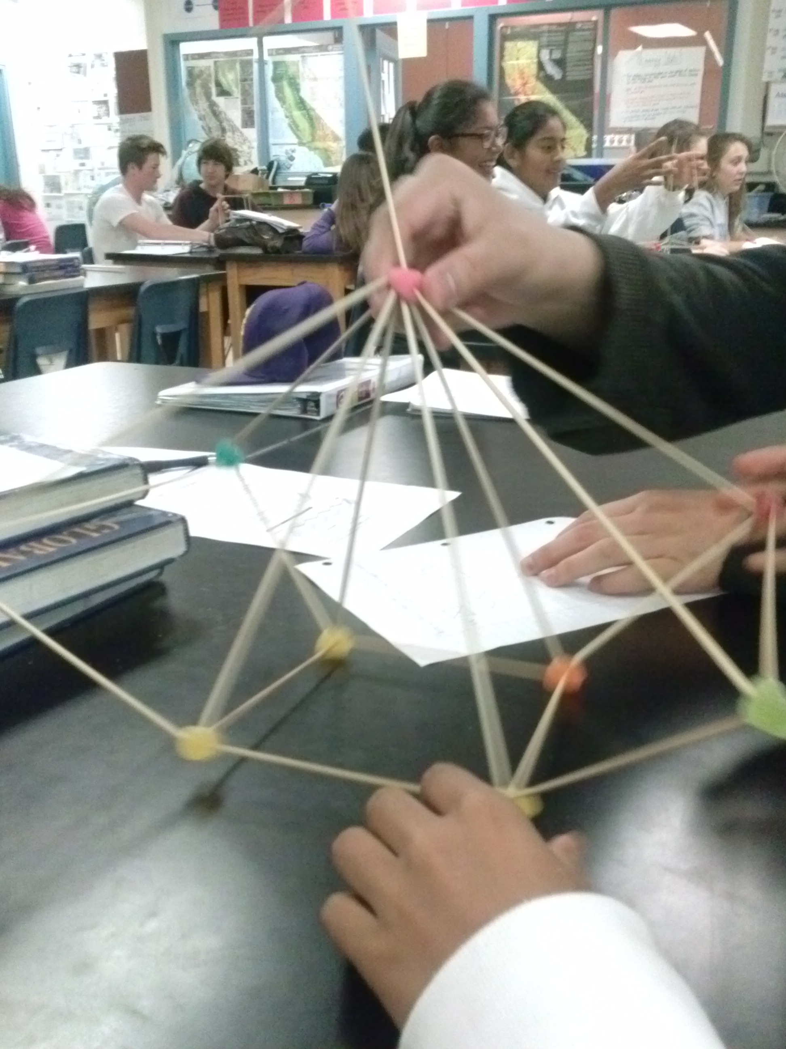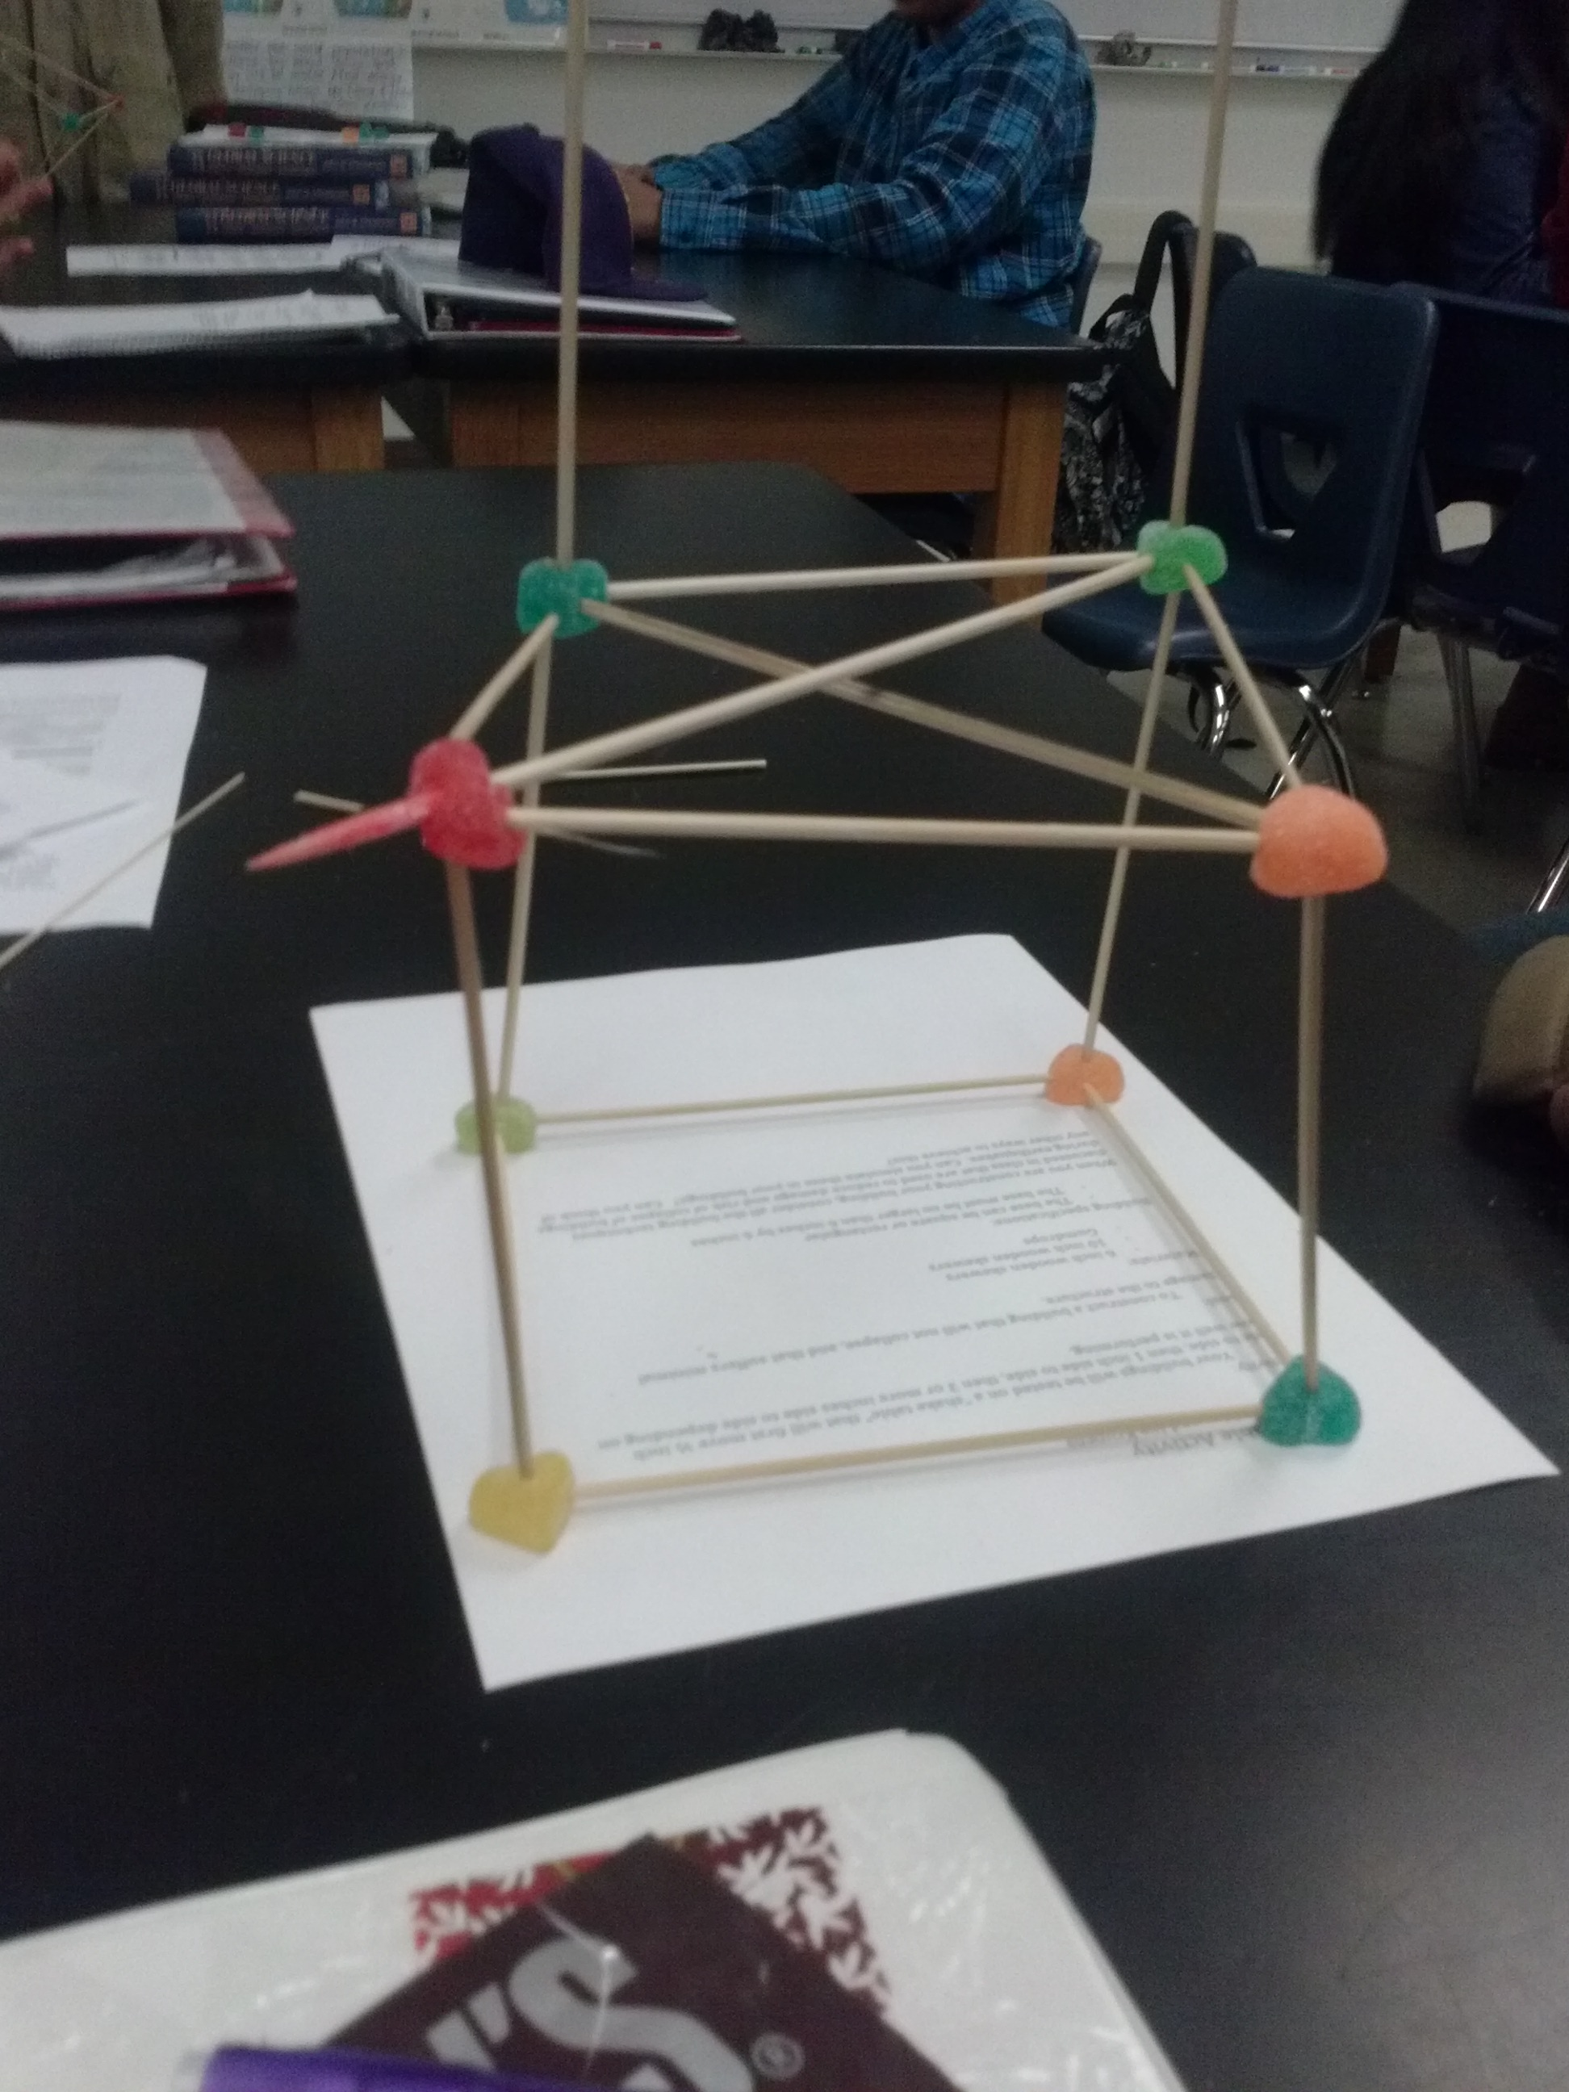
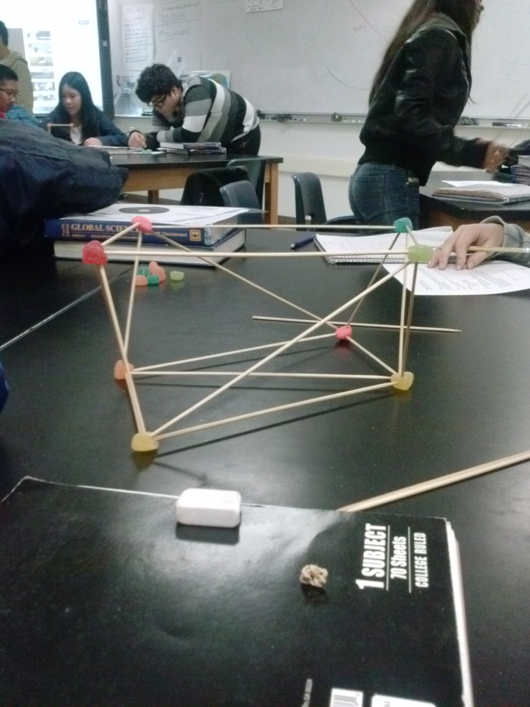
Photos: Examples of buildings (some incomplete).

