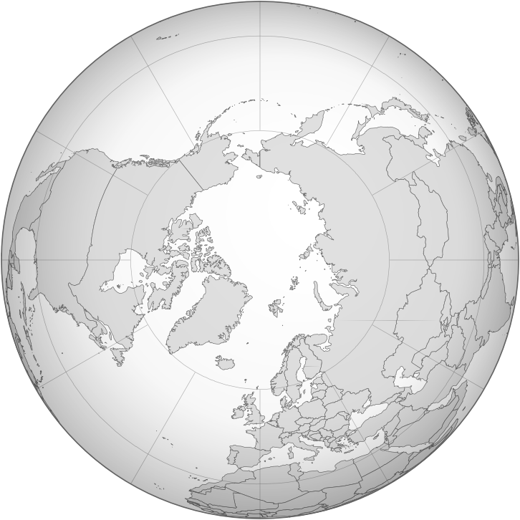

Photo from: http://commons.wikimedia.org/wiki/File:Blankmap-ao-090N-north_pole.png
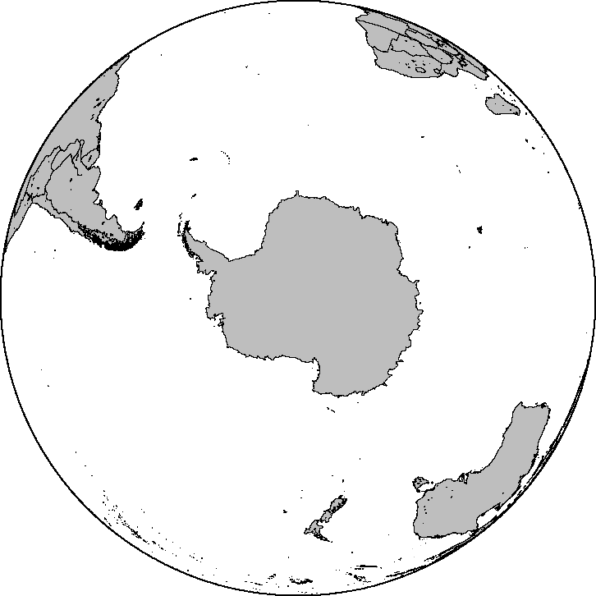

Photo from: http://commons.wikimedia.org/wiki/File:Blankmap-ao-090S-south_pole.png

