Name:__________________________
GNOME Oil Spill Modeling Lab
Goal: After simulating an actual oil spill event, you will understand how oceanographers help to protect marine resources from pollution such as oil spills. You will use an actual modeling program, GNOME, to observe and predict oil spill trajectories. You will understand how weather and ocean conditions affect the fate of oil transport, and how modeling these conditions can help remediation efforts.
Materials: GNOME (General NOAA Operational Modeling Environment) installed with a location file. In this case, we use the Santa Barbara location file. Also required are a pencil, lab sheet and the “GNOME manual.”

Part 1
Warm up: Re-Create the Santa Barbara Oil Spill of Jan 28, 1969.
The goal in part 1 is to test the model. Does it work? Can we actually use it? Scientists call this “hindcasting” (rather than forecasting). Hindsight is 20-20!
Procedure:
1) Set up the spill in the model using the “GNOME manual” and the details of the spill and local weather conditions provided below.
- Model Run Duration: 3 days
- Weather conditions:
Current: Davidson current (“Relaxation state”)
Wind: Variable
Day 1: NNW, 10 Knots (Auto-increment by 24 hours)
Day 2: WNW, 10 Knots
Day 3: WSW, 15 Knots
- Spill location: 34° 19’ 54’’ N and 119° 36’ 47’’ W
- Spill amount: 100,000 barrels (non-weathering)
2) Simulate the oil spill (push “play”). Pay attention to the wind, time, and location where oil comes onshore (you can pause the simulation if you want).
Part 1 Question:
1) Does the spill you modeled agree with the local account of the actual Santa Barbara oil spill (below)? List some similarities and differences between the model and the observations of the actual spill

Local account of the Oil Spill:
Santa Barbara was experiencing a stormy winter, with a large flood event having occurred on January 25, just three days before the blowout. Enormous amounts of fresh water were still running offshore from local streams, flowing south and southwest in the vicinity of the rig. Combined with the prevailing north-northwesterly winds typical of the area between storm systems, this pushed the expanding oil slick away from the shore, and it seemed for several days that the beaches of Santa Barbara would be spared. However, another huge storm system affected the region on February 4, with winds moving around the compass clockwise from southeast to west; this pushed the oil slick north into Santa Barbara harbor and onto all the beaches of southern Santa Barbara County and northwestern Ventura County.
Straughan, Dale (1973). "Biological studies of the Santa Barbara oil spill". American Association of Petroleum Geologists, Trip 3, 1973 Annual Meeting (University of Southern California: AAPG): 4–16.

Part 2
What if the spill happened today?
Disaster! There has been an oil spill off the coast of Santa Barbara.
It is your job as a NOAA Oceanographer to do everything possible to reduce the impact of the oil spill on the coastal environment. There are 10 miles of booms available at the NOAA response station in Santa Barbara, but more booms and other coastal cleanup materials need to be loaded and driven from the Los Angeles – this will take 24 hours.
You must decide where to deploy the 10 miles of booms in Santa Barbara and what to do with the remaining resources available a day later.

- Today’s Weather Conditions:
Current: Winter (Sep-Feb) choose “Relaxation”
Spring (Feb-May) choose “Upwelling”
Summer (June-Aug) choose “Convergent”
Wind: 10 knots, ESE (all three days) or consult the local forecast.
- Spill Location: 34° 19’ 54’’ N and 119° 36’ 47’’ W
- Spill Amount: 100,000 barrels (non-weathering)

Part 2 questions:
- Describe some of the differences between the 1969 Santa Barbara oil spill and this hypothetical spill. Include details on the wind and current.

- Where did the oil make landfall after the first day? How about the second and third days? You can indicate on the map on the next page:
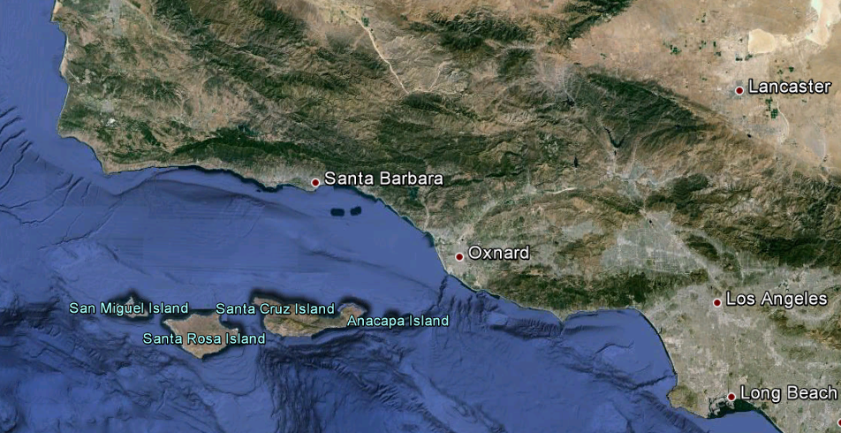

3) As a NOAA Oceanographer, where would you recommend the 10 miles of booms stored at Santa Barbara be deployed? Where would you send the extra resources from LA; a day’s drive away?

Part 3
What are the most important things to know about the model?
Experiment with wind speed, direction and current. See what happens!
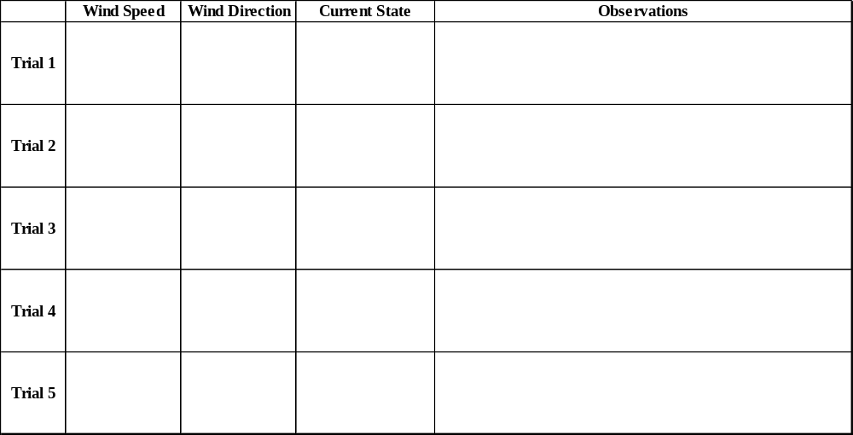

Lab Questions:
1) What are the most important variables (things you changed) in the model? Why do you think they are important? Which do you think are the most important variables that determine where the oil will end up?

2) What kinds of things changed when you made changes to the wind speed and direction? What happened when you changed the current?

3) The Channel Islands contain a delicate marine ecosystem. What kinds of conditions would threaten the Channel Islands if there were an oil spill in Santa Barbara channel.

4) Although this model was actually used by NOAA, it is several years old. Newer versions take several other factors into account. Using your knowledge of ocean currents, can you think of other things that may affect how water moves around that aren’t modeled in this simulation and would improve the accuracy of the model?

