Name:__________________________
GNOME Oil Spill Modeling Lab
Goal: After simulating an actual oil spill event, you will understand how oceanographers help to protect marine resources from pollution such as oil spills. You will use an actual modeling program, GNOME, to observe and predict oil spill trajectories. You will understand how weather and ocean conditions affect the fate of oil transport, and how modeling these conditions can help remediation efforts.
Materials: GNOME (General NOAA Operational Modeling Environment) installed with a location file. In this case, we use the Santa Barbara location file. Also required are a pencil, lab sheet and the “GNOME manual.”

Part 1
Warm up: Re-Create the Santa Barbara Oil Spill of Jan 28, 1969.
The goal in part 1 is to test the model. Does it work? Can we actually use it? Scientists call this “hindcasting” (rather than forecasting). Hindsight is 20-20!
Procedure:
1) Set up the spill in the model using the “GNOME manual” and the details of the spill and local weather conditions provided below.
- Model Run Duration: 3 days
- Weather conditions:
Current: Davidson current (“Relaxation state”)
Wind: Variable
Day 1: NNW, 10 Knots (Auto-increment by 24 hours)
Day 2: WNW, 10 Knots
Day 3: WSW, 15 Knots
- Spill location: 34° 19’ 54’’ N and 119° 36’ 47’’ W
- Spill amount: 100,000 barrels (non-weathering)
2) Simulate the oil spill (push “play”). Pay attention to the wind, time, and location where oil comes onshore (you can pause the simulation if you want).
Part 1 Question:
- Does the spill you modeled agree with the local account of the actual Santa Barbara oil spill (below)? List some similarities and differences between the model and the observations of the actual spill
Similarities may include: The time the spill touched shore, the motion of the spill, the location of the contaminated coastline etc…
Differences may include subtle changes in the aforementioned details.
Local account of the Oil Spill
Santa Barbara was experiencing a stormy winter, with a large flood event having occurred on January 25, just three days before the blowout. Enormous amounts of fresh water were still running offshore from local streams, flowing south and southwest in the vicinity of the rig. Combined with the prevailing north-northwesterly winds typical of the area between storm systems, this pushed the expanding oil slick away from the shore, and it seemed for several days that the beaches of Santa Barbara would be spared. However, another huge storm system affected the region on February 4, with winds moving around the compass clockwise from southeast to west; this pushed the oil slick north into Santa Barbara harbor and onto all the beaches of southern Santa Barbara County and northwestern Ventura County.
Straughan, Dale (1973). "Biological studies of the Santa Barbara oil spill". American Association of Petroleum Geologists, Trip 3, 1973 Annual Meeting (University of Southern California: AAPG): 4–16.

Part 2
What if the spill happened today?
Disaster! There has been an oil spill off the coast of Santa Barbara.
It is your job as a NOAA Oceanographer to do everything possible to reduce the impact of the oil spill on the coastal environment. There are 10 miles of booms available at the NOAA response station in Santa Barbara, but more booms and other coastal cleanup materials need to be loaded and driven from the Los Angeles – this will take 24 hours.
You must decide where to deploy the 10 miles of booms in Santa Barbara and what to do with the remaining resources available a day later.

- Today’s Weather Conditions:
Current: Winter (Sep-Feb) choose “Relaxation”
Spring (Feb-May) choose “Upwelling”
Summer (June-Aug) choose “Convergent”
Wind: 10 knots, ESE (all three days) or consult the local forecast.
- Spill Location: 34° 19’ 54’’ N and 119° 36’ 47’’ W
- Spill Amount: 100,000 barrels (non-weathering)

Part 2 questions:
- Describe some of the differences between the 1969 Santa Barbara oil spill and this hypothetical spill. Include details on the wind and current.
Depending on the wind and current the students chose to model, the differences may include the location of the landfall, how much oil coated the land, the length of the coastline affected, the trajectory of the oil in the water etc…

- Where did the oil make landfall after the first day? How about the second and third days? You can indicate on the map on the next page:
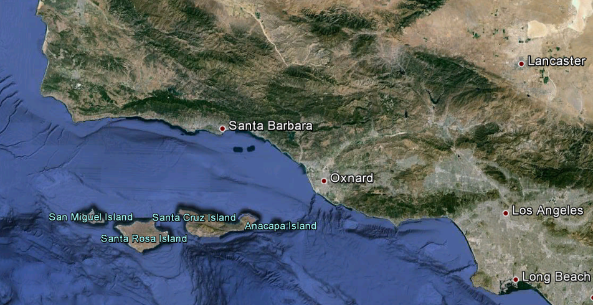

- As a NOAA Oceanographer, where would you recommend the 10 miles of booms stored at Santa Barbara be deployed? Where would you send the extra resources from LA; a day’s drive away?
Students may want to pause their simulation after 1 day has passed to see where the first 10 miles of booms should be deployed. They then can continue the simulation to see where the remaining resources should be deployed.

Part 3
What are the most important things to know about the model?
Experiment with wind speed, direction and current. See what happens!
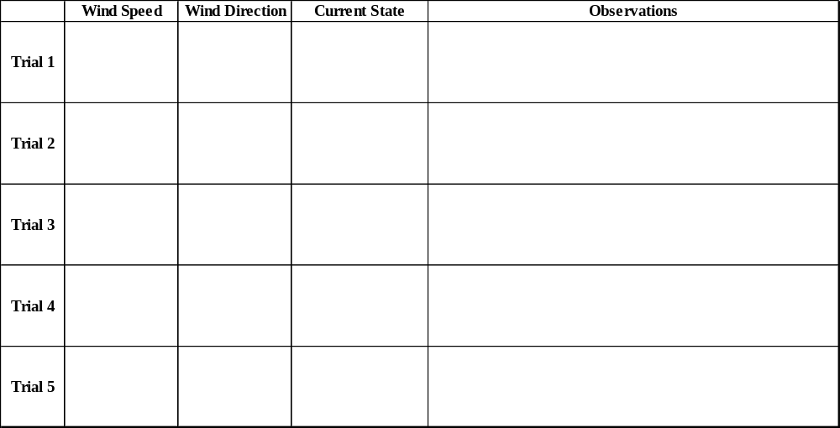

Students should try out a variety of wind speed, direction and current states to see what happens. Observations may include: The trajectory of oil, how much made landfall, how fast it traveled etc…

The point is to get students to see which variables affect objects floating on the surface the most. Generally, in this part of the ocean, wind will affect the surface waters the most, however, other locations may act differently. Some teachers may want to experiment with different location files to see locations with strong tides (San Diego harbor for instance) or complicated topography (like Casco Bay, Maine – with lots of islands and rivers).
Lab Questions:
- What are the most important variables (things you changed) in the model? Why do you think they are important? Which do you think are the most important variables that determine where the oil will end up?
In Santa Barbara, winds are generally the most important. Students may want to model Santa Ana winds (strong winds that typically blow from the northeast to southwest in this region.

- What kinds of things changed when you made changes to the wind speed and direction? What happened when you changed the current?
Possible changes include the speed, direction and distribution of the oil. The landfall location, amount of time the oil remains on land (students may notice that some oil gets “re-suspended” after it’s been on land for a while.

- The Channel Islands contain a delicate marine ecosystem. What kinds of conditions would threaten the Channel Islands if there were an oil spill in Santa Barbara channel.
Santa Ana winds (winds from the northeast) will likely cause the channel islands to be covered in oil. Also, upwelling currents (currents that push surface water offshore and pull bottom water in to replace it) may also cause oil to drift to the channel islands

- Although this model was actually used by NOAA, it is several years old. Newer versions take several other factors into account. Using your knowledge of ocean currents, can you think of other things that may affect how water moves around that aren’t modeled in this simulation and would improve the accuracy of the model?
This is an extension question. Students may think of the following, even though this unit hasn’t significantly covered these topics:
- Waves (which act to push surface water in the direction of the wave in a process called “stokes drift”)
- Water temperature and salinity (can cause density driven currents)
- River runoff (can create jets and plumes of freshwater that affect surface flow and is dependent on rainfall)
- Eddies or “swirls” in the regular average current. In reality currents meander, but in this simulation, only the average current is modeled.

