  1 | 1 | 1 | 1
  3  2 | 3  2 | 3  2 | 3  2
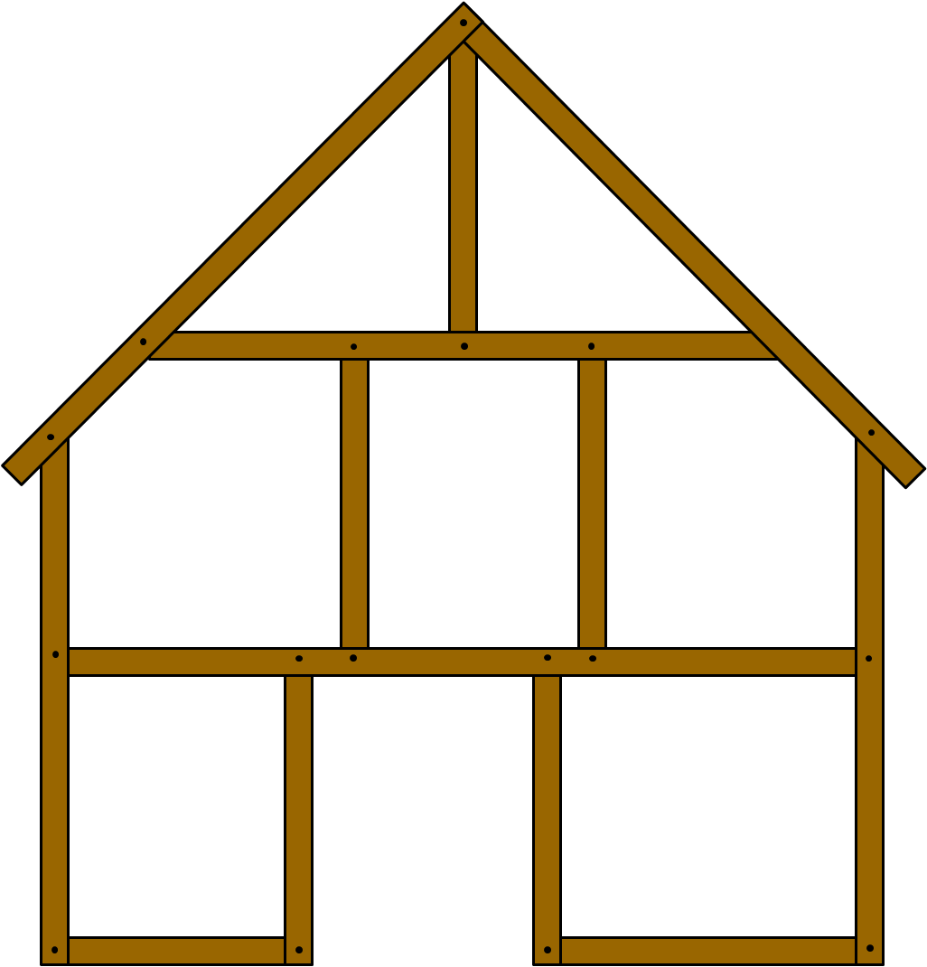  4 | 4 | 4 | 4
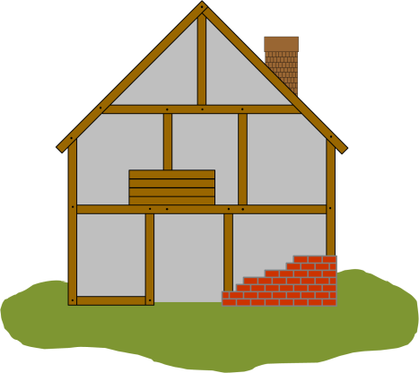
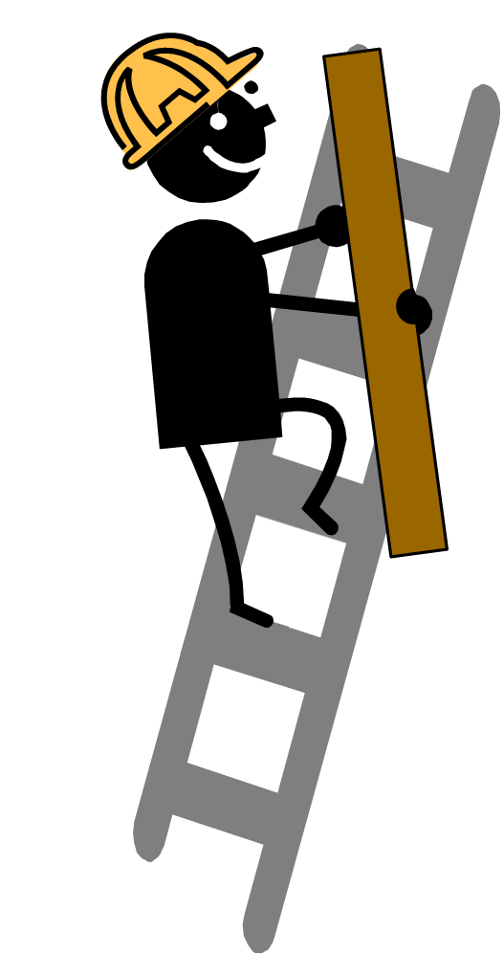  5 | 5  5 | 5

A. Protein that determines the cell shape | A. Protein that determines the cell shape | A. Protein that determines the cell shape | A. Protein that determines the cell shape
B. Protein that transports the cell’s building blocks | B. Protein that transports the cell’s building blocks | B. Protein that transports the cell’s building blocks | B. Protein that transports the cell’s building blocks
C. Protein that builds the cell wall | C. Protein that builds the cell wall | C. Protein that builds the cell wall | C. Protein that builds the cell wall
D. Protein that starts and stops processes | D. Protein that starts and stops processes | D. Protein that starts and stops processes | D. Protein that starts and stops processes
E. A cell | E. A cell | E. A cell | E. A cell

