Cellular Construction Zone

Questions:
Answer AFTER all evidence and analysis are finished

- What are proteins?

- What jobs do proteins have in the cell?

- How do protein's different jobs effect a cell's phenotype?

Hypotheses:
1.

2.

3.

Evidence:
Brain Pop: Cellular Life and Genetics
1.

2.

3.

What is a protein?
1.

2.

3.

All these functions come together to make a cell that _____________ a certain way.

Cellular Construction Zone
Matching construction workers and materials with proteins and their functions
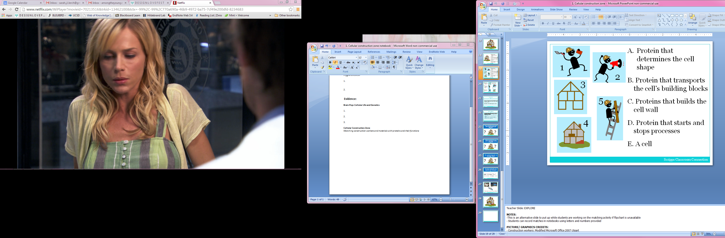
A. Protein that determines the cell shape

B. Protein that transports the cell’s building blocks

C. Protein that builds the cell wall

D. Protein that starts and stops processes

E. A cell

Vocabulary:
- Protein:

- Function:

Analysis:
- What would happen to the building if the workers did their jobs differently?

- What is an example of way a worker could change what they were doing?

- How would this change the way the building looked?

- How does a construction site represent a cell with proteins?
Possible ways to answer this:

The worker who builds the walls on the house is like a _____________ that builds ___________ in the cell.

The frame of the house is like the _____________________ of a cell.

- What causes a mutant to look different?

