Cellular Construction Zone Key
Answers are in bold. When multiple answers are correct an example will be given, noted as Ex:

Questions:
Answer AFTER all evidence and analysis are finished

- What are proteins?
Proteins are compounds made by organisms bodies that are involved in almost everything happening in them, including determining phenotype.

- What jobs do proteins have in the cell?
Proteins have lots of different jobs in the cell such as: Determining the cell's shape, transporting the cells building blocks, building the cell wall as well as starting and stopping processes.

- How do protein's different jobs effect a cell's phenotype?
All of the different proteins jobs come together to determine the overall phenotype, the phenotype would change if their jobs did.

Hypotheses:
1.

2.

3.

Evidence:
Brain Pop: Cellular Life and Genetics
1.

2.

3.

What is a protein?
1. A compound made by an organism.

2. Something that is involved in everything happening in a living organism.

3. Something that is involved in determining phenotype.

All these functions come together to make a cell that __looks___ a certain way.

Cellular Construction Zone
Matching construction workers and materials with proteins and their functions
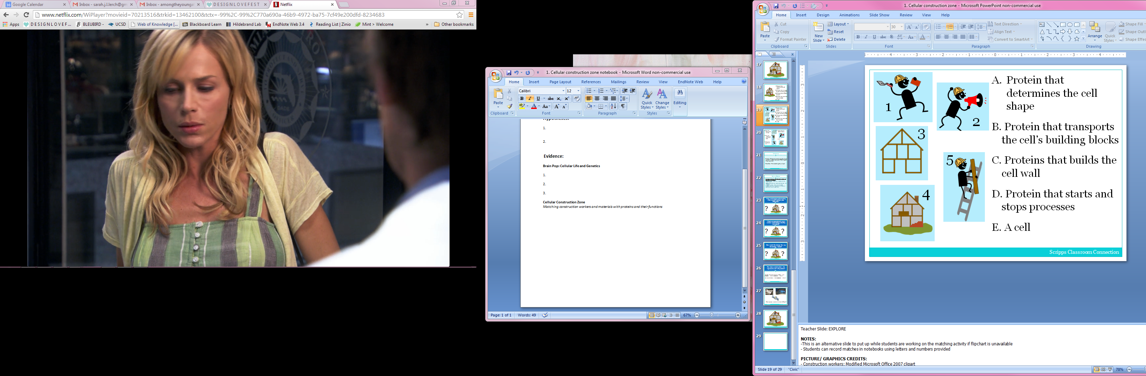
A. Protein that determines the cell shape

B. Protein that transports the cell’s building blocks

C. Protein that builds the cell wall

D. Protein that starts and stops processes

E. A cell

Vocabulary:
- Protein:
Compounds made by organisms that are involved in almost every aspect of what happens in living organisms.

- Function:
What something does, or its job.

Analysis:
- What would happen to the building if the workers did their jobs differently?
The building would look different.

- What is an example of way a worker could change what they were doing?
Ex: The worker transporting the house's building blocks could start bringing different materials such as steel or string cheese instead of wood.

- How would this change the way the building looked?
Ex: If the house was build of steel it might look metallic. If the house was built of string cheese it might look white and the walls might bow in since they would be weak.

- How does a construction site represent a cell with proteins?
Possible ways to answer this:

The worker who builds the walls on the house is like a _protein_ that builds _the cell wall_ in the cell.

The frame of the house is like the ____proteins that determine the shape__ of a cell.

- What causes a mutant to look different?
Changes in the way proteins are doing their jobs.

