From gene to protein

Question:
Answer AFTER all evidence and analysis are finished

- What is the relationship between genes and proteins?

Hypothesis:
1.

Evidence:
Discussion/ Warm-up questions
Use evidence from your Cellular construction zone notebook

1. What do you know about genes?

2. What do you know about proteins?

Protein making activity
Insert photos of genes and proteins
- Normal gene

- Normal protein

- Mutant gene

- Mutant protein

Vocabulary:
- Protein:

- Function:

Analysis:
- List the differences in your two proteins

- Complete the Protein to Phenotype activities below. Summarize what this sheet helps you understand.

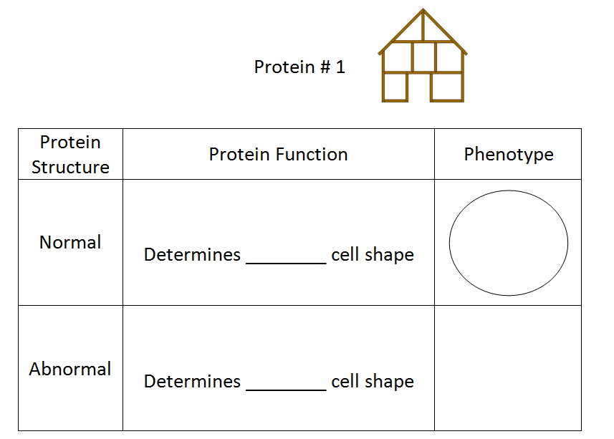
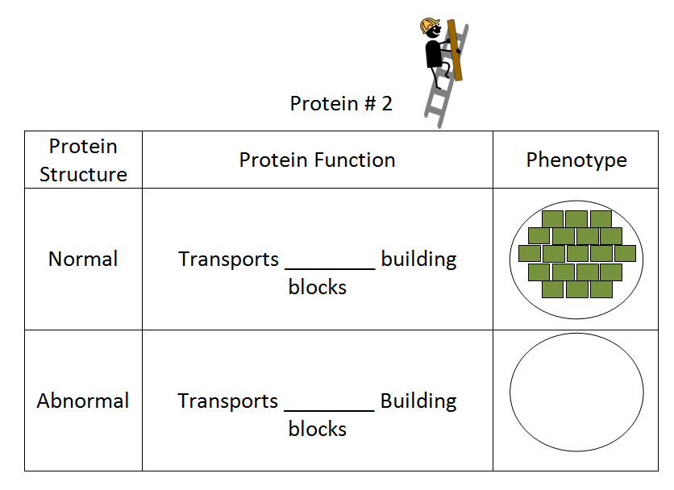
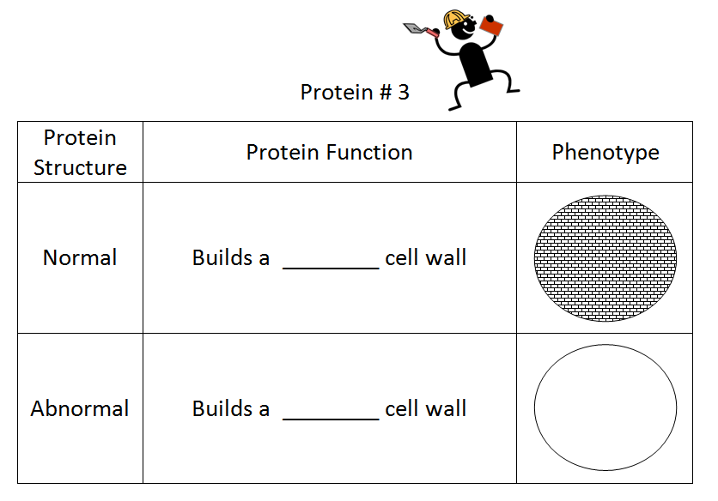
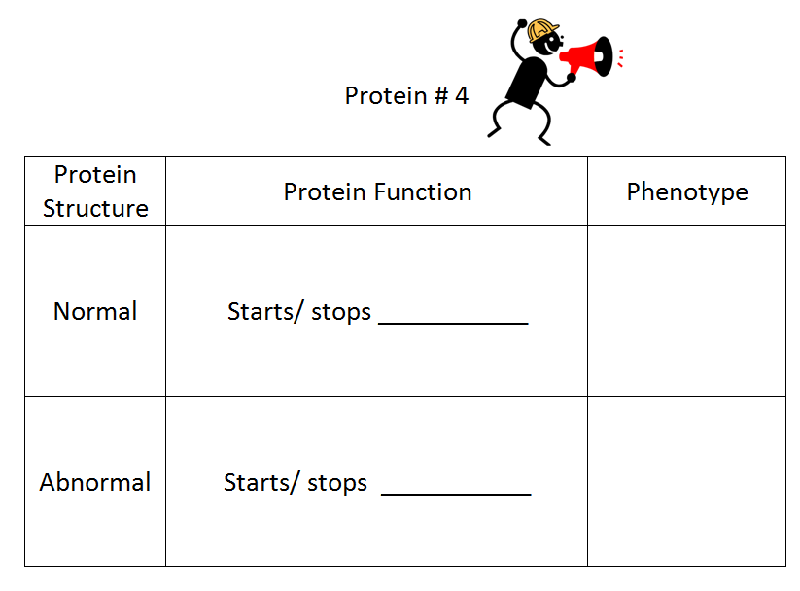

- What determines a protein's structure?

- What happens to a protein if gene instructions change?

- What causes a change in a protein's function?

- If a protein's structure changes that will affect its __________________________________.

- How are genes used as instructions to make proteins?

