From Gene to Protein Key
Answers are in bold. When multiple answers are correct an example will be given, noted as Ex:

Question:
Answer AFTER all evidence and analysis are finished

- What is the relationship between genes and proteins?
The pattern of base pairs in a gene determines the shape of the protein which is made from it.

Hypothesis:
1.

Evidence:
Discussion/ Warm-up questions
Use evidence from your Cellular construction zone notebook

1. What do you know about genes?

2. What do you know about proteins?

Protein making activity
Insert photos of genes and proteins
- Normal gene

- Normal protein

- Mutant gene

- Mutant protein

Analysis:
- List the differences in your two proteins
There should be a numbered list here of the specific differences between each student made "protein".

- Complete the Protein to Phenotype activities below. Summarize what this sheet helps you understand.

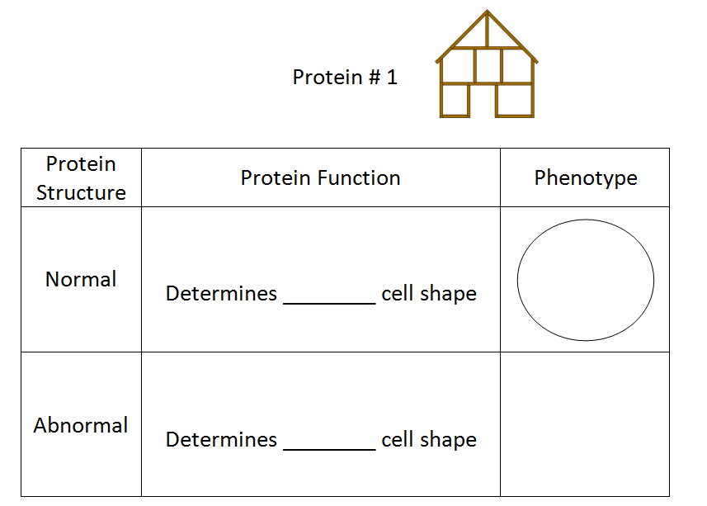
EX: Square
circular
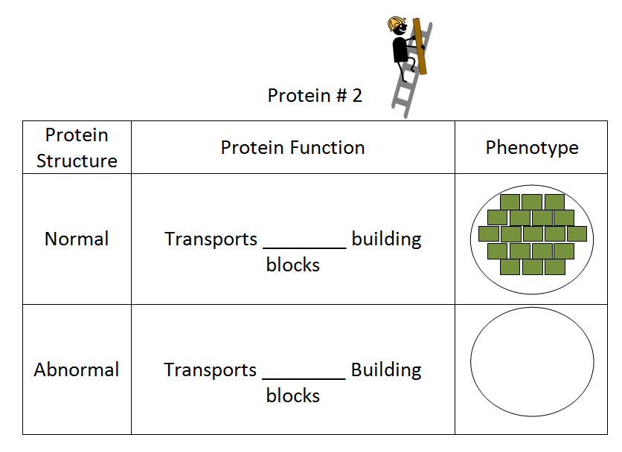
EX: yellow, triangular
green,
rectangular
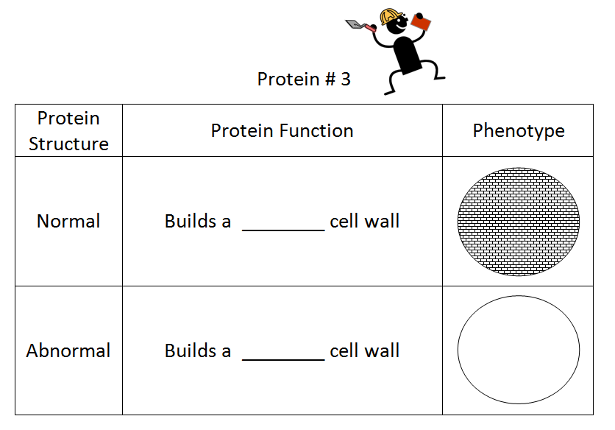
EX: circular
brick
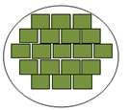
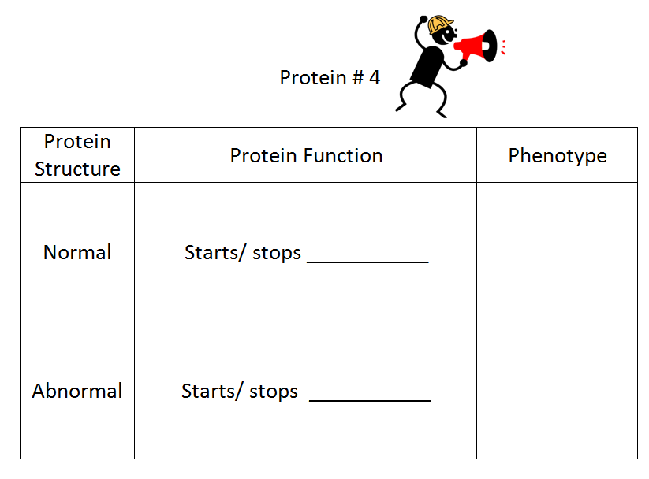
EX: stop transporting
the cell blocks
EX: does not stop transporting
the cell blocks

- What determines a protein's structure?

The pattern of base pair in the gene that it is made from.

- What happens to a protein if gene instructions change?

The shape or structure of the protein changes.

- What causes a change in a protein's function?

A change in the protein's structure.

- If a protein's structure changes that will affect its ______function_______.

- How are genes used as instructions to make proteins?
The pattern of base pairs in the genes is a code which can be read and determines different parts of a protein's structure.

