Gene | Feature Controlled by Gene | Cellular Function | How it Works | What Would Happen if: | Environmental Factor Affected
Shape gene | Overall shape | Contains and protects the cell's organelles | Frustule is shaped to contain everything in the cell | The shape were too big or too small? | All factors
Pore Gene | Pores | Allows the cell to get nutrients | Pores allow nutrients into the cell | The pores were larger, smaller, a different shape or not there? | Nutrients: High vs. low
Pore Gene | Pores | Protects the cell from viruses | Pores are too small for viruses to get through |  | Viruses: High vs. low
Rib gene | Rib | Provides structural support | Ribs stop the frustules from collapsing | The ribs change shape or aren't there at all? | All factors
Spine gene | Spines | Defend against herbivores | Spines make diatoms harder to eat | The spines were bigger, smaller or not there? | Herbivores: High vs. low
Spine gene | Spines | Help diatom float | Spines increase the surface area, slowing sinking | The spines were bigger, smaller or not there? | Light: High vs. low
Mutant Model:
Species: Stephanodiscus minutulus
Possible Mutant Genes:
- Shape gene
- Pore gene
- Spine gene
- Rib gene

1. How did your mutation change the feature your mutant gene controls?

2. What might the protein your gene code for do normally? (its normal function)

3. What might the protein your gene codes for do when the gene is mutated?

Mutant
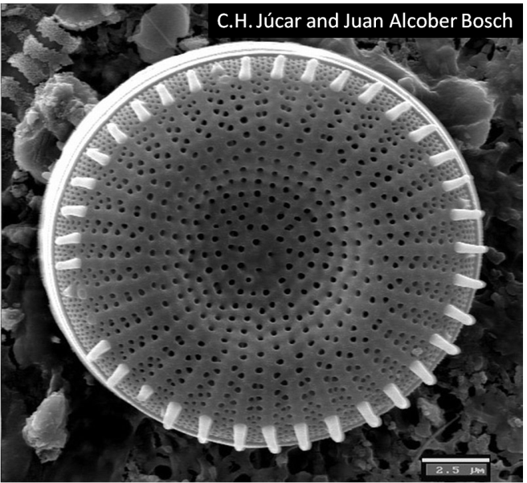
4. What environmental factor is affected in your mutant?

5. What environment would your mutant live well in?

Normal
Normal

