Evidence Sheet 1
Continent shape

In the 1500s, long before Wegener’s time, seagoing explorers created some of the first geographically accurate world maps. Almost right away, scholars noticed that the coastlines of some continents looked like they fit together. It seemed like the fit was too good to be a simple coincidence, but they could not explain why they would be shaped that way.
MAIN THOUGHT: some continents look like they fit together.

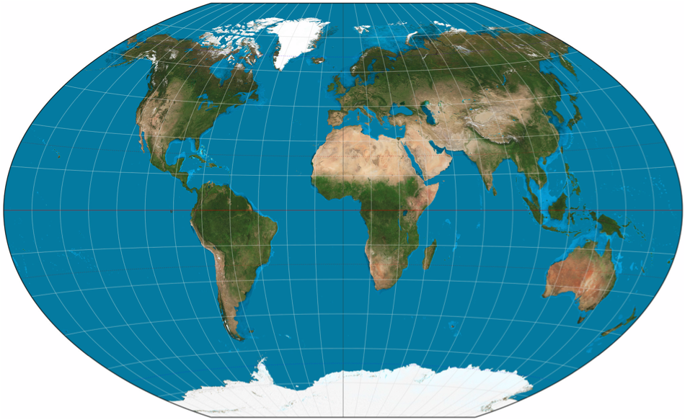
http://en.wikipedia.org/wiki/World_map

Evidence Sheet 2
Locations of past glaciers

Glaciers are massive sheets of ice that slowly flow over land. As the glacier moves, it drags rocks, pebbles, and other debris underneath it. It also leaves striations, or scratches, on the earth below it. By Wegener’s time, geologists had mapped the locations of glacier deposits and glacial striations around the world. Look carefully at the map below of worldwide ancient glacial deposits.
MAIN THOUGHT: ancient glaciers existed where there are none today.

“Earth: portrait of a planet” by Marshak 2012

Evidence Sheet 3
Coal deposits

The map below shows the locations of ancient coal deposits in gray ovals. Coal is usually formed in densely forested tropical areas, when plant material is covered up by thick sediments. The carbon within the plant material is subjected to great temperature and pressure, and is eventually transformed into coal.
MAIN THOUGHT: Coal deposits can be found in regions that are not tropical today.

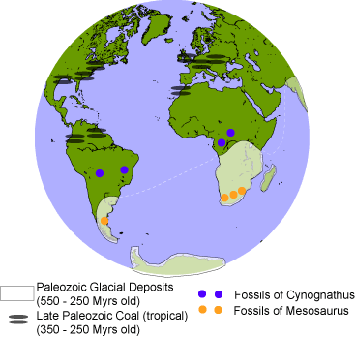

http://quakeinfo.ucsd.edu/~gabi/sio15/supps/cdrift.gif

Evidence Sheet 4
Fossil distribution

The map below also shows the locations of fossils of Mesosaurus and Cynognathus.

MAIN THOUGHT: Fossils from the same extinct species can be found on two continents separated by an ocean.

http://quakeinfo.ucsd.edu/~gabi/sio15/supps/cdrift.gif

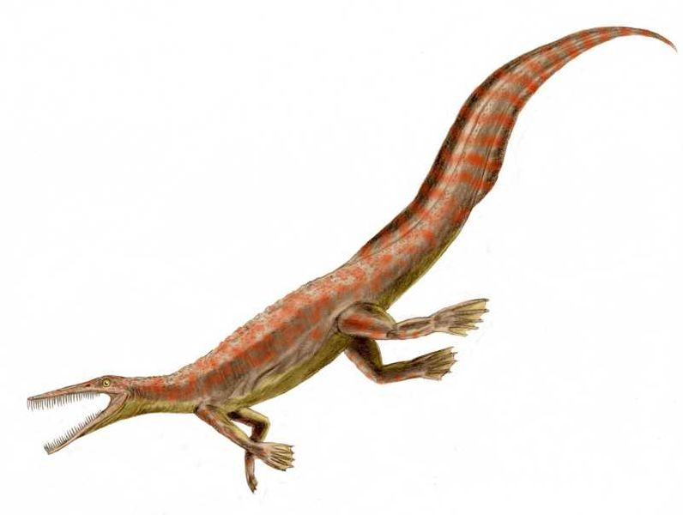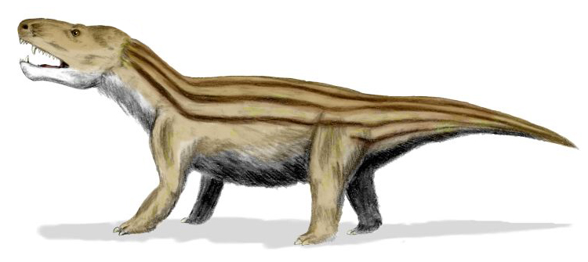
http://en.wikipedia.org/wiki/File:Mesosaurus_BW.jpg
http://en.wikipedia.org/wiki/File:Cynognathus_BW.jpg
Evidence Sheet 5
Matching mountain belts

Map (a) below on the left shows the locations of Proterozoic mountain belts, with the Atlantic Ocean removed. The directions of folds within the rock layers (denoted by the black lines in figure (a)) also match up across the ocean. Map (b), below on the right, shows the distribution of Paleozoic mountain belts, with the Atlantic Ocean removed. The Appalachian mountains of the eastern United States contain the same kind of rocks as the west coast of Africa, as well as parts of Greenland and Scandanavia.
MAIN THOUGHT: The same kind of rocks exist on the coastlines of continents that are separated by an ocean. Also, the shapes of the folded rock layers match up on those continents.

“Earth: portrait of a planet” by Marshak 2012

Evidence Sheet 6
Paleomagnetism: Apparent polar wander

The Earth has a global magnetic field. When you look at a compass, its needle points north because it aligns with the direction of the magnetic field where you are standing. Rocks can actually record the Earth’s magnetic field, and geologists can measure it within those rocks. Think about a lava flow erupting from a volcano. The hot, molten lava has no crystal structure. As it cools, little crystals of a mineral called magnetite start to form and the rock becomes solid at the solidus temperature, about 900ºC. Because of the great heat energy of the rock, the magnetic dipoles within the crystals move around in all directions so that there is no net magnetic field of the rock. As the rock cools even more the magnetic dipoles slow down and start to become aligned with the direction of the Earth’s magnetic field. Once the rock cools to the Curie temperature, about 700 ºC, the magnetic dipoles become locked in to the rock in the direction of the Earth’s magnetic field. So the magnetic dipole of a rock that is created today should point toward the North pole. In the early 1900s, geologists measured the direction of the magnetic field in very old to very young rocks. They made a surprising discovery- it looked like the direction of the magnetic north pole (as recorded by those rocks) had changed locations around the globe over time, this is called an apparent polar-wander path. They made measurements on other continents and found that they had different polar-wander paths.
MAIN THOUGHT: The magnetic field recorded in rocks on different continents seem to suggest that in the past the Earth’s magnetic north pole existed in many places at one time. This isn’t possible.

Shape of Earth’s magnetic field.

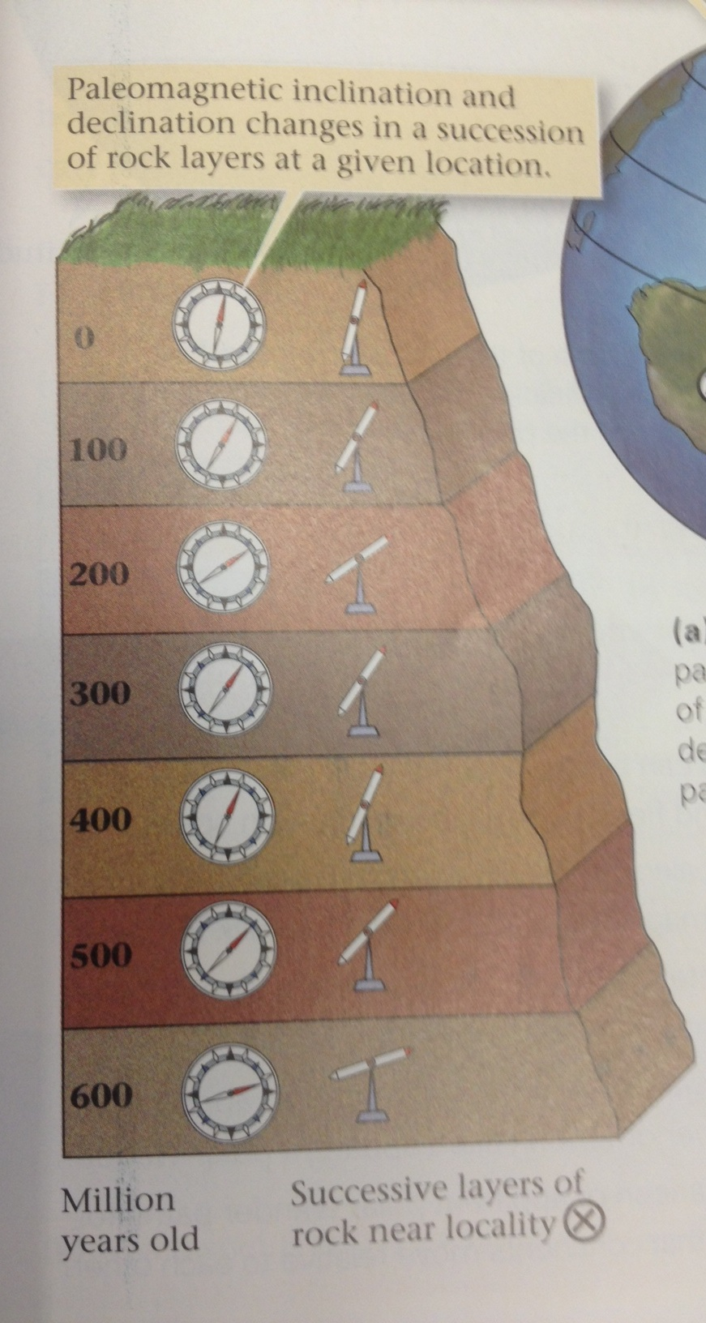
Magnetic field direction recorded in lava layers throughout time.
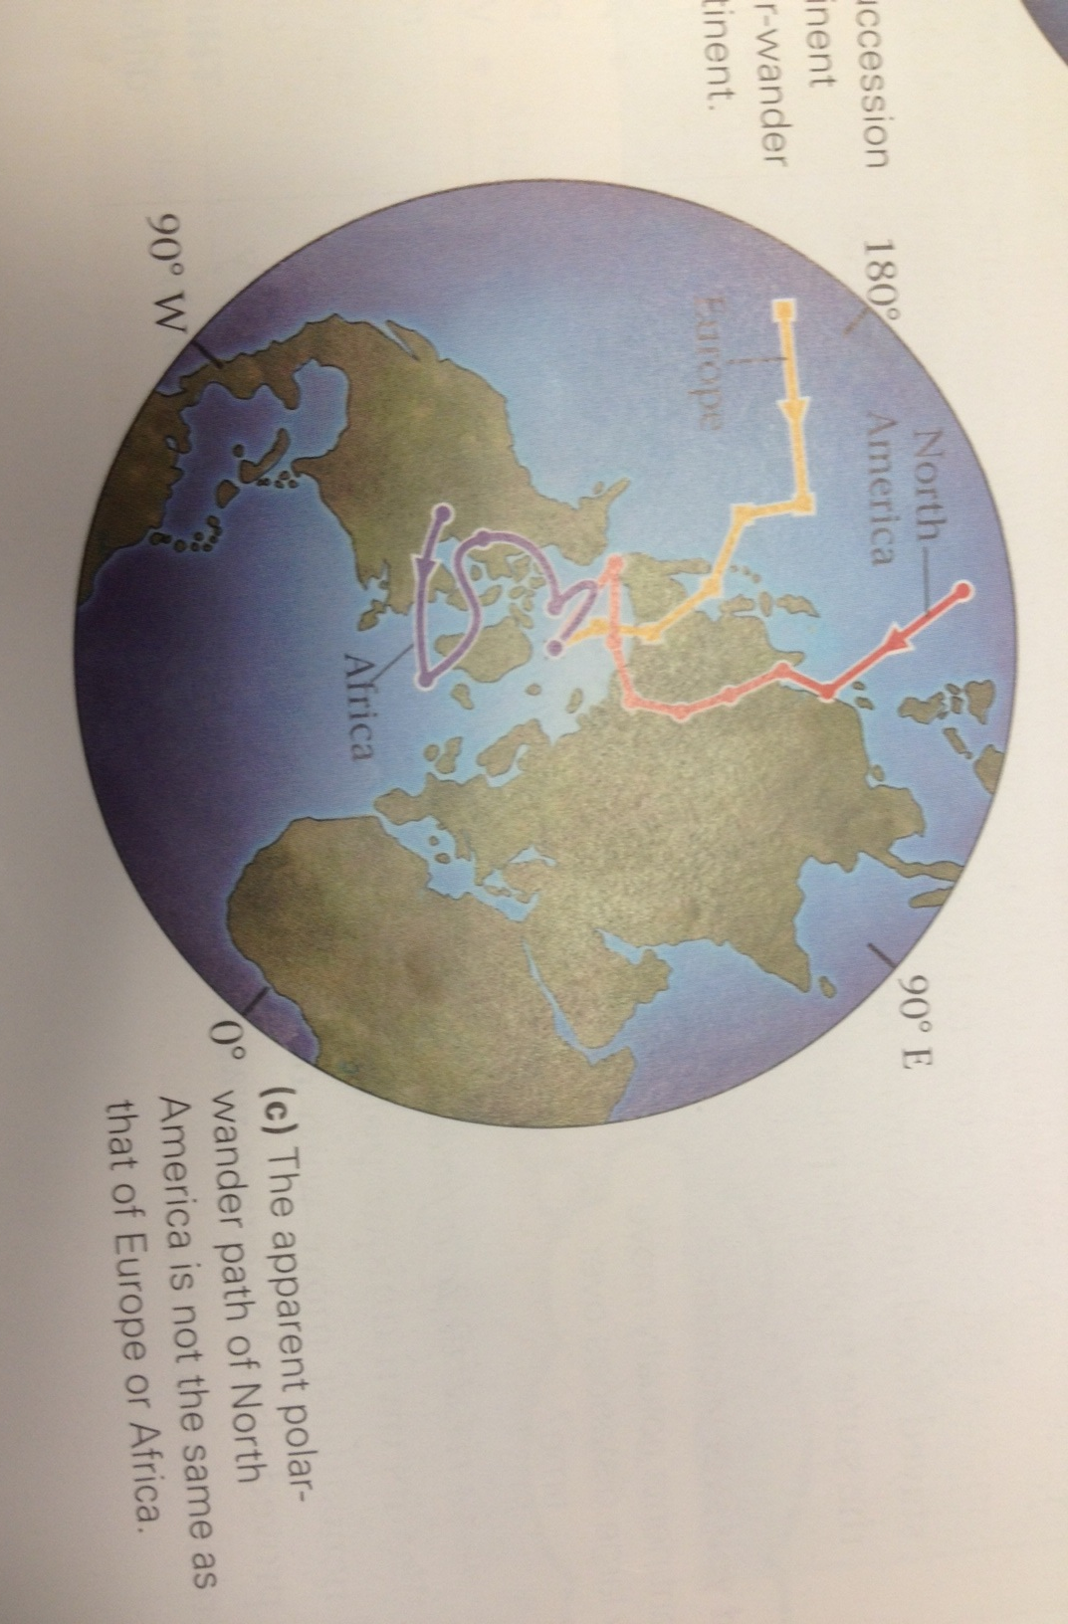
Apparent polar wander curves of three different contienents. Arrows show how the apparent poles moved in time.

All three figures from: “Earth: portrait of a planet” by Marshak 2012
Evidence Sheet 7
Sea floor bathymetry

“Before World War II, we knew less about the shape of the ocean floor than we did about the shape of the Moon’s surface” Marshak (2012). The invention of sonar allowed the navy to measure how deep the ocean was below a ship, by bouncing sound waves off of the ocean floor. Detailed studies of the ocean floor revealed important features:
Mid ocean ridges, abyssal plains, continental margins.
Other parts of the world showed deep ocean trenches, seamount chains, and fracture zones (not pictured on this map).
MAIN THOUGHT: After Wegener’s death, new technology allowed scientists to see the shape of the sea floor. It has an important symmetry.

“Earth: portrait of a planet” by Marshak 2012

Evidence Sheet 8
Heat flow measurements

Scientists measured greater heat flow at mid ocean ridges than at abyssal plains or continental shelves. By drilling boreholes, they also measured that sediment thickness increased away from mid ocean ridges.
MAIN THOUGHTS: 1) There is more heat flow at mid ocean ridges than there is away from mid ocean ridges. 2) Sediments take a long time to accumulate on the sea floor. Thicker sediments mean that the sea floor has been exposed for a long time.

“Earth: portrait of a planet” by Marshak 2012
Evidence Sheet 9
Global earthquake distribution

Below is a map from 1963 of earthquakes (shown in red dots) around the globe. Today’s earthquake distribution looks very similar.
MAIN THOUGHT: earthquakes do not occur at random locations around the world. There are certain areas that have lots of earthquakes, and other areas that have few. They seem to occur in belts around the globe.

“Earth: portrait of a planet” by Marshak 2012

Evidence Sheet 10
Paleomagnetism: Marine Magnetic anomalies

Over geologically long times, the Earth’s magnetic field has experienced magnetic reversals many times. This means that the shape of the magnetic field is still a dipole, but the north and south magnetic directions are switched. The most recent magnetic reversal happened 780,000 years ago. In the ancient past, before humans existed, your compass could have pointed at the South pole! Geologists made a timeline of these reversals (normal-reverse-normal-reverse…). They suspected that the ocean floor was being created as magma flowed up at mid ocean ridges and cooled as it spread apart. If this was true, they would expect the ancient magnetic reversals to be recorded on the sea floor. During the 1960s, geologists made new measurements of the magnetic field trapped in rocks along the ocean floor. They towed magnetometers behind boats to measure magnetic anomalies (changes in the expected magnetic field) in the rocks. They made an astounding discovery- the pattern of magnetic anomalies was like stripes along the mid ocean ridges, and the pattern was symmetric about the mid ocean ridges. This pattern was exactly what they expected due to their magnetic reversal timeline. This was the most important piece of evidence that scientists needed to prove that the sea floor was spreading. New crust rises up as magma at mid ocean ridges, cools and locks in the magnetic field, and spreads outward, pushing the continents with it.
MAIN THOUGHT: The symmetry of magnetic “stripes” on the sea floor suggests that the sea floor is being created and is spreading apart at mid ocean ridges.

All three figures from: “Earth: portrait of a planet” by Marshak 2012

