Name _______________________________

Continental Drift Mystery:
Research Notes

Introduction: Below are photos of Alfred Wegener, a German meteorologist and geophysicist, on a research expedition to measure the thickness of Greenland’s ice sheet. Wegener was well known for publishing his idea that long ago the Earth’s continents had all fit together like one giant continent. The best geologists of the time strongly rejected his idea. In September 1930, he and a group of researchers set out by dog sled to bring supplies to two researchers stuck at a remote camp. They never returned. Wegener never lived to see the scientific community accept his idea. In this Continental Drift Mystery Activity, we will discover what evidence made Wegener so sure that the continents had moved. We will also learn about advances in technology that helped scientists explain how the continents moved.
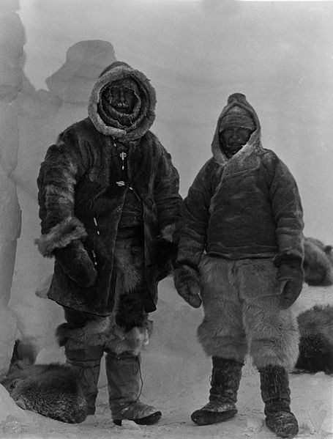
Left photo: “Earth: portrait of a planet” by Marshak 2012
Right photo: http://en.wikipedia.org/wiki/File:Wegener_Expedition-1930_026.jpg

Question 0) Why do you think geologists rejected Wegener’s idea?

Question 1a) Name two sets of coastlines that look like they could fit together like puzzle pieces. If you can only find one set of matching coastlines using the provided map, try looking at a globe or using Google Earth to get a better perspective.

Question 1b) Why do you think the coastlines look like they could fit together?

Question 2a) What continent today has the largest glaciers? Is that continent closer to the poles or closer to the equator?

Question 2b) Looking at the map provided, what do you notice about the locations of past glaciers? Why don’t large glaciers exit there now?

Question 3) Is the eastern coast of the United States currently a dense tropical forest? What about Northern Europe? How do you think coal was formed in those locations?

Question 4) How do you think the fossils of Mesosaurus and Cynognathus ended up on two separate continents? Do you think those creatures could have swam across the Atlantic ocean? Do you think they could have evolved by coincidence, separately on each continent?

Question 5a) Wegener had shown that not only do coastlines match across oceans, but the rock types are the same too. Based on the evidence so far, do you think Wegener has made a strong argument for continental drift? What evidence is most (or least) convincing to you and why?

Question 5b) Geologists biggest criticism of Wegener’s theory was that he had no way to explain how or why the continents moved, or if they are still moving today. If Wegener had lots of money to spend on research, and today’s best technology, what kind of measurements would you advise him to make to figure it all out?

Question 6a) Why must the apparent polar wander curves from different continents all meet in the same location today? Where is that location?

Question 6b) How could the paleomagnetic records from each continent produce a different apparent polar wander path?

Question 7) Do you notice any symmetry about the sea floor profile? If so, please describe.

Question 8a) What could be causing greater heat flow at the mid ocean ridges?

Question 8b) If sediment thickness increases away from the mid ocean ridges, what does that tell you about the age of the oceanic crust away from the ridge compared to at the ridge?

Question 9) What do you notice about the locations of earthquakes? Any patterns? Do they correlate with any geological features?

Question 10a) What was special about the pattern of magnetic anomalies along the ocean floor that helped geologists prove that the oceanic crust is spreading?

Question 10b) Where is the youngest oceanic crust? Where is the oldest oceanic crust?

Question 11) How did the theory of seafloor spreading prove that Wegener’s continental drift theory was correct?

