Name _______________________________

Continental Drift Mystery:
Research Notes

Introduction: Below are photos of Alfred Wegener, a German meteorologist and geophysicist, on a research expedition to measure the thickness of Greenland’s ice sheet. Wegener was well known for publishing his idea that long ago the Earth’s continents had all fit together like one giant continent. The best geologists of the time strongly rejected his idea. In September 1930, he and a group of researchers set out by dog sled to bring supplies to two researchers stuck at a remote camp. They never returned. Wegener never lived to see the scientific community accept his idea. In this Continental Drift Mystery Activity, we will discover what evidence made Wegener so sure that the continents had moved. We will also learn about advances in technology that helped scientists explain how the continents moved.
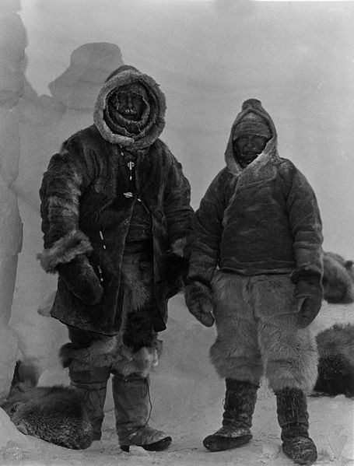
Left photo: “Earth: portrait of a planet” by Marshak 2012
Right photo: http://en.wikipedia.org/wiki/File:Wegener_Expedition-1930_026.jpg

Question 0) Why do you think geologists rejected Wegener’s idea?

He had no way to explain how or why the continents moved. What was the incredibly powerful force that could do it? Other answers are fine too.

Question 1a) Name two sets of coastlines that look like they could fit together like puzzle pieces. If you can only find one set of matching coastlines using the provided map, try looking at a globe or using Google Earth to get a better perspective.

Eastern coast of South America and western coast of Africa.

Antarctica and Australia.

Others.

Question 1b) Why do you think the coastlines look like they could fit together?

Maybe it’s random chance? Maybe they were once a single continent that split apart.

Question 2a) What continent today has the largest glaciers? Is that continent closer to the poles or closer to the equator?

Antarctica has the largest glaciers. It is at the South Pole.

Question 2b) Looking at the map provided, what do you notice about the locations of past glaciers? Why don’t large glaciers exit there now?

Ancient glacier deposits are located near the equator. There is no way a large glacier could exist there now because the climate it too hot. Those regions must have been located closer to the south pole in the past.

Question 3) Is the eastern coast of the United States currently a dense tropical forest? What about Northern Europe? How do you think coal was formed in those locations?

No, the eastern US is not a dense tropical forest. Neither is Northern Europe. In order for coal to form, those locations must have been dense tropical forests in the past. Those regions must have been located closer to the equator in the past.

Question 4) How do you think the fossils of Mesosaurus and Cynognathus ended up on two separate continents? Do you think those creatures could have swam across the Atlantic ocean? Do you think they could have evolved by coincidence, separately on each continent?

Scientists believe that there is no way that either of those animals could have swam all the way across the ocean. It is also very unlikely that the same two species could have evolved separately on either continent. South America and Africa must have been connected in the ancient past, and have separated, leaving some of each animal population on either continent.

Question 5a) Wegener had shown that not only do coastlines match across oceans, but the rock types are the same too. Based on the evidence so far, do you think Wegener has made a strong argument for continental drift? What evidence is most (or least) convincing to you and why?

The student can explain yes or no, just make sure they give some logical reasoning.

Question 5b) Geologists biggest criticism of Wegener’s theory was that he had no way to explain how or why the continents moved, or if they are still moving today. If Wegener had lots of money to spend on research, and today’s best technology, what kind of measurements would you advise him to make to figure it all out?

GPS technology can be used to measure the current locations of the continents today. Repeated measurements months later can give us the speed of the continents.

Question 6a) Why must the apparent polar wander curves from different continents all meet in the same location today? Where is that location?

A rock that is formed from lava today will capture the direction of the Earth’s magnetic field today. That should point toward the North Pole, no matter where you are on the earth.

Question 6b) How could the paleomagnetic records from each continent produce a different apparent polar wander path?

When rocks formed millions of years ago, they trapped the direction of the Earth’s magnetic field at that time. Since then, the continents have moved and rotated in different directions, making it look like the magnetic field had a different orientation on each continent.

Question 7) Do you notice any symmetry about the sea floor profile? If so, please describe.

Yes, the bathymetry (underwater topography) is symmetric about the mid ocean ridge. It is high at the ridge and becomes lower farther from the ridge.

Question 8a) What could be causing greater heat flow at the mid ocean ridges?

Magma is rising at the mid ocean ridge. This makes it hotter than the crust farther from the ridge.

Question 8b) If sediment thickness increases away from the mid ocean ridges, what does that tell you about the age of the oceanic crust away from the ridge compared to at the ridge?

Since it takes a long time for sediments to accumulate on the ocean floor, the crust far from the ridges must be much older than the crust near the ridge.

Question 9) What do you notice about the locations of earthquakes? Any patterns? Do they correlate with any geological features?

They seem to appear in belts. One long feature of earthquakes seems to go along the middle of the Atlantic ocean, kind of tracing the shape between eastern South America and western Africa.

Question 10a) What was special about the pattern of magnetic anomalies along the ocean floor that helped geologists prove that the oceanic crust is spreading?

The anomalies were symmetric about the mid ocean ridge, and matched what they expected based on the magnetic reversal timeline.

Question 10b) Where is the youngest oceanic crust? Where is the oldest oceanic crust?

The youngest is at the mid ocean ridge. The oldest is far from the ridge.

Question 11) How did the theory of seafloor spreading prove that Wegener’s continental drift theory was correct?

Sea floor spreading is a mechanism that helps explain how the continents move around.

