Name: _________________________
Date: _____________________________

Title: Candy Bar Tectonics

Introduction: In this lab, you will be simulating plate tectonics with candy bars. The candy bar layers represent earth layers involved in plate tectonics. You will be simulating convergent, divergent, and transform plate motions and you should expect to see different changes in the candy bar shape for each type of motion. The changes in candy bar shape should look similar to geological features found at those kinds of tectonic plate boundaries.

Question: How can tectonic plates move relative to each other? What kinds of geological features can be created by each type of relative motion?

Initial Ideas: _______________________________________________________
__________________________________________________________________

Pre-Lab Activity:
1. Draw lines connecting the names of the earth layers to the diagram of earth layers.

modified from: http://pubs.usgs.gov/gip/dynamic/inside.html

We will use a Milky Way bar as a model of the earth with the layers labeled below.

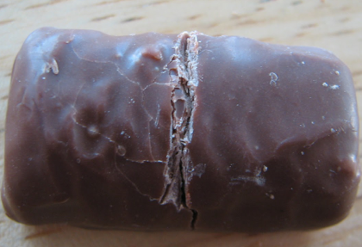
Experiment Procedures:

1. Use your fingernail or a knife to make a crack in the chocolate/crust of the candy bar.

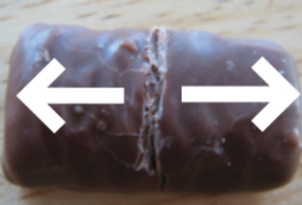
2. Hold each end of the candy bar and slowly, gently stretch the candy bar apart, but no farther than about a centimeter. You have created a divergent boundary.
Write or draw 2 observations: ______________________________________________________________________________________________________________________________________________________________________________________________________

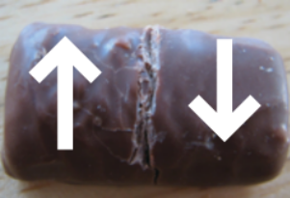
3. Push the candy bar back together to the original position. Now gently push one side away from you while pulling the other side towards you so that the pieces move along the crack. You have created a transform boundary.
Write or draw 2 observations: __________________________________________________________________________________________________________________________________________________________________________________

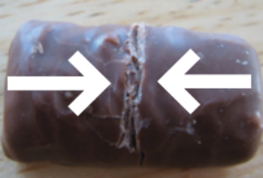
4. Push the candy bar back to the original position. Now push the two pieces towards each other.
You have created a convergent boundary.
Write or draw 2 observations:
________________________________________________________________________________________________________________________________________________________________________________________

Interpretation:
1) Label each of the plate boundaries drawn below as either divergent, convergent, or transform.
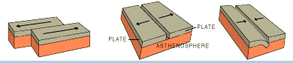

__________________ ___________________ ______________________

2) Based on your observations, at which type of boundary would you expect to see mountain ranges? _____________________________________

3) At which type of boundary would you expect to see thinned crust and asthenosphere? ____________________________________

4) At which type of boundary would you expect to see a kink (change in direction) in a stream or river? __________________________________

5) At which type of boundary would you expect to see a trench (one plate diving underneath another)?___________________________________

6) Where do we usually observe earthquakes – at plate boundaries, or in the middle of plates? ________________________________

7) Below is a map of the tectonic plates. We live very close to a transform boundary between two plates. Which are they? _______________________________________________________________
______________________________________________________________

8) What kind of geological feature do you expect to see north of the Indian plate? What is the name of this feature? ______________________________________________
______________________________________________________________

9) What kind of plate boundary exists between the South American plate and the African plate? What is the name of this feature? ________________________________________
______________________________________________________________

