Primary Production

Question:
Answer AFTER all evidence and analysis are finished

- How does nutrient availability impact primary production?

Using graphs

Low nutrient treatment Medium nutrient treatment High nutrient treatment
Hypotheses:
1.

Using graphs

Possibilities: Low nutrient treatment
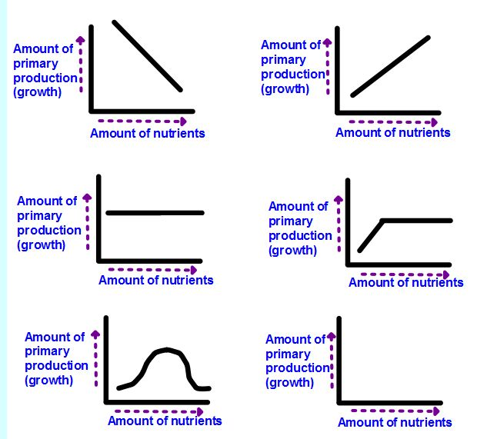

Medium nutrient treatment

High nutrient treatment

Evidence:
Food web worksheet (homework)
Use the information from the following web quest to fill out the worksheet below.
(http://www.ducksters.com/science/ecosystems/food_chain_and_web.php)


Vocabulary:
- Primary producer:

- Treatment:

- Diatom:

Analysis:
Graphs created in excel for all three treatments

Looking at growth rate three different ways

- You can see how the growth rates in the treatments change each day by looking at how the slope of the line between your data points changes.

Look at your three graphs with a partner. Identify what days the diatoms were growing slowly and what days they were growing quickly. Fill out the chart below, using words like: No growth, dying, medium, fast and very fast to describe the growth rates for each day.

Qualitative evaluation growth rate
Time period | Description of growth rate
 | High | Medium | Low
From Day 1 to Day 2
From Day 2 to Day 3
From Day 3 to Day 4
From Day 4 to Day 5

- You can see how growth rates change over time by calculating the number of new cells produced each day.

Use your Diatom Culture Data Tables and a calculator to fill in the chart below:

Number of new cells produced each day
Time period | Calculation | New cells/ per day
 |  | High | Medium | Low
From Day 1 to Day 2 | Day 2 − Day 1
From Day 2 to Day 3 | Day 3 − Day 2
From Day 3 to Day 4 | Day 4 − Day 3
From Day 4 to Day 5 | Day 5 − Day 4

- You can see how growth rates change over time by calculating how many times more cells there are each day.

Use your Diatom Culture Data Tables and a calculator to fill in the chart below:

How many times more cells there are
Time period | Calculation | Number of times more cells/ per day
 |  | High | Medium | Low
From Day 1 to Day 2 | Day 2 ÷ Day 1
From Day 2 to Day 3 | Day 3 ÷ Day 2
From Day 3 to Day 4 | Day 4 ÷ Day 3
From Day 4 to Day 5 | Day 5 ÷ Day 4

- Using your charts and observations from above, describe any patterns you see in growth rate for each treatment.
Low Treatment

Medium Treatment

High Treatment

- Do the diatoms in the three treatments grow differently? Explain why or why not.

- Which treatment had the greatest number of cells at the end of Day 5?

- Why did the treatment stated in #6 above have the greatest number of cells by Day 5?

- Did the graphs you hypothesized at the beginning of class match your results? If not which graphs do they match? Explain why.

Low Treatment

Medium Treatment

High Treatment

- What is one factor that can limit primary production? How does this limit the growth of
food webs ?

- What would be the consequences of changes in the amount primary production at the base of food webs?

