Primary Production Notebook Key
Answers are in bold. Student data may deviate from the expected graphs seen in this key, this may dramatically alter student answers.

Question:
Answer AFTER all evidence and analysis are finished

- How does nutrient availability impact primary production?

The amount of nutrients available to primary producers limits how much they can grow. Primary producers with more nutrients available to them will be able to grow more than primary producers with less nutrients available.

Using graphs

Low nutrient treatment Medium nutrient treatment High nutrient treatment
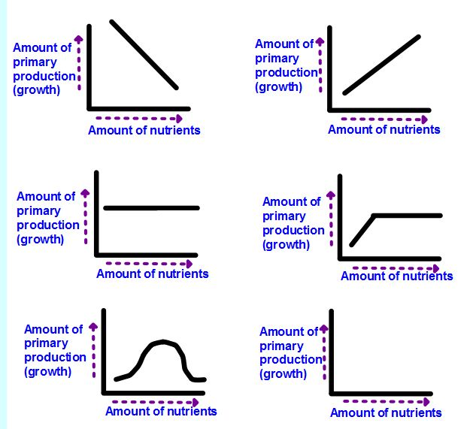

Although the graphs will likely vary from these quite a bit these might be the closest to what the class finds. The most correct answer to this question would be the graphs actually generated in the class.

Hypotheses:
1.

Using graphs

Possibilities: Low nutrient treatment

Medium nutrient treatment

High nutrient treatment

Evidence:
Food web worksheet (homework)
Use the information from the following web quest to fill out the worksheet below.
(http://www.ducksters.com/science/ecosystems/food_chain_and_web.php)


Vocabulary:
- Primary producer: Organisms in an ecosystem that grow using sunlight and nutrients.

- Treatment: A level a variable is tested at. Ex: Different levels or concentrations of nutrients (low, medium, high)

- Diatom: A unicellular primary producer found in the ocean.

Analysis:
Graphs created in excel for all three treatments

Looking at growth rate three different ways

Graphs filled in with numbers from charts I generated, these are the expected trends but are not the only correct answers.

- You can see how the growth rates in the treatments change each day by looking at how the slope of the line between your data points changes.

Look at your three graphs with a partner. Identify what days the diatoms were growing slowly and what days they were growing quickly. Fill out the chart below, using words like: No growth, dying, medium, fast and very fast to describe the growth rates for each day.

Qualitative evaluation growth rate
Time period | Description of growth rate
 | High | Medium | Low
From Day 1 to Day 2 | Fast | Fast | Fast
From Day 2 to Day 3 | No growth | Fast | Fast
From Day 3 to Day 4 | No growth | No growth | Fast
From Day 4 to Day 5 | Dying | No growth | Less fast

- You can see how growth rates change over time by calculating the number of new cells produced each day.

Use your Diatom Culture Data Tables and a calculator to fill in the chart below:

Number of new cells produced each day
Time period | Calculation | New cells/ per day
 |  | High | Medium | Low
From Day 1 to Day 2 | Day 2 − Day 1 | 6 | 6 | 6
From Day 2 to Day 3 | Day 3 − Day 2 | 12 | 12 | .5
From Day 3 to Day 4 | Day 4 − Day 3 | 24 | 0 | -.5
From Day 4 to Day 5 | Day 5 − Day 4 | 7 | -1 | .1

- You can see how growth rates change over time by calculating how many times more cells there are each day.

Use your Diatom Culture Data Tables and a calculator to fill in the chart below:

How many times more cells there are
Time period | Calculation | Number of times more cells/ per day
 |  | High | Medium | Low
From Day 1 to Day 2 | Day 2 ÷ Day 1 | 2 | 2 | 2
From Day 2 to Day 3 | Day 3 ÷ Day 2 | 2 | 2 | 1.04
From Day 3 to Day 4 | Day 4 ÷ Day 3 | 2 | 1 | .69
From Day 4 to Day 5 | Day 5 ÷ Day 4 | 1.15 | .95 | .92

- Using your charts and observations from above, describe any patterns you see in growth rate for each treatment.
Low Treatment
The low treatment starts of growing fast but then quickly slows down and stops growing, eventually dying off

Medium Treatment
The medium treatment grows quickly for the first three days but then stops growing by the 4th day.

High Treatment
The high treatment grows quickly over the entire length of the experiment, slowing a little at the end.

- Do the diatoms in the three treatments grow differently? Explain why or why not.
Yes, this is because they were given different amounts of nutrients. The cells in the low treatment quickly ran out of nutrients and stopped growing, it took longer for the cells in the medium treatment to use up all their nutrients and stop growing. The high nutrient treatment never runs out of nutrients completely, growth slows towards the end of the experiment though, implying they may be starting to.

- Which treatment had the greatest number of cells at the end of Day 5?

The high nutrient treatment.

- Why did the treatment stated in #6 above have the greatest number of cells by Day 5?

It had the highest number of cells because the cells in this treatment never ran out of nutrients. The nutrients are what limited growth in the other treatments, preventing them from reaching such high cell numbers.

- Did the graphs you hypothesized at the beginning of class match your results? If not which graphs do they match? Explain why.
This will be highly variable depending on student hypotheses.

Low Treatment

Medium Treatment

High Treatment

- What is one factor that can limit primary production? How does this limit the growth of
food webs ?
Nutrient availability. This can limit the growth of food webs by limiting growth of primary producers at the base of the food web. If there are fewer primary producers than there will be less food for the consumers in the food web, this impacts the entire food web.

- What would be the consequences of changes in the amount primary production at the base of food webs?
Less primary production would result in less food for herbivores. If herbivores started to die off due to starvation there would be less food for the predators that eat them.

