Name______________________________________ Period________________ Date______________________

Salmon Head Dissection Lab
Created by W. Jones

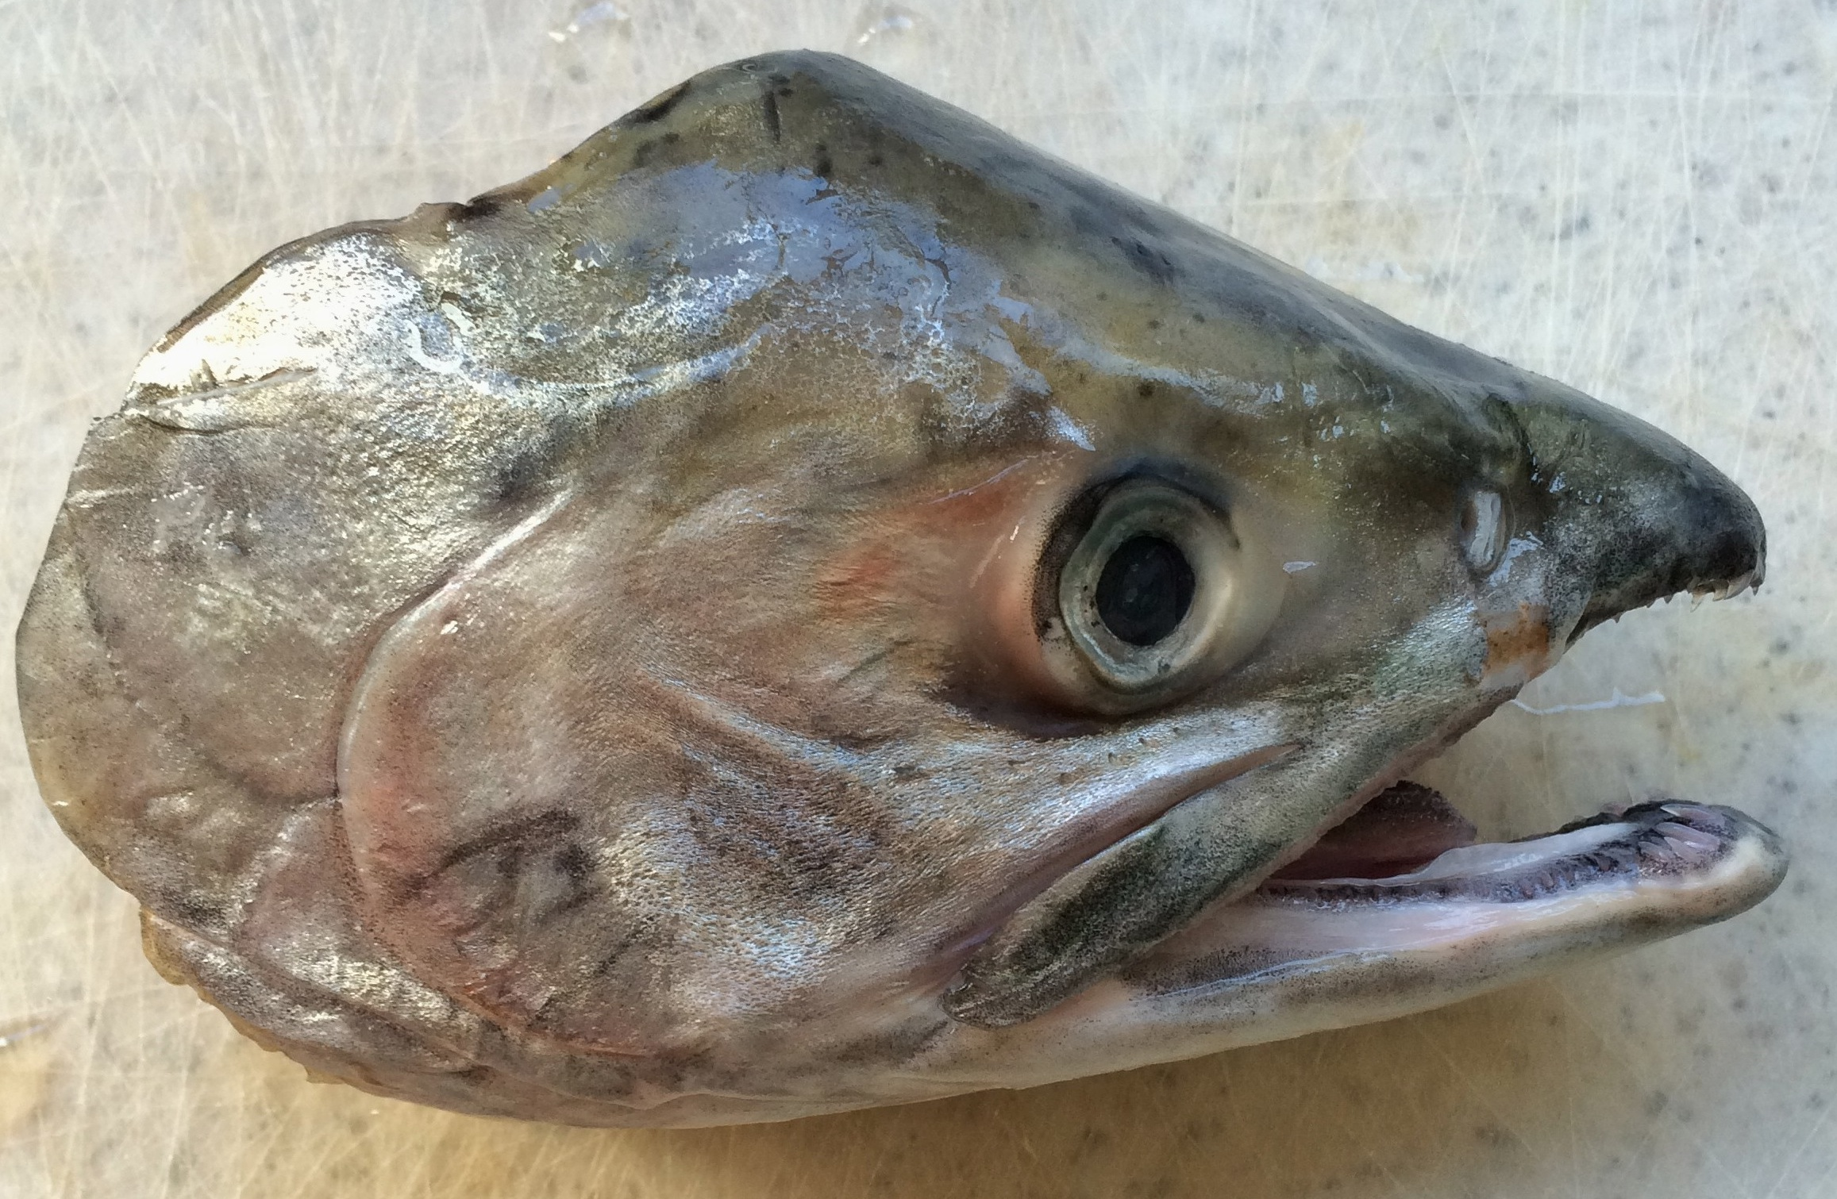
Salmon is the common name for several species of fish in the family Salmonidae. Other fish in the same family are called trout. The difference between salmon and trout is sometimes said to be that salmon migrate and trout are resident, and that salmon spawn once and trout spawn many times, though these distinctions are not always strictly true. Salmon live along the coast of both the North Atlantic and Pacific Oceans, and have been introduced into the Great Lakes. Salmon are also intensively produced in aquaculture in many parts of the world. Typically, salmon are anadromous; they are born in fresh water, migrate to the oceans, then return to fresh water to reproduce.

In this lab, you will be looking at two species of salmon, Pacific Ocean wild caught Chinook salmon (Oncorhynchus tshawytscha) and farmed Atlantic salmon (Salmo salar). First, you will examine the external and internal structures of fish anatomy. You will then remove the otolith, or “ear bone” from the head. Next, you will use the otoliths size to estimate the original size of the fish. Finally, you will combine your fish size results with other students in the class and compare and analyze the observed differences between Chinook and Atlantic salmon.

OBJECTIVES:
Learn why and how fisheries scientist dissect fish
Identify and describe the appearance and function of external and internal structures of fish anatomy.
Compare and contrast the features of a salmon to other organisms, including other fish.
Dissect a salmon head, including the removal of the otoliths, or “ear bones”.
Reconstruct the original size of the fish using the otolith size.
Analyze the fish size results, noting differences between the two salmon species.
Understand the function/role of the otolith for the fish and fisheries scientists.

MATERIALS
The class should be broken up into groups with 4 students per group.
- Dissection kit; dissecting pins, tray, forceps, scissors, scalpel, probe (one set per group)
- Safety goggles (one for each student)
- Lab apron (one for each student)
- Small wire cutters (one per group)
- Gloves (one for each student)
- Salmon head (one per group)
- Hand lens / magnifying lens (one per group)
- Dissecting microscope (3-4 set up in the front of the class room)

Procedure
Part A: Observing the Fish’s External and Internal Anatomy

- Ensure each group member is wearing an apron and goggles properly.
- Obtain one pair of vinyl gloves per group member
- Place the fish in the dissecting pan
- Locate all the external features as shown in Figure 1 on your specimen and then answer the questions on your “Fish Head Dissection Worksheet”.

Figure 1.
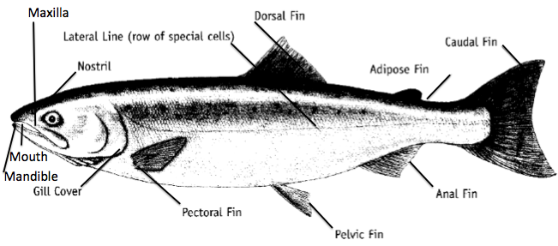
Identify your species
- Identify the species of your salmon head and record it on your “Fish head dissection worksheet”.

Atlantic salmon have black spots on head and the interior of he mouth is entirely white. Chinook (King) salmon have black gums

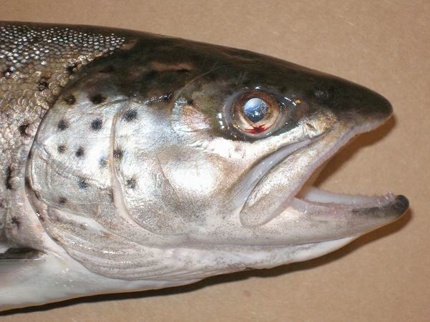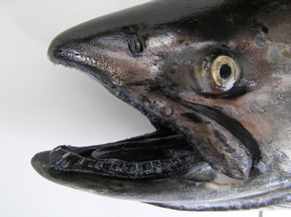
Atlantic Salmon - Farmed Chinook Salmon – Wild Caught
(image from: www.fishcreeksalmon.org) (image from wdfw.wa.gov)

Shape
Since water has more resistance to movement then air, fish are streamline shaped to reduce the amount of energy required to move through water. A fish’s body shape and external anatomical features (outside body parts) can tell us a lot about a species – where it lives in the water, how it finds food, what it eats, and how it protects itself from predators. For example, the body shape of a fish can indicate where that fish lives in the water and what type of swimmer it might be. In addition, tail fin shape also signifies a fish’s swimming speed. A sharply forked tail, like that of a shark, implies a fast swimmer, where as a rounded tail means the fish is good at turning.

- There are several other species of fish on display at the front of the room. Pick one of the other fish to sketch and answer the questions about it on your “Fish head dissection worksheet”.
Fins
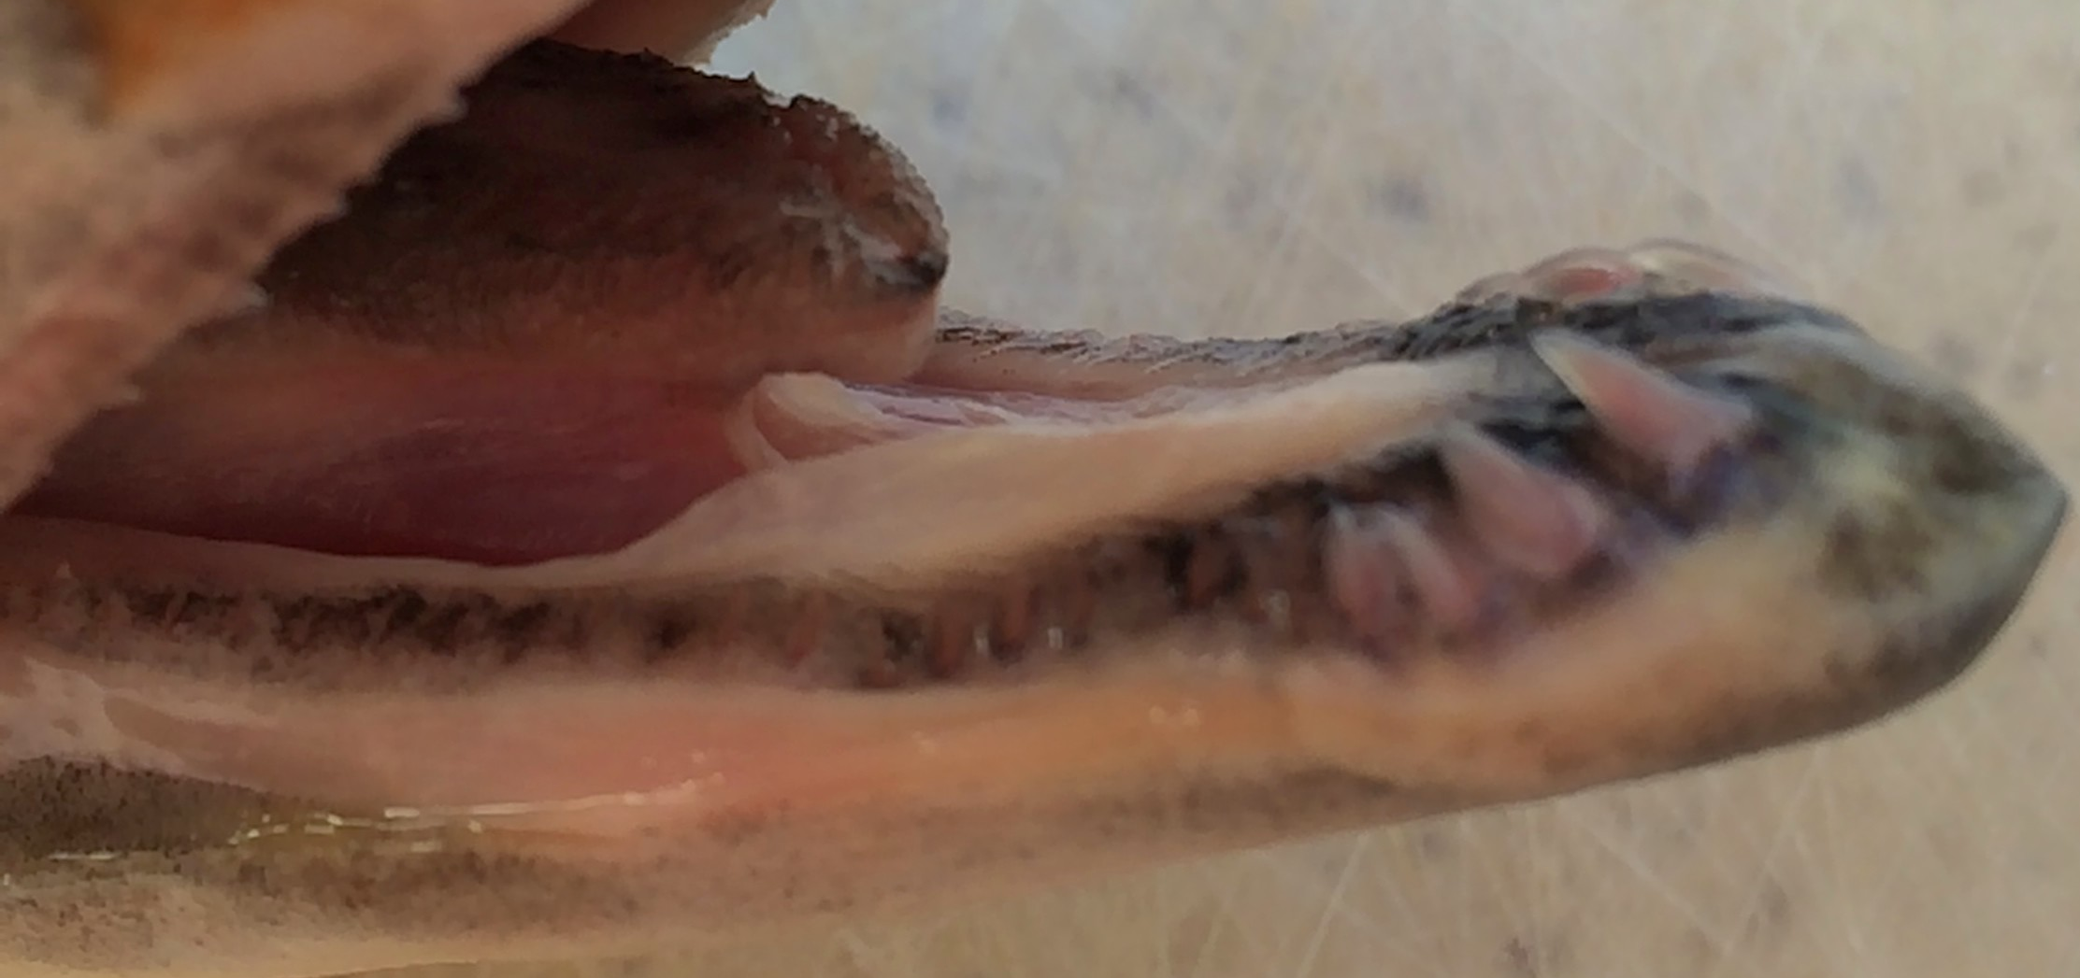
- Salmon have eight fins including the tail. They are made up of bony spines with a thin skin stretched between them. The fins are embedded in the salmon’s muscle, not linked to other bones, as limbs are in people. This gives them a great deal of flexibility and maneuverability.
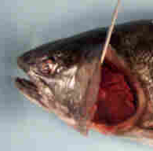
Each fin has a different function. The caudal or tail, is the largest and most powerful. It pushes from side to side and moves the fish forward in a wavy path. The dorsal fin acts like a keel on a ship. It keeps the fish upright, and it also controls the direction the fish moves in. The anal fin also helps keep the fish stable and upright. The pectoral and pelvic fins are used for steering and for balance. They can also move the fish up and down in the water. The adipose fin has no known function. It is sometimes clipped off in hatchery fish to help identify the fish when they return or are caught.

Mouth and Gills
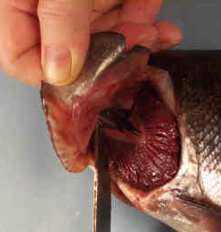
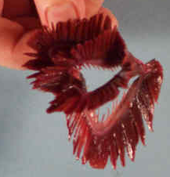
- Open and close the salmon’s mouth to observe the action of the mandible and the maxilla. Examine the teeth and the tongue. Note the direction that the teeth point. Salmon teeth are sharp and needle-like, which they use to grab their prey. Their tongue has two sharp shafts and, like human tongues, contains taste buds. Salmon do not chew their food.

- Place your probe under the gill cover (operculum) and gently push it out. You should notice several gill arches, which hold the gill rakers and gill filaments. Fish breathe by gulping water through their mouth forcing water over their gills and out through the gill plate opening. The gills are red because they are filled with blood, which picks up oxygen as water passes over them.

- Remove one gill arch by cutting its dorsal and ventral attachment. Place it in a small beaker of water and examine it with a hand lens / magnifying glass or a dissecting microscope. Look for the thin delicate structures called gill filaments. These filaments are filled with capillaries that carry blood from the heart.

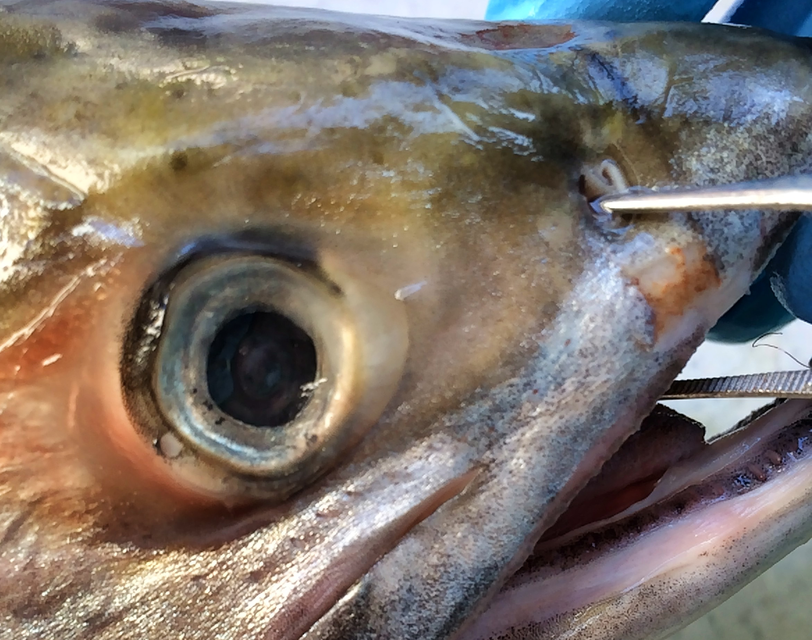
- Locate the gill rakers on each gill arch. These projections separate the gill arches from each other and create spaces between each of the gill arches. Notice how the gill rakers project inside the fish’s mouth.

Nostrils
- Explore the inside of the nostrils with the probe. Fish smell very tiny amounts of chemicals in the water. They use this information to detect harmful pollution and avoid potential threats. Salmon also use smells to recognize their way home from the ocean.

Lateral Line
- Try to identify where the lateral line starts near the top of the gill cover (your head may not have any part of the lateral line present – look at figure 1). The lateral line functions as a sensory organ combining aspects of touch, hearing, and seeing. It detects vibrations and pressure waves in water, similar to what an ear does in air, and allows fish to sense water flow and disturbances.

Slime
- Many fish, including salmon, have a layer of slime covering their body. Touch the top of the head to feel the slime. The slime layer helps fish to:
  - Slip away from predators, including bears or other fish.
  - Slip over rocks or other obstacles to avoid injuries
  - Protect against diseases, parasites, and pollutants.
Scales
Most fish, including salmon, have a layer of scales covering their skin. Scales are small, hard plates, like fingernails, that cover the body for protection. The scales overlap to form a flexible armor plating to protect from predators and bruising. Fish have the same number of scales all their lives. As the fish grows, the scales grow. They form growth lines, like the rings in a tree or otolith.

- Remove a scale from the fish (if there are no fish scales on your head, look the fish scale already set up under the microscope set up by your teacher). Look at the scale with a magnifying lens or dissecting microscope. Draw the scale and growth rings on your Observation Worksheet.

Eyes
Salmon have two eyes, but unlike people, salmon do not have binocular vision, which would give them depth perception. However, they swivel each eye independently forward and backward to cover a much wider field of vision than people have. Fish have very sharp vision under water. Some can see five meters or more.

- Remove one eye by reaching inside the fish’s mouth with one finger and pushing hard to loosen the muscles in the socket behind the eye. When it is pushed out of the socket remove your finger. From the outside gently pull up on the eye with one hand as you cut it away from the head.

Human eyes are approximately the size of a golf ball. As do salmon, most of the eye is hidden inside their skull for protection. Unlike humans, salmon have no eyelids and no need to blink. Their eyes are continuously washed in water.
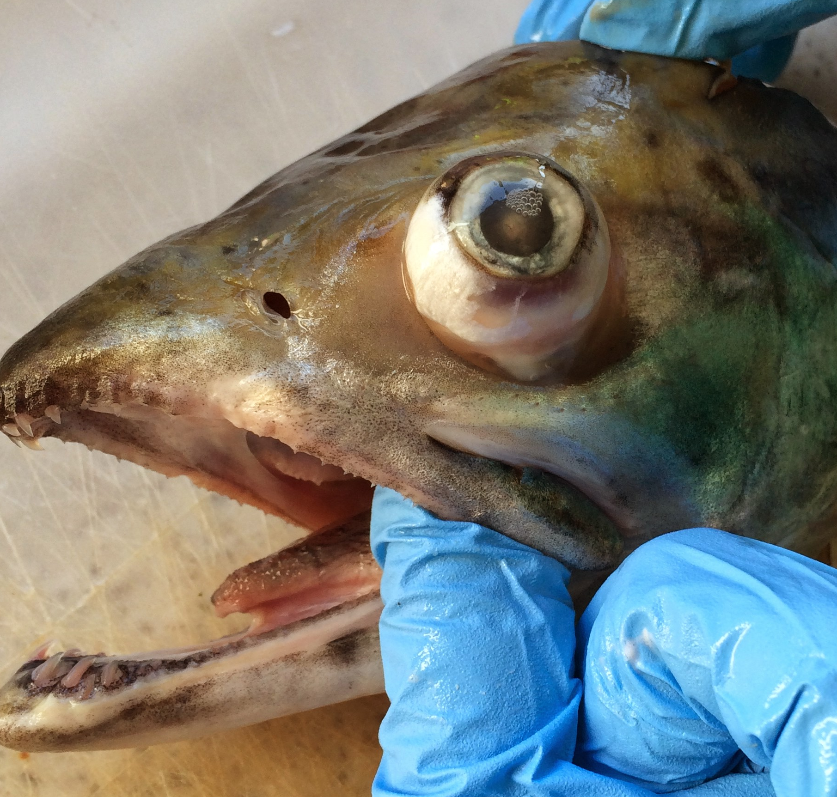

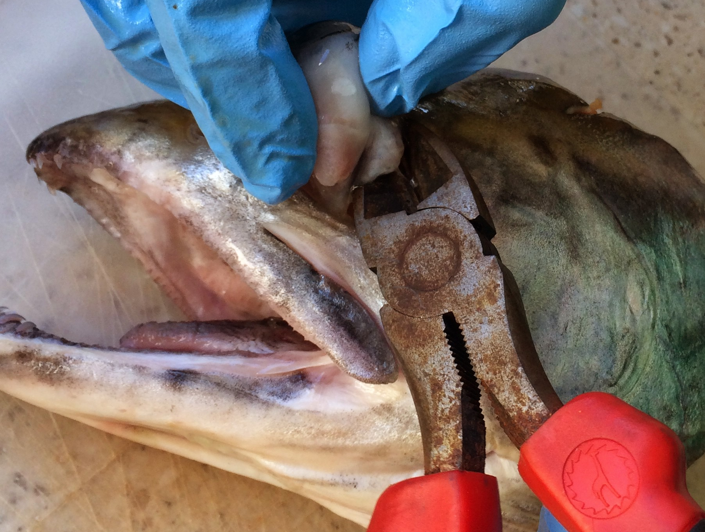

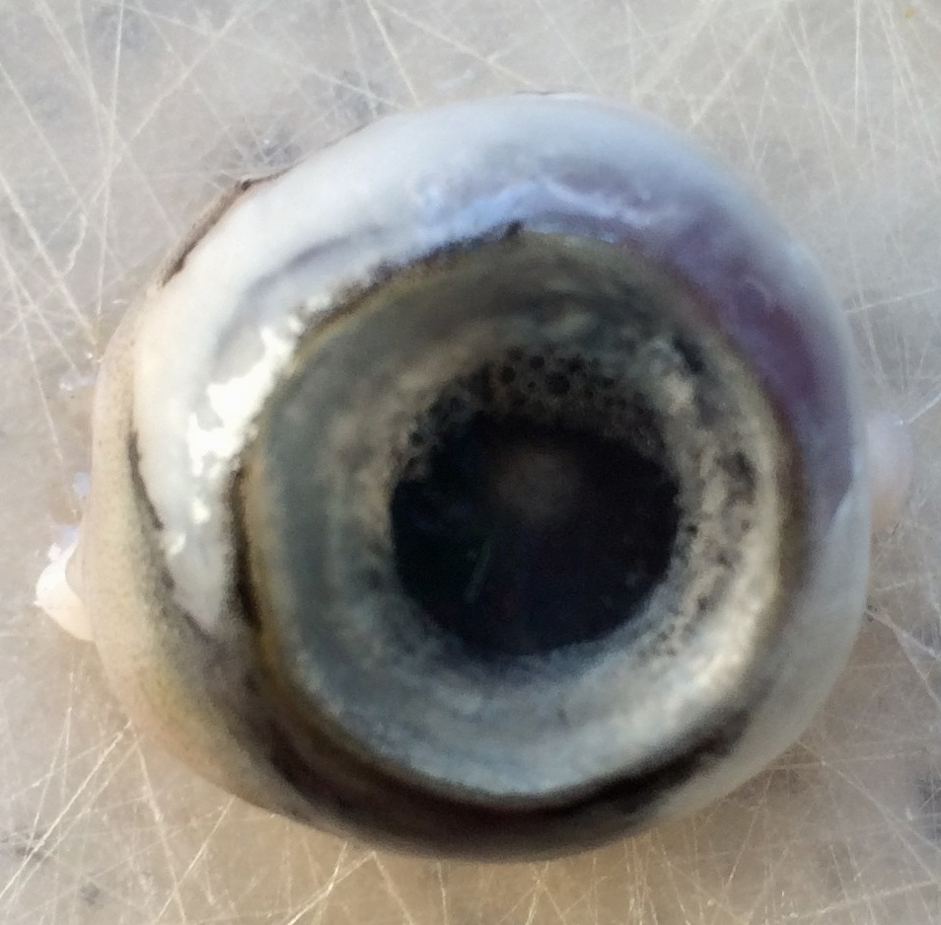

Part B: Otolith Removal

Otolith
Fish have an inner ear, but no outer ear. Sound waves travel through the water and through their body to the bones (otolith) in the inner ear. Salmon probably use hearing to detect predators and other threats. Fish also detect sound waves through their lateral line.

- To remove the otolith, place the head upside down with the gills up on the dissecting tray.
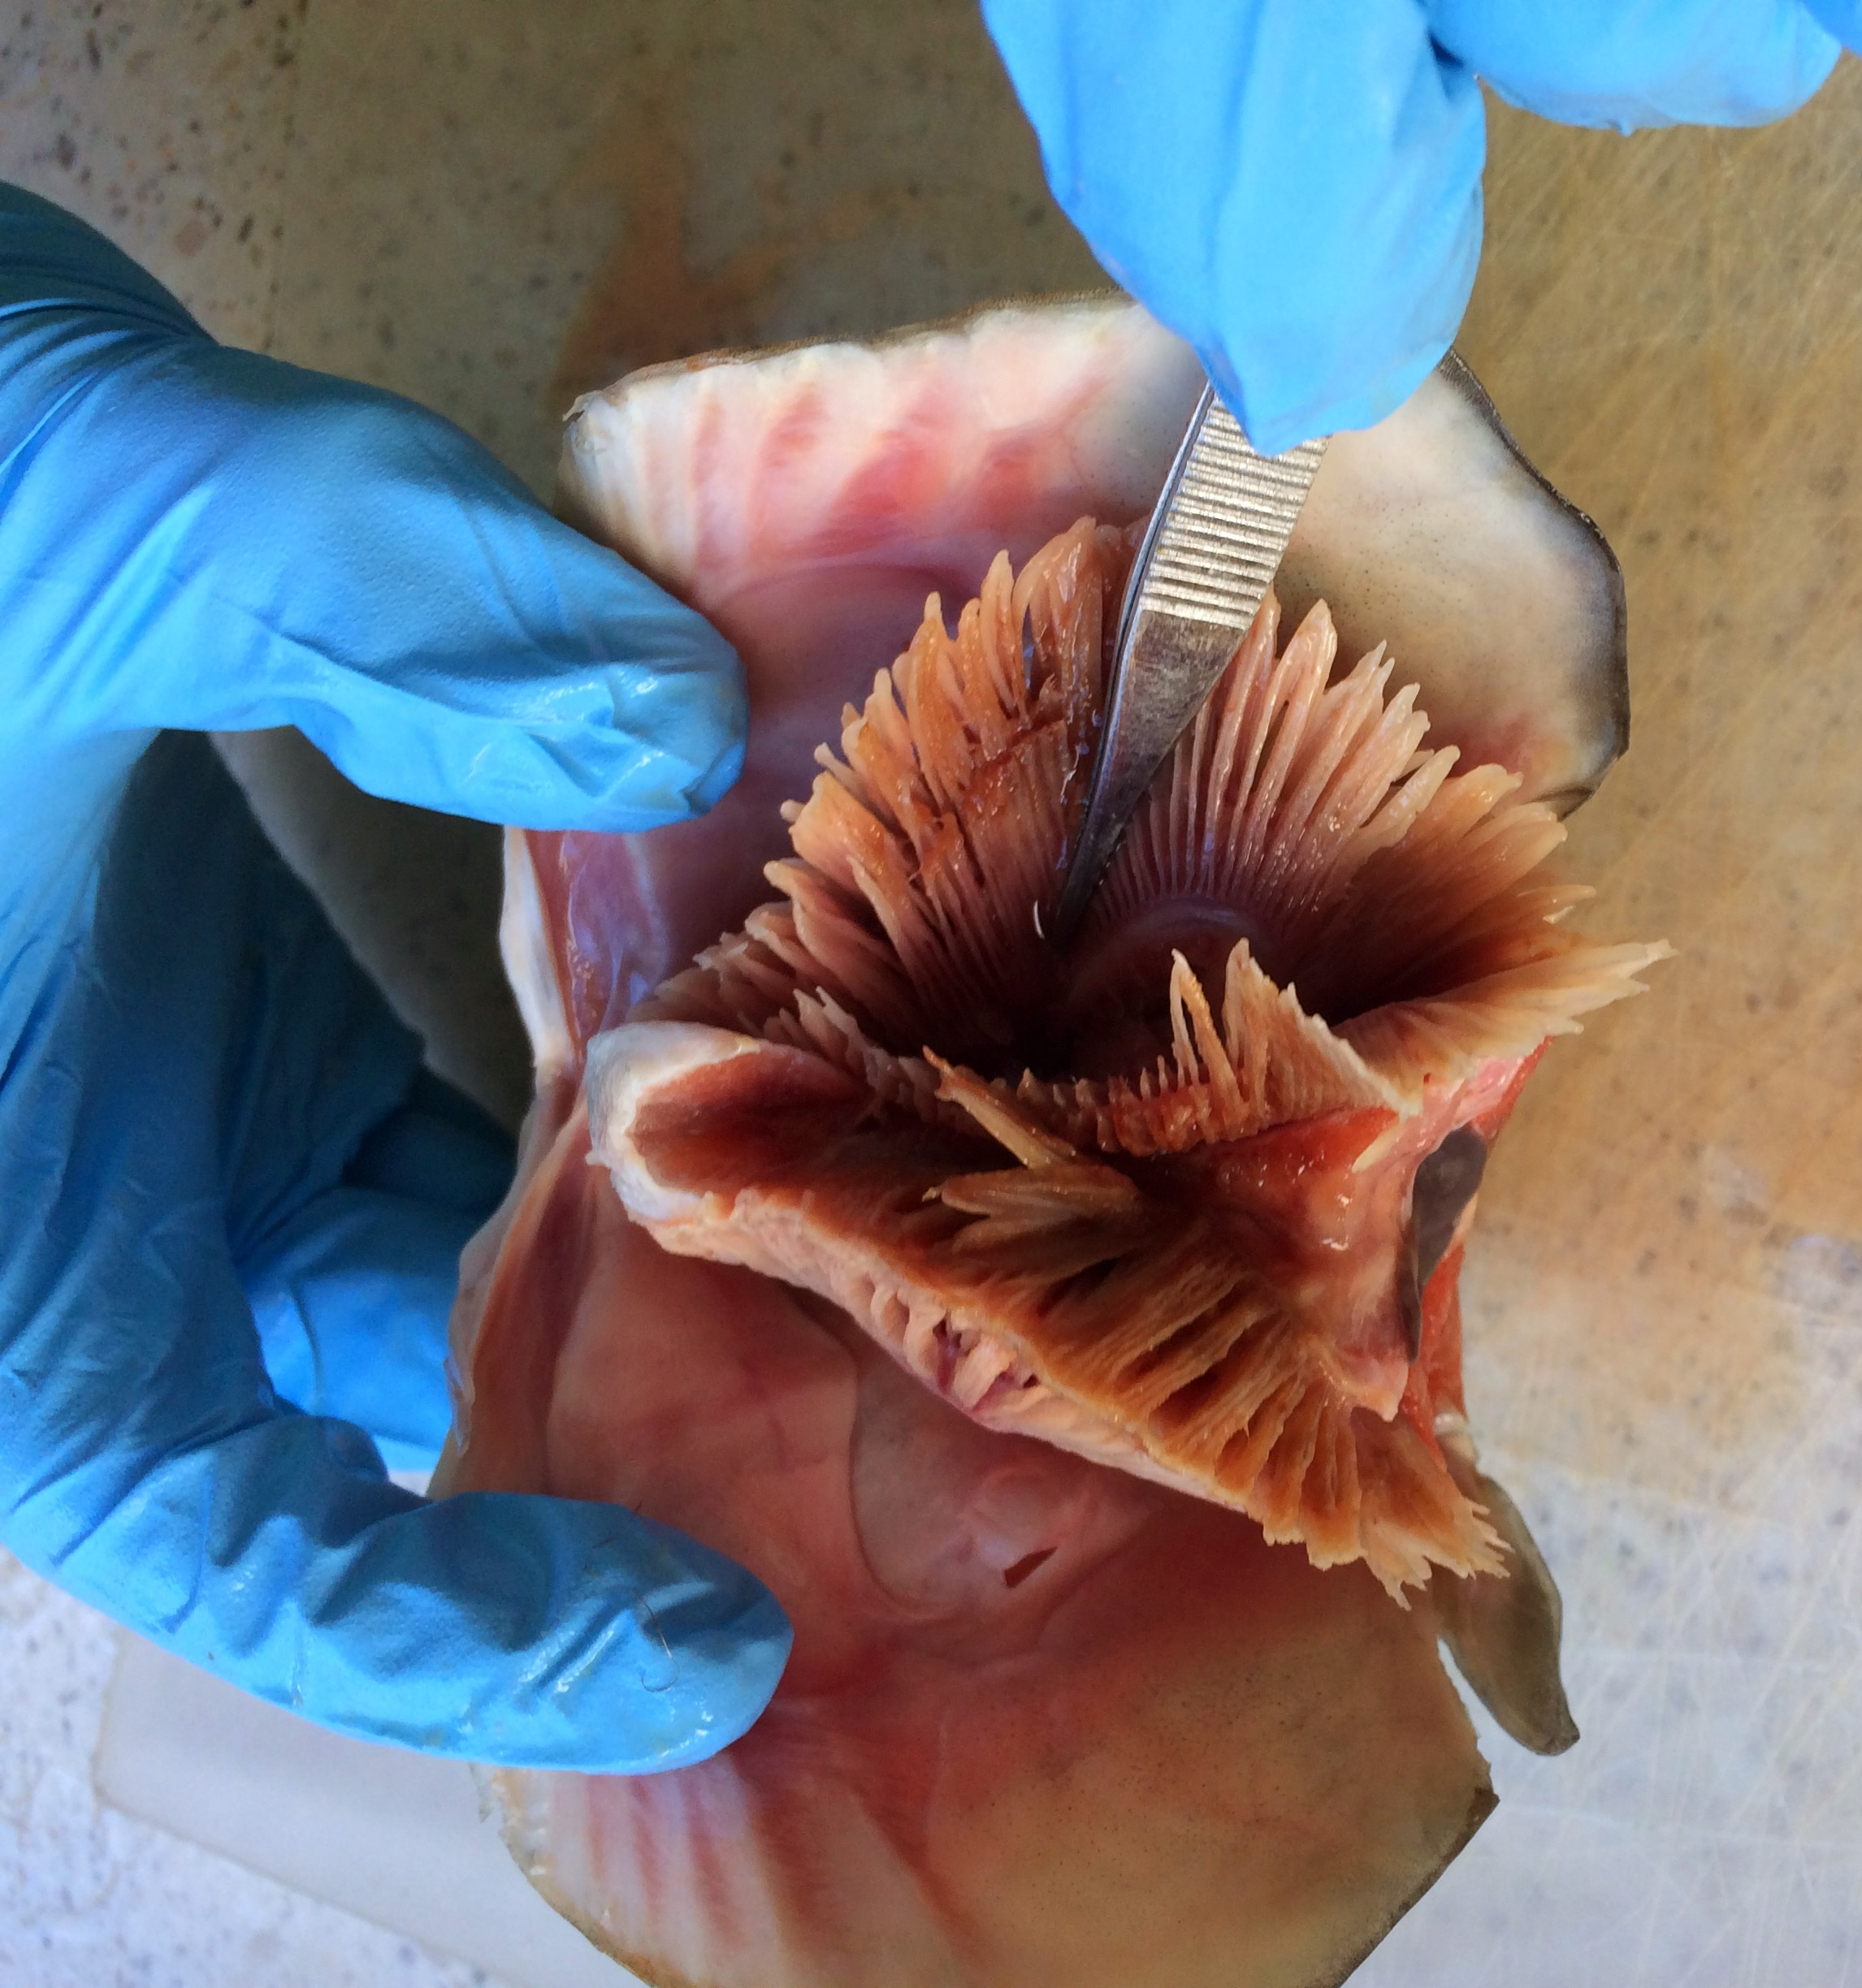

- cut the bony part where the gills connect to the lower jaw area as shown below. The gills should fold back out of the way.
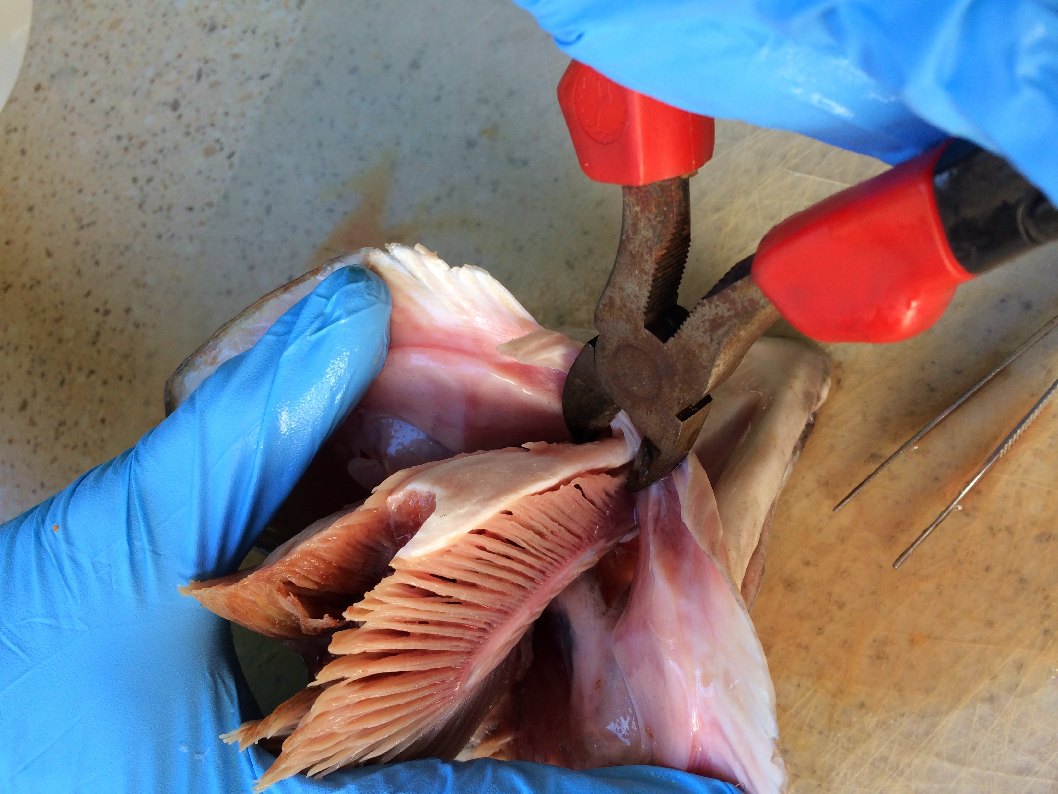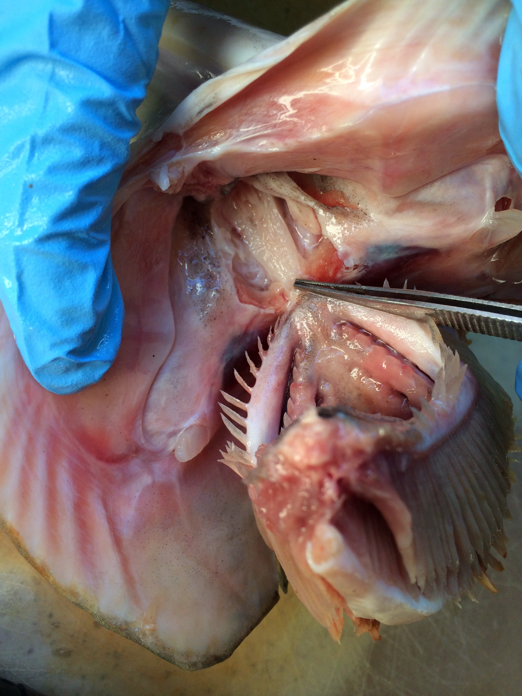

- Next, cut through the tissue (not through bone, which is below the tissue) where the gills remain connected as shown below. You want remove the tissue to expose the bone below (red arrow).
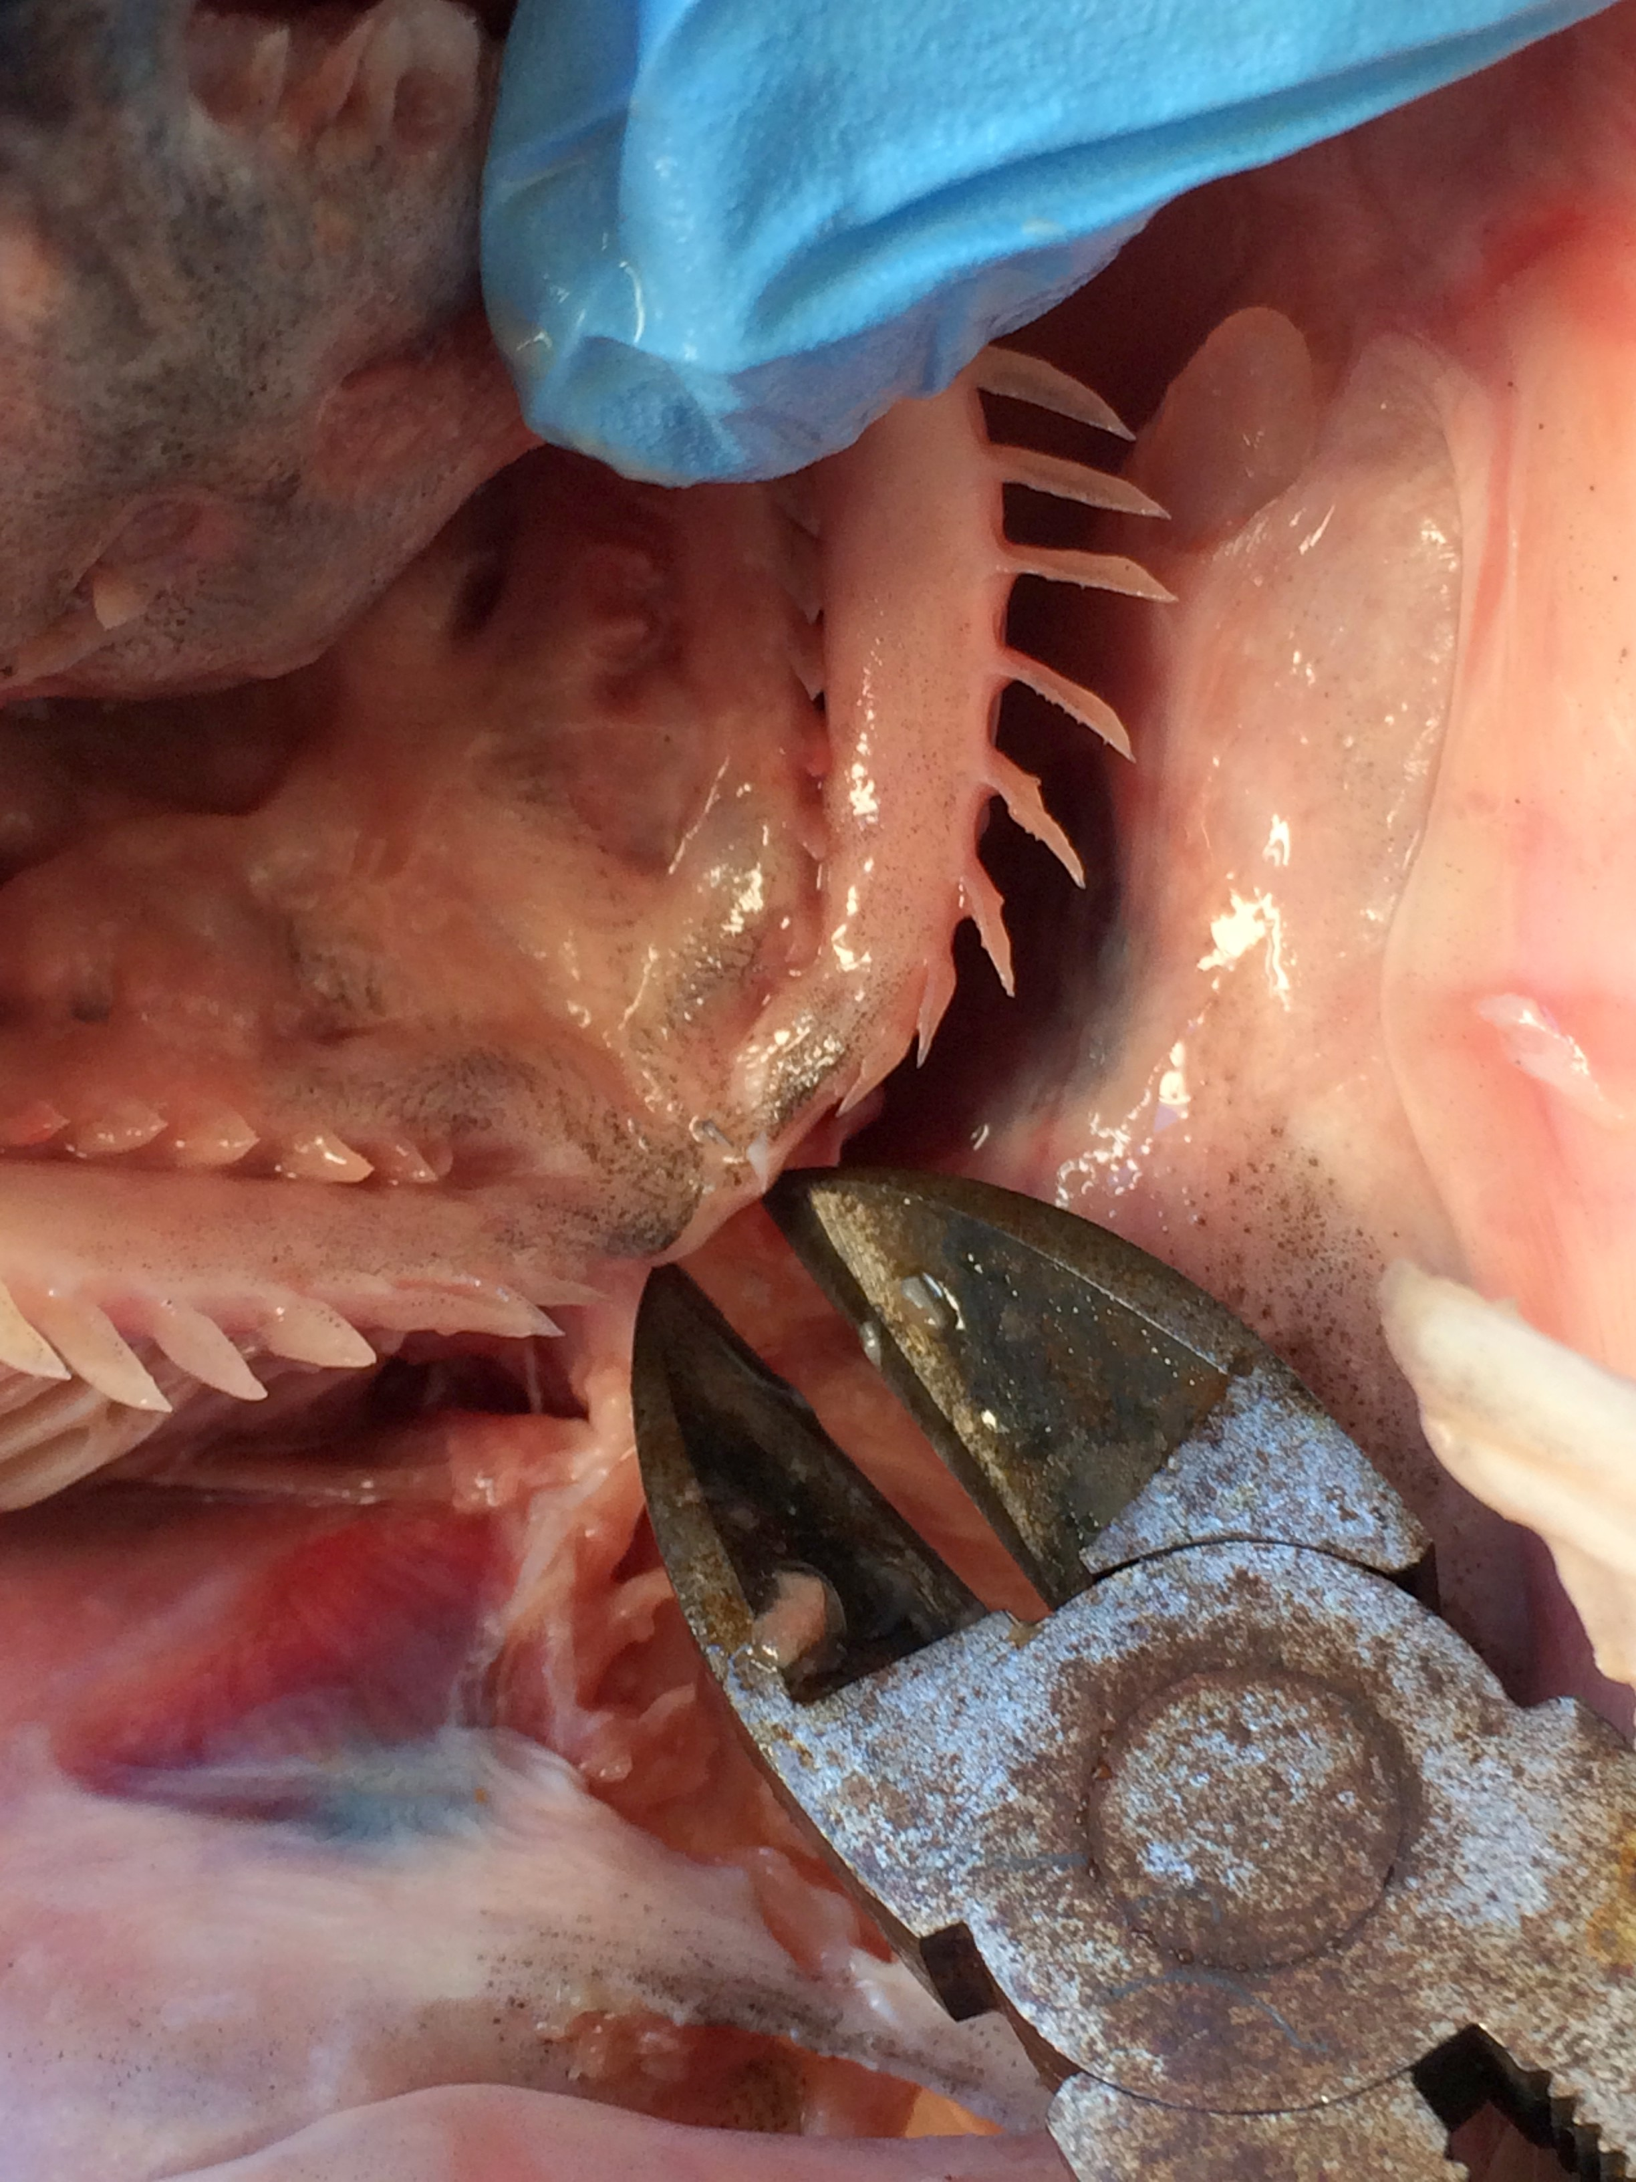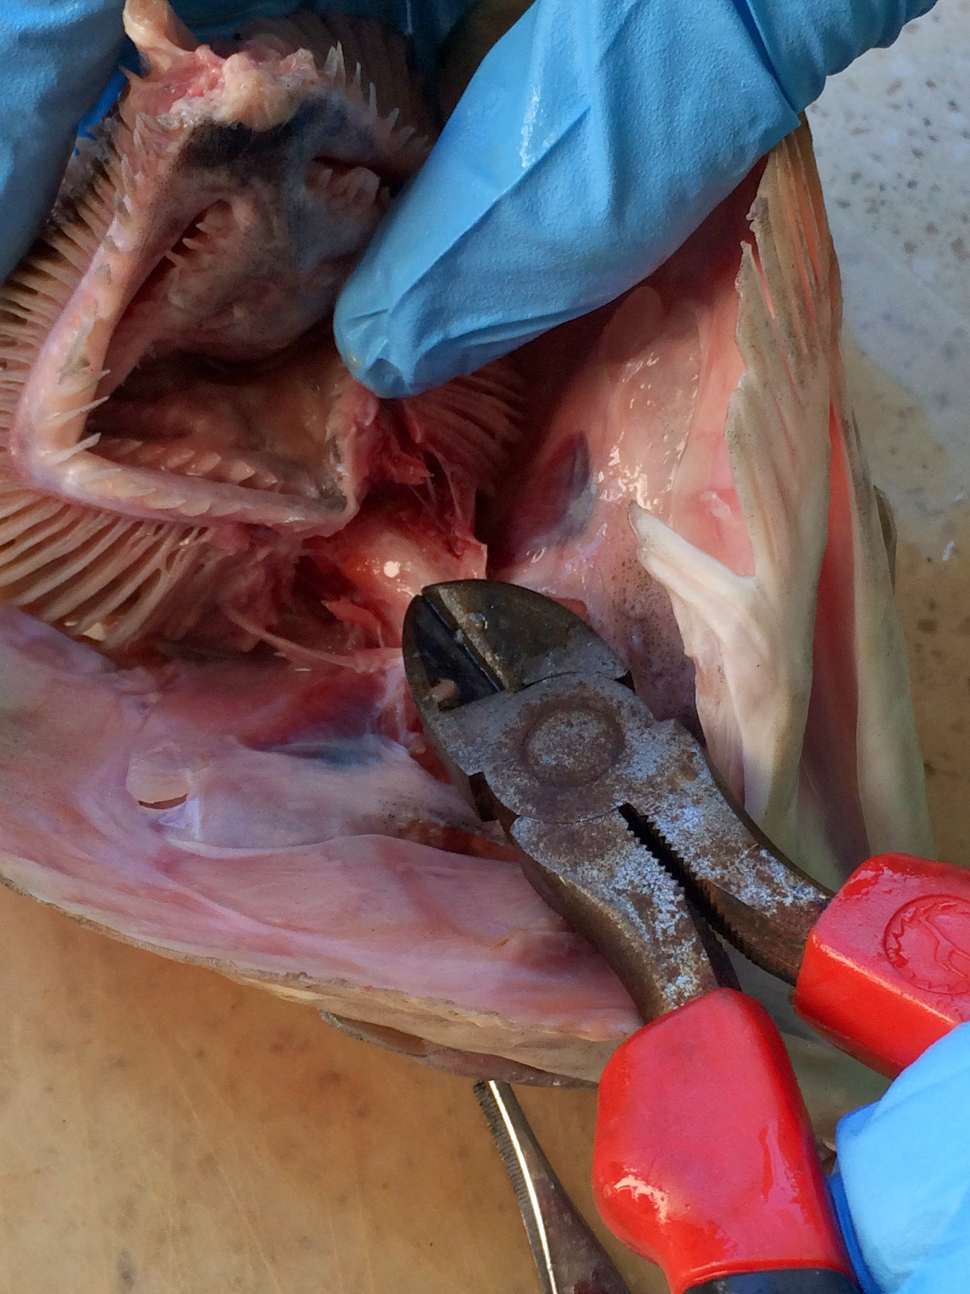
- Carefully cut through the bone that you exposed. Start the cut at the closest part to the mouth opening and pry the bone up. Below the bone is a cavity where the otoliths are. If you cut too aggressively you will destroy the otoliths, which are very fragile. The red arrow below shows the otolith within the otolith cavity. Remove the otolith carefully with forceps.
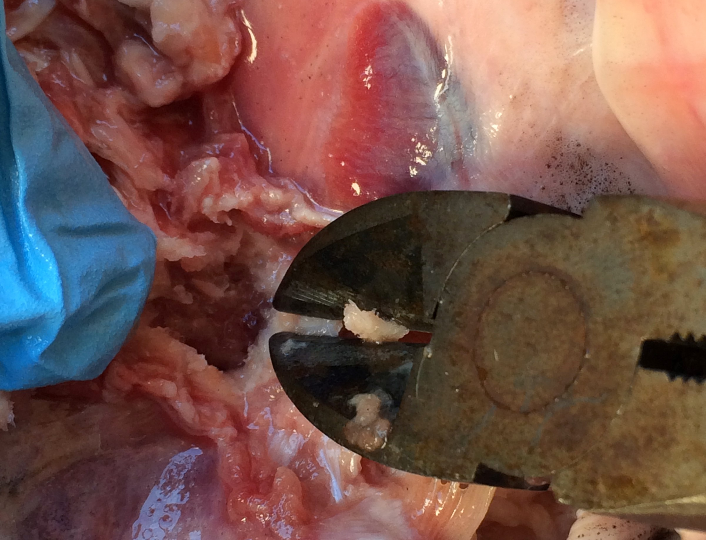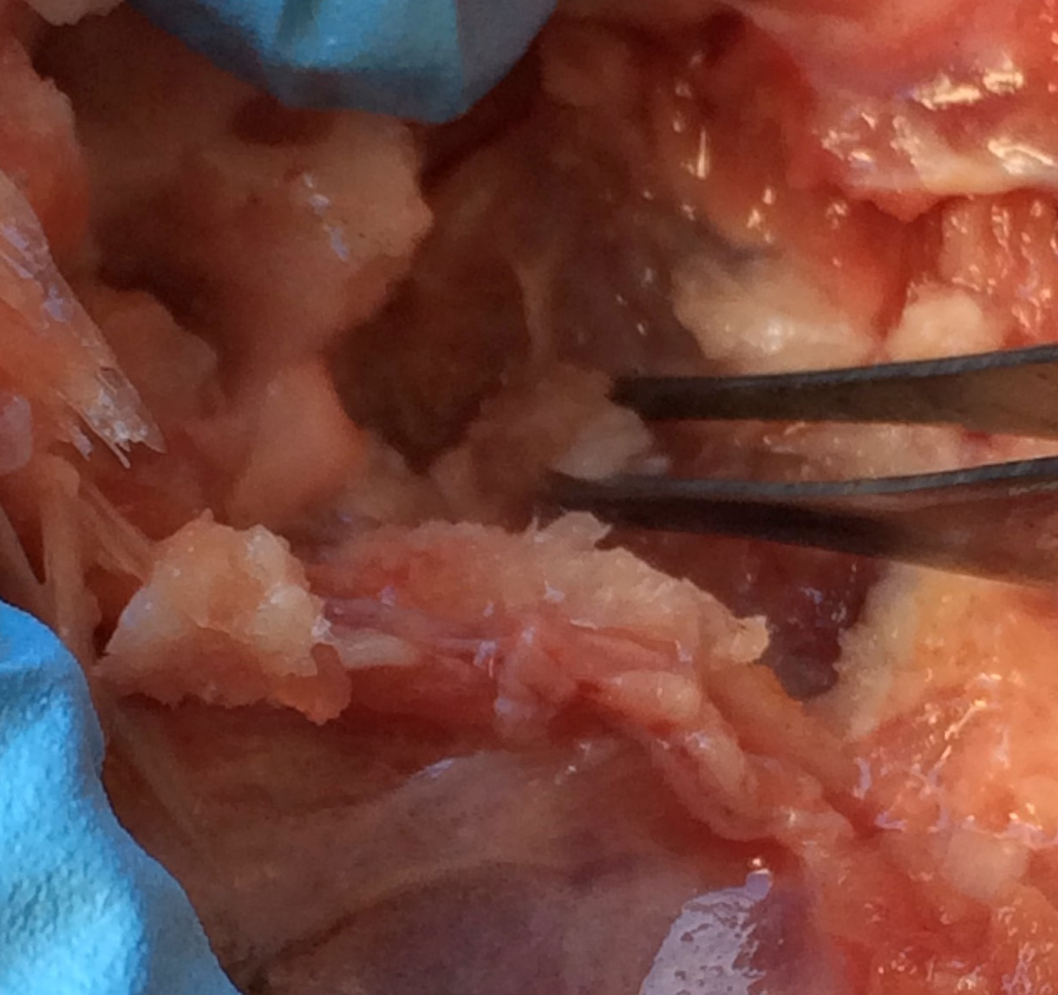

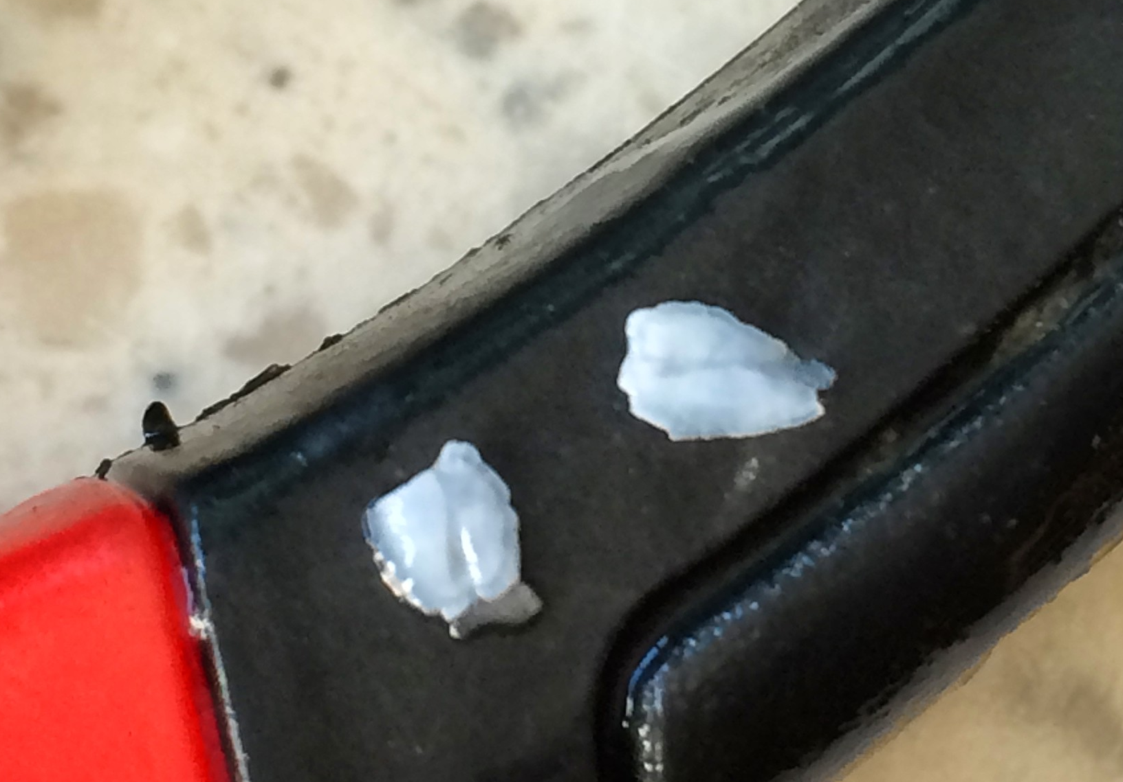

- Gently clean the otolith with water – be careful not to drop it.
- Draw the otolith on your “Fish head dissection worksheet”.
- Measure the length and width of the otolith to the nearest millimeter under the dissection microscope and record it on your “Fish head dissection worksheet”.
- The teacher will collect the otoliths.

Brain
- Like all chordates, salmon have a brain at the end of their spinal cord where the nervous system transmits the information they receive about their environment. The brain is located below the cavity where the otoliths are found. After removing the otolith, use the forceps to expand the cavity hole. Gently probe further into the cavity and scrape out the brain. Tilt the head up side down and continue to scrape until removed.

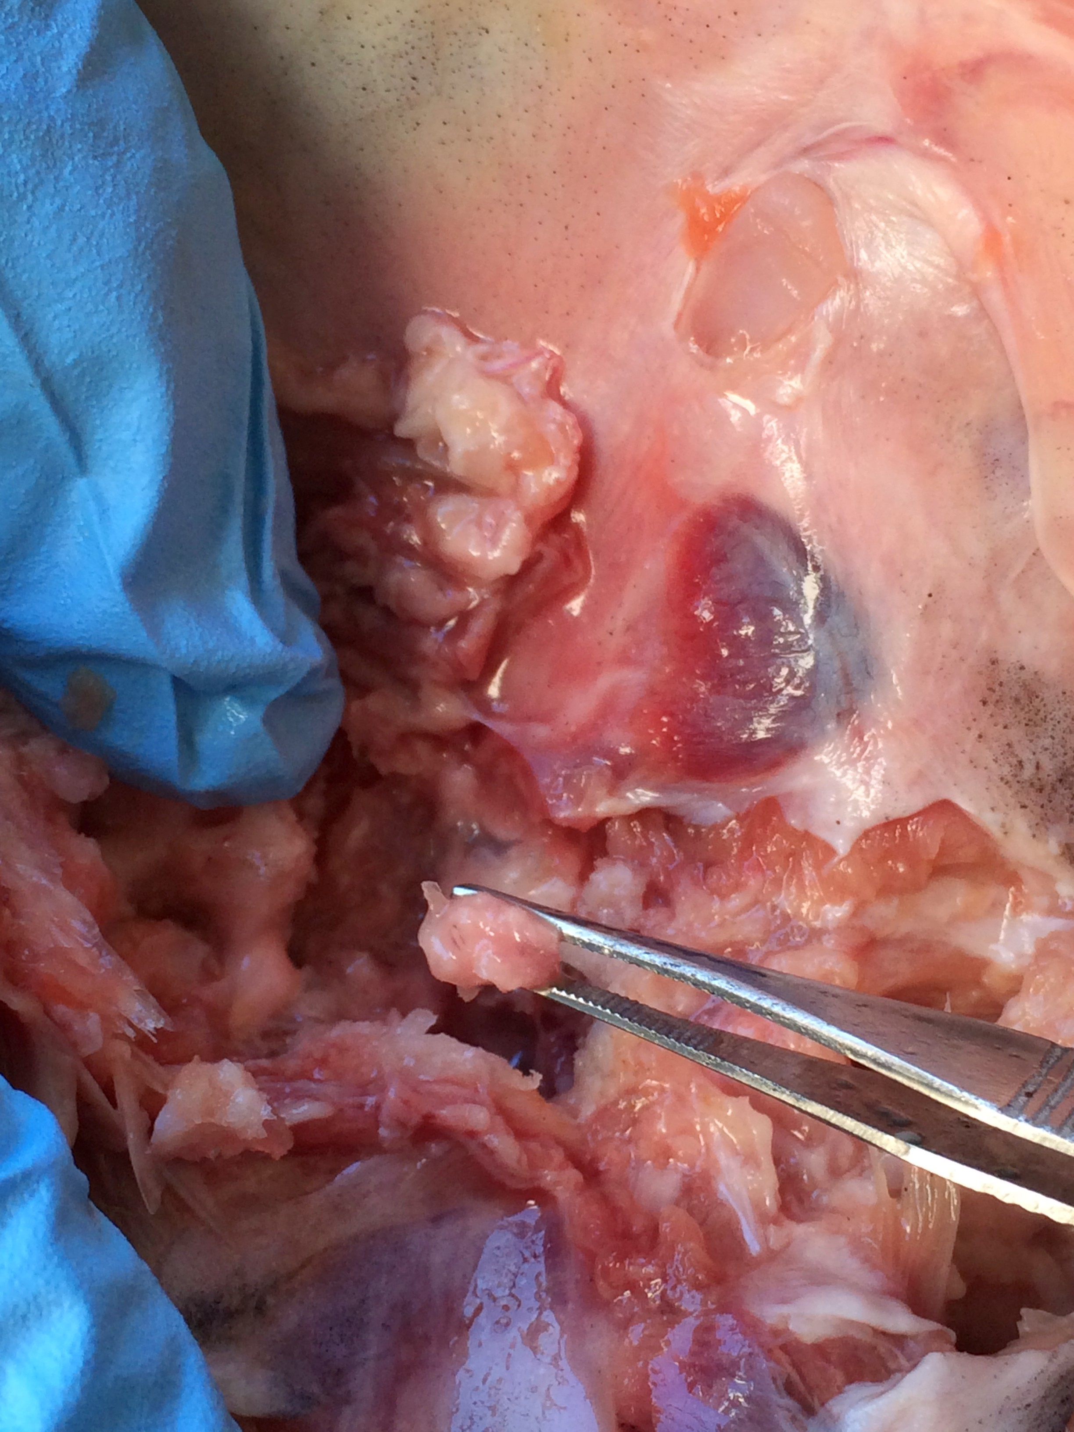

Part C: Clean up and disposal
- Once your group has finished observing and identifying the structures of the salmon head and removed the otoliths, the head must be disposed of safely. If there are any excess fluids in your dissecting tray, please pour them down the sink with plenty of water.
- Place all the fish and fish tissue directly into the garbage bag provided by your teacher.
- Wash your dissecting instruments and dry them to prevent rusting.
- Place dissecting instruments back into the kit only when fully dry.
- Wash out the dissecting tray with soapy water and lay them on a common bench to drip dry.
- Dispose of your gloves with the fish waste and wash your hands thoroughly.
- The teacher will collect the otoliths. The teacher will gently wash the otoliths in water and then let them dry. Otoliths will be stored in small glass or plastic vials.

